

CAPSTONE PROJECT REPORT
Report 3 – Software Requirement Specification

Ho Chi Minh City, October 2026
Table of Contents
I. Record of Changes 3
II. Software Requirement Specification 4
1. Product Overview 4
2. User Requirements 4
2.1 Actors 4
2.2 Use Cases 6
3. Functional Requirements 10
3.1 System Functional Overview 10
3.2 Authentication & User Account 14
3.3 Retailer Registration & Assessment 16
3.4 Product & Category Management 17
3.5 Promotion & Batch Discount Management 19
3.6 Purchase Order & Offline Synchronization 21
3.7 FEFO–MLOR Allocation & Availability 24
3.8 Warehouse Receiving & Batch Inventory 26
3.9 Picking & Retailer Receipt Confirmation 28
3.10 Payment & Loyalty Management 30
3.11 Sales Groups & Operational Reporting 32
3.12 System Configuration & Notifications 33
3.13 Delivery Operations 34
4. Non-Functional Requirements 34
4.1 External Interfaces 34
4.2 Quality Attributes 35
5. Requirement Appendix 38
5.1 Business Rules 38
5.2 Common Requirements 44
5.3 Application Messages List 45

I. Record of Changes
Date | A, M, D * | In charge | Change Description
29/09/2026 | A | Tran Ngoc Khiet | Version 1.0  Add:  - 1. Product Overview  - 2.1 Actors
12/10/2026 | A | Tran Ngoc Khiet | Version 1.1  Add:  - 2.2 Use Cases  - 3.2 -> 3.12 Features  - 4. Non-Functional Requirements  Modify:  - New system context diagram  - 2.1 Actors: Update actors
17/10/2026 | M | Tran Ngoc Khiet | Version 1.2:  Add:  - 5.2 Common Requirements  - 5.3 Application Messages List
18/10/2026 | A | Nguyen Thien Nhan | Version 1.3:  Add:  - 5.1 Business Rules BR-01–BR-58: daily allocation at 12:00 with Administrator run approval. Version 1.4 adds BR-59–BR-65 for near-expiry offers, effective line MLOR and customer acceptance; aligns functions, data and diagrams.
18/10/2026 | M | Nguyen Thien Nhan | Version 1.4: Add offer-specific accepted MLOR, line types and validation. Align daily run, approval/reservation, data model, diagrams and scope; remove internal transfers and stock holds.
19/10/2026 | M | Nguyen Thien Nhan | Version 1.5: Mentor review — final-price payment timing, manual refunds, complaint receivable adjustments, bounded replacement attempts, MLOR definition and unchanged one-time resubmission priority.
25/10/2026 | A | Vo Minh Son | Version 1.6:  Add:  - Add UC-87 🡪 UC-91  Modify:  - 2.2: Update UC-77
27/10/2026 | M | Vo Minh Sơn | Version 1.7:  Add:  - 3.6.6 Respond to Quotation and Choose Payment Method  - Function type of each function in 3.2 -> 3.13  Modify:  - 3.1.1 Screen flows  - 3.1.2 Screen Descriptions: quotation, payment and delivery failure screen  - 3.1.3 Screen Authorization  - 3.2.1, 3.2.2 Login: one Mobile App, Microsoft pop-up, Retailer OTP  - 3.6, 3.7.2, 3.10.1: quotation, prepaid bank transfer or credit, PO before picking  - 5.1 Business Rules: BR-13, BR-21, BR-37, BR-45, BR-49, BR-51, BR-66  - 5.2 Common Requirements: CR-13
27/10/2026 | M | Vo Minh Son | Version 1.8:  Add:  - Acceptance criteria (AC tables) and traceability for every function in 3.2 – 3.13  - Prototype screen layouts for all screen functions  - 3.5.4 Manage Shelf-Life Discount Rules and Batch Pricing  - UC-92 – UC-98; BR-71 – BR-80; entities 58 – 61  - 5.4 Traceability Matrix  - 5.5 Scope Reconciliation with Registration  Modify:  - 3.2 – 3.13: explicit primary/secondary/system actors; all PENDING business rules resolved  - 3.13.1 fully specified  - 4. Non-Functional Requirements: metric, threshold and measurement method for every NFR  - 2.2.2: UC-16, UC-23, UC-34 – UC-36, UC-58, UC-74, UC-77  - 5.1: BR-11, BR-34, BR-41, BR-55, BR-60
28/10/2026 | A, M | Truong Le Huy Hoang | Version 1.8:  Add: Conceptual and Physical ERD  Modify: Entities Description table content according to latest Conceptual and Physical ERD
*A - Added M - Modified D - Deleted

II. Software Requirement Specification

1. Product Overview
FSCM supports one distributor with multiple warehouses. Sales create orders for retailers online or offline. Approved orders enter a daily allocation run at 12:00 Vietnam time. Eligible batches are selected using weighted remaining-life, distance and quantity coverage scores. Administrator approval commits reservations and releases picking lists. The system supports goods receipts, QR dispatch and receipt, complaints, payment records and loyalty. MLOR means Minimum Life on Receipt, the minimum remaining shelf life accepted at receipt, expressed as a ratio of total shelf life. Near-expiry offers use a separate line MLOR only when the customer has accepted it. Internal warehouse transfers are outside scope.
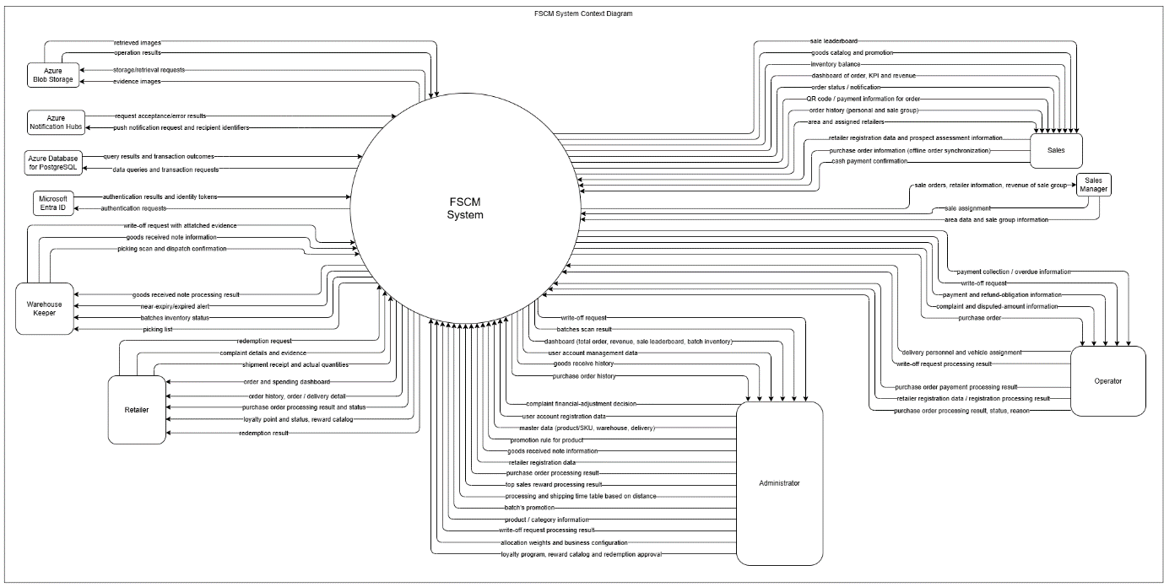
Figure 1. FSCM System Context diagram

2. User Requirements

2.1 Actors
# | Actor | Description
1 | Retailer | Uses a provisioned account to track own orders/shipments, confirm QR receipt, submit complaints, view payment obligations and loyalty, and request gifts. Cannot self-register, create orders or manage store inventory.
2 | Sales | Declares potential retailers for approval; creates/synchronizes orders for active assigned retailers, records customer acceptance of near-expiry offers, and views run results and own performance.
3 | Sales Manager | Manages sales areas, groups and assignments; reviews retailer and sales information, team orders, revenue, and sales leaderboard.
4 | Warehouse Keeper | Records receipts, views assigned batch stock and approved picking lists, scans quantities, marks readiness and confirms dispatch; reports shortages and write-off evidence.
5 | Operator | Reviews orders before cutoff within authority, handles operational exceptions/complaints, assigns deliveries and records authorized payments. Cannot replace Administrator allocation-run approval.
6 | Administrator | Manages users, master data, allocation settings, offers and loyalty; reviews and approves daily allocation proposals before reservation and picking-list release.
7 | Microsoft Entra ID | External identity service used by FSCM for authentication requests and identity token/authentication results.
8 | Azure Blob Storage | External object storage for evidence images and other files; handles storage and retrieval requests.
9 | Azure Notification Hubs | External push-notification service receiving notification requests and recipient identifiers and returning request outcomes.
10 | Azure Database for PostgreSQL | Managed database service used for data queries, transactions, and returning stored data and transaction results.

2.2 Use Cases

2.2.1 Diagram(s)
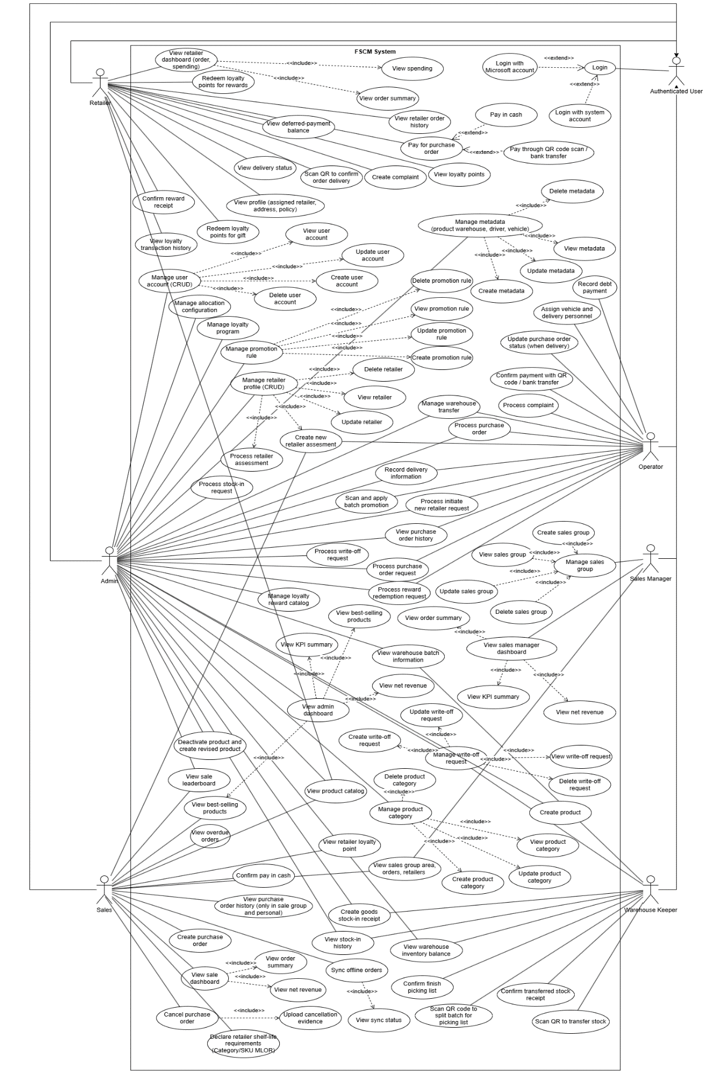
Figure 2. FSCM use-case overview by role

2.2.2 Descriptions
ID | Use Case | Actors | Use Case Description
UC-01 | View admin dashboard | Admin | Displays administrative operational indicators, order summaries, net revenue, KPI information and best-selling product information available to the Administrator.
UC-02 | Manage user account (CRUD) | Admin | Allows the Administrator to maintain system user accounts and their account information through create, view, update and delete operations permitted by the system.
UC-03 | Manage metadata (warehouse, driver, vehicle ) | Admin | Allows the Administrator to maintain operational master data for warehouses, drivers and vehicles.
UC-04 | Create goods stock-in receipt | Admin, Warehouse Keeper | Creates a goods receipt for products received into a warehouse, including the batch-related information required for inventory tracking.
UC-05 | View purchase order history | Admin, Operator | Displays historical purchase orders and their recorded processing information.
UC-06 | View stock-in history | Admin, Warehouse Keeper | Displays historical goods receipts and stock-in records for traceability.
UC-07 | Manage promotion rule | Admin | Allows the Administrator to create, view, update and delete promotion rules used by the system.
UC-08 | Manage retailer profile (CRUD) | Admin | Allows authorized staff to maintain retailer information and supporting retailer assessment information.
UC-09 | View sale leaderboard | Admin, Sales | Displays the sales ranking used to compare Sales Representative performance.
UC-10 | Process purchase order | Admin, Operator | Reviews and processes a submitted purchase order according to its current workflow state.
UC-11 | Process stock-in request | Admin | Reviews and processes a stock-in request before or during warehouse receiving operations.
UC-12 | Process purchase order request | Admin, Operator | Reviews a purchase order request and records the corresponding approval or rejection decision.
UC-13 | Process initiate new retailer request | Admin, Operator | Reviews a request to register or activate a newly declared retailer.
UC-14 | Update purchase order status (when delivery) | Operator | Updates the order delivery-related status as the order progresses through delivery.
UC-15 | Create new retailer assessment | Operator, Sales | Records assessment information collected for a retailer, such as potential, store characteristics or purchasing capability.
UC-16 | Verify prepaid bank transfer and create PO | Operator, Admin | Verifies the Retailer's prepaid bank-transfer proof against the approved quotation amount before its deadline; on success the sales order becomes a PO and picking slips are released (3.6.6, BR-51, BR-72).
UC-17 | Process goods report / complaint from retailer | Operator | Reviews and handles a goods-related complaint or issue reported by a retailer after receipt.
UC-18 | Manage sales group | Sales Manager | Allows the Sales Manager to maintain sales groups and their organizational information.
UC-19 | View sales group area, orders, retailers | Sales Manager, Sales | Displays the sales group scope, including assigned areas, retailers and orders accessible to the actor.
UC-20 | View sales manager dashboard | Sales Manager | Displays aggregated sales-group performance, order summaries, net revenue and KPI information for the Sales Manager.
UC-21 | Create purchase order | Sales | Creates a purchase order on behalf of an assigned retailer using the available product, price and promotion information.
UC-22 | View retailer order history | Retailer | Displays the Retailer’s historical orders and recorded order statuses.
UC-23 | Record cash collection of credit order | Sales | Records full cash collection of a delivered credit (deferred) receivable for an assigned retailer, with evidence; not used for prepaid orders, which are paid by bank transfer (3.10.1, BR-51, BR-52).
UC-24 | View purchase order history (only in sale group and personal) | Sales | Displays purchase orders limited to the Sales Representative’s permitted sales-group and personal scope.
UC-25 | View sale dashboard | Sales | Displays the Sales Representative’s sales information, including order summary and net revenue indicators.
UC-26 | Scan QR to confirm order delivery | Retailer | Scans issued batch QR labels to confirm that the retailer has received the delivered order quantities.
UC-27 | View retailer dashboard (order, spending) | Retailer | Displays the Retailer’s order summary and spending information.
UC-28 | View profile (assigned retailer, address, policy) | Retailer | Displays the retailer profile information assigned to the logged-in Retailer account, including address and applicable policy information.
UC-29 | Create report / complaint | Retailer | Creates a complaint or goods issue report related to received products or order fulfillment.
UC-30 | View warehouse inventory balance | Admin, Warehouse Keeper | Displays current warehouse inventory balances and availability information.
UC-31 | Confirm finish picking list | Warehouse Keeper | Confirms completion of the picking list and finalizes the recorded warehouse picking result.
UC-32 | Scan QR code to split batch for picking list | Warehouse Keeper | Scans a source batch QR and records a quantity split required to fulfill a picking-list item.
UC-33 | View warehouse batch information | Admin, Warehouse Keeper | Displays warehouse batch details such as product, quantity, expiry and current batch status.
UC-34 | Pay for purchase order | Retailer | Allows the Retailer, after accepting the quotation, to choose Prepaid – bank transfer or Credit (only with an approved payment term) for a purchase order (3.6.6, BR-51, BR-73).
UC-35 | Pay credit receivable in cash | Retailer | Pays a delivered credit receivable in cash to the assigned Sales Representative, who records it (UC-23); the Retailer sees the recorded payment. Not available for prepaid orders; COD is not used (BR-51).
UC-36 | Pay by bank transfer (VietQR) | Retailer | Pays a prepaid quotation, or a credit receivable, by bank transfer using the displayed VietQR code and submits the transaction code and proof for staff verification (3.6.6, 3.10.1).
UC-37 | Login | Authenticated User | Authenticates a user before access to protected FSCM functions is granted.
UC-38 | Login with system account | Authenticated User | Authenticates a user using the FSCM system account credentials.
UC-39 | Login with Microsoft account | Authenticated User | Authenticates a user using the supported Microsoft sign-in method.
UC-40 | Create sales group | Sales Manager | Creates a new sales group for organizing Sales Representatives and retailer coverage.
UC-41 | View sales group | Sales Manager | Displays sales-group information, assignments and related scope information.
UC-42 | Delete sales group | Sales Manager | Removes a sales group when deletion is permitted by the applicable business rules.
UC-43 | Update retailer | Admin | Updates permitted retailer profile information.
UC-44 | View retailer | Admin | Displays retailer profile, status and relevant business information.
UC-45 | Delete retailer | Admin | Removes a retailer record when deletion is permitted by the applicable business rules.
UC-46 | Update promotion rule | Admin | Updates an existing promotion rule when the rule is still editable.
UC-47 | View promotion rule | Admin | Displays promotion rule configuration and eligibility information.
UC-48 | Delete promotion rule | Admin | Deletes a promotion rule when deletion is permitted.
UC-49 | Create promotion rule | Admin | Creates a promotion rule with its applicability and discount configuration.
UC-50 | Update metadata | Admin | Updates warehouse, driver or vehicle master data.
UC-51 | View metadata | Admin | Displays warehouse, driver or vehicle master data.
UC-52 | Delete metadata | Admin | Deletes warehouse, driver or vehicle master data when deletion is permitted.
UC-53 | Create metadata | Admin | Creates warehouse, driver or vehicle master data.
UC-54 | Update user account | Admin | Updates permitted information or settings of an existing user account.
UC-55 | View user account | Admin | Displays user-account information and assigned access information.
UC-56 | Delete user account | Admin | Removes or deactivates a user account when permitted by account-management rules.
UC-57 | Create user account | Admin | Creates a system account for an authorized system role subject to account-creation restrictions.
UC-58 | Scan and apply batch promotion | Admin, Operator | Identifies near-expiry batch stock and maintains the remaining-shelf-life discount rules applied to allocated batches (3.5.4, BR-79); confirms near-expiry offers where retained (3.5.2, see 5.5 R-07).
UC-59 | Manage product category | Admin | Maintains the hierarchical product-category structure used to organize products.
UC-60 | Update product category | Admin | Updates an existing product category or its position in the category hierarchy.
UC-61 | View product category | Admin | Displays product categories and their hierarchical relationships.
UC-62 | Delete product category | Admin | Deletes a product category when it is not protected by dependency or business rules.
UC-63 | Create product category | Admin | Creates a new product category and optionally assigns it under a parent category.
UC-64 | Process retailer assessment | Admin | Reviews collected retailer assessment information and records the assessment result for future prioritization.
UC-65 | Manage write-off request | Admin, Warehouse Keeper | Allows authorized staff to create, view, update and delete write-off requests for unusable or expired stock before final processing.
UC-66 | Create write-off request | Admin, Warehouse Keeper | Creates a write-off request identifying affected batch quantities, reason and supporting information.
UC-67 | Update write-off request | Admin, Warehouse Keeper | Updates an editable write-off request and its supporting details.
UC-68 | View write-off request | Admin, Warehouse Keeper | Displays a write-off request, affected items, evidence and current processing status.
UC-69 | Delete write-off request | Admin, Warehouse Keeper | Deletes a write-off request when it has not reached a state that prevents deletion.
UC-70 | Process write-off request | Admin | Reviews a submitted write-off request and records the processing decision for the affected inventory.
UC-71 | View best-selling products | Admin, Sales | Displays products ranked by sales performance based on completed or otherwise eligible order data.
UC-72 | View net revenue | Admin, Sales Manager, Sales | Displays revenue calculated after applicable promotion discounts rather than gross pre-discount value.
UC-73 | View KPI summary | Admin, Sales Manager | Displays summarized KPI results for the relevant administrative or sales-management scope.
UC-74 | Process delivery | Admin, Operator | Assigns a vehicle and delivery person to each PO shipment, starts delivery after dispatch and records failed delivery attempts with reason and evidence (3.13.1, BR-76).
UC-75 | View order summary | Sales Manager, Sales, Retailer | Displays summarized order counts or order values for the actor’s permitted scope.
UC-76 | View retailer loyalty point | Sales | Displays the loyalty-point balance and loyalty status of the retailer currently being served by the Sales Representative.
UC-77 | Redeem loyalty points for gift | Retailer | Allows the Retailer to request a gift from the redemption catalog using available loyalty points. Points and gift stock are held on request and become used on approval; rejection or cancellation releases them (BR-75). No discount is applied to any purchase order.
UC-78 | Cancel purchase order | Sales | Cancels an eligible purchase order and records the cancellation information required by the workflow.
UC-79 | Upload cancellation evidence | Sales | Uploads the file or image evidence required to support the purchase-order cancellation.
UC-80 | Sync offline orders | Sales | Synchronizes locally queued offline purchase orders with the server when network connectivity is available.
UC-81 | View sync status | Sales | Displays offline-order synchronization states, including pending, synchronizing and synchronized records.
UC-82 | View loyalty points | Retailer | Displays the Retailer’s current loyalty points and related loyalty information.
UC-83 | View delivery status | Retailer | Displays the current delivery status of the Retailer’s order.
UC-84 | View spending | Retailer | Displays the Retailer’s recorded spending for the applicable period or dashboard scope.
UC-85 | Review daily allocation run | Administrator | Review proposal revisions, prices, MLOR and shortages; approve or request recalculation. Only approval after revalidation reserves stock.
UC-86 | Select near-expiry offer | Sales | Record customer acceptance of the offer-specific MLOR and price on a distinct order line; no stock is held at selection.
UC-87 | Declare retailer shelf-life requirements (Category/SKU MLOR) | Sales | Records the minimum life on receipt requirements for an assigned retailer at Category and SKU level. A SKU-level requirement takes priority over its Category requirement; the product default applies when neither is configured.
UC-88 | Create product | Admin | Creates a new SKU in Draft status with its identity, category, shelf-life information and initial price, then publishes it once all required information is complete.
UC-89 | View product catalog | Admin, Sales, Retailer | Displays Published products with filtering by category and SKU search within the actor’s permitted visibility. Draft and Inactive products are not shown as purchasable items.
UC-90 | Deactivate product and create revised product | Admin | Marks an existing Published product as Inactive and creates a new product from it to reflect a required change, as Published product details are locked and cannot be edited in place.
UC-91 | View deferred-payment balance | Retailer | Displays the Retailer’s current outstanding deferred-payment balance and payment history under the approved payment terms.
UC-92 | Respond to quotation | Retailer | Accepts or rejects the versioned quotation sent after run approval before its deadline and, on acceptance, chooses the payment method (3.6.6, BR-51, BR-72).
UC-93 | Review complaint and approve financial adjustment | Admin, Operator | The Operator reviews a receipt complaint and evidence; the Administrator accepts or rejects it, posting a capped adjustment at actual net price (3.10.4, BR-67 – BR-69).
UC-94 | Record and verify manual refund | Operator, Admin | Records the external refund transfer and evidence for a refund obligation; the Administrator verifies or requests supplements (3.10.4, BR-74).
UC-95 | Manage system configuration | Admin | Maintains allocation weights, service distance, transit table, 12:00 schedule, reminders, quotation deadline and loyalty rate; changes apply to later runs only (3.12.1, BR-57).
UC-96 | Manage loyalty program and gift catalog | Admin | Maintains the loyalty program, earning rate and gift catalog with gift stock (3.10.3, BR-54, BR-75).
UC-97 | Process gift redemption request | Admin | Approves or rejects a gift request and records gift delivery and completion (3.10.3, BR-75).
UC-98 | Lock unusable batch quantity | Admin, Warehouse Keeper | Locks damaged or unusable batch quantity with reason and evidence so that it is excluded from allocation and dispatch until written off or unlocked (3.8.2, BR-71).

3. Functional Requirements

3.1 System Functional Overview

3.1.1 Screens Flow
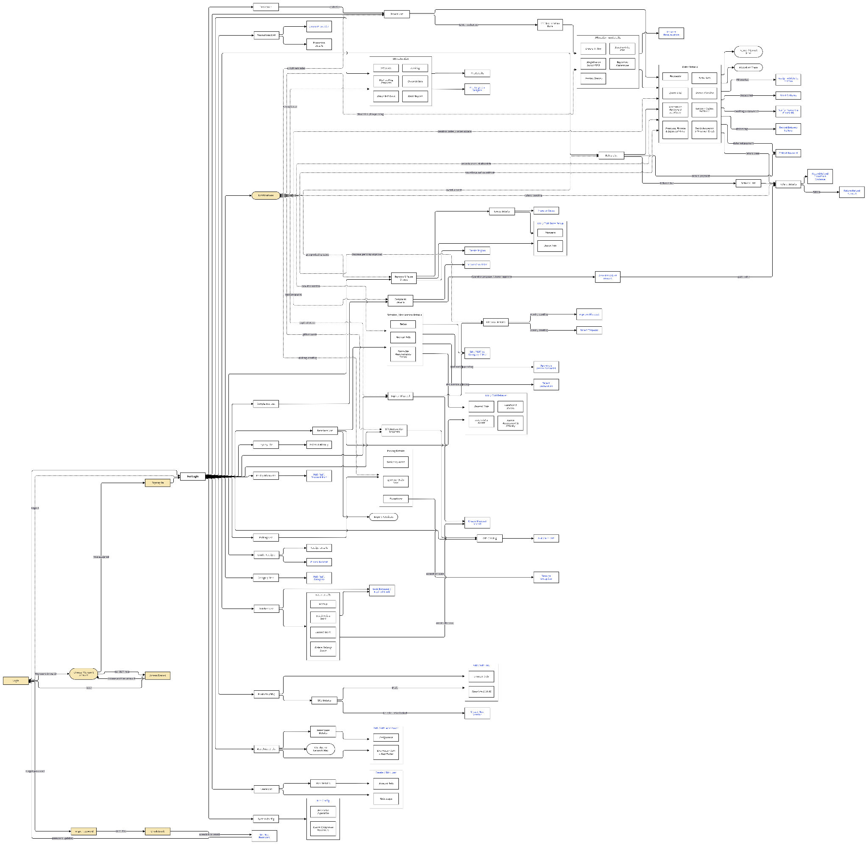

Figure 3.1. Web Portal Screen Flow Diagram
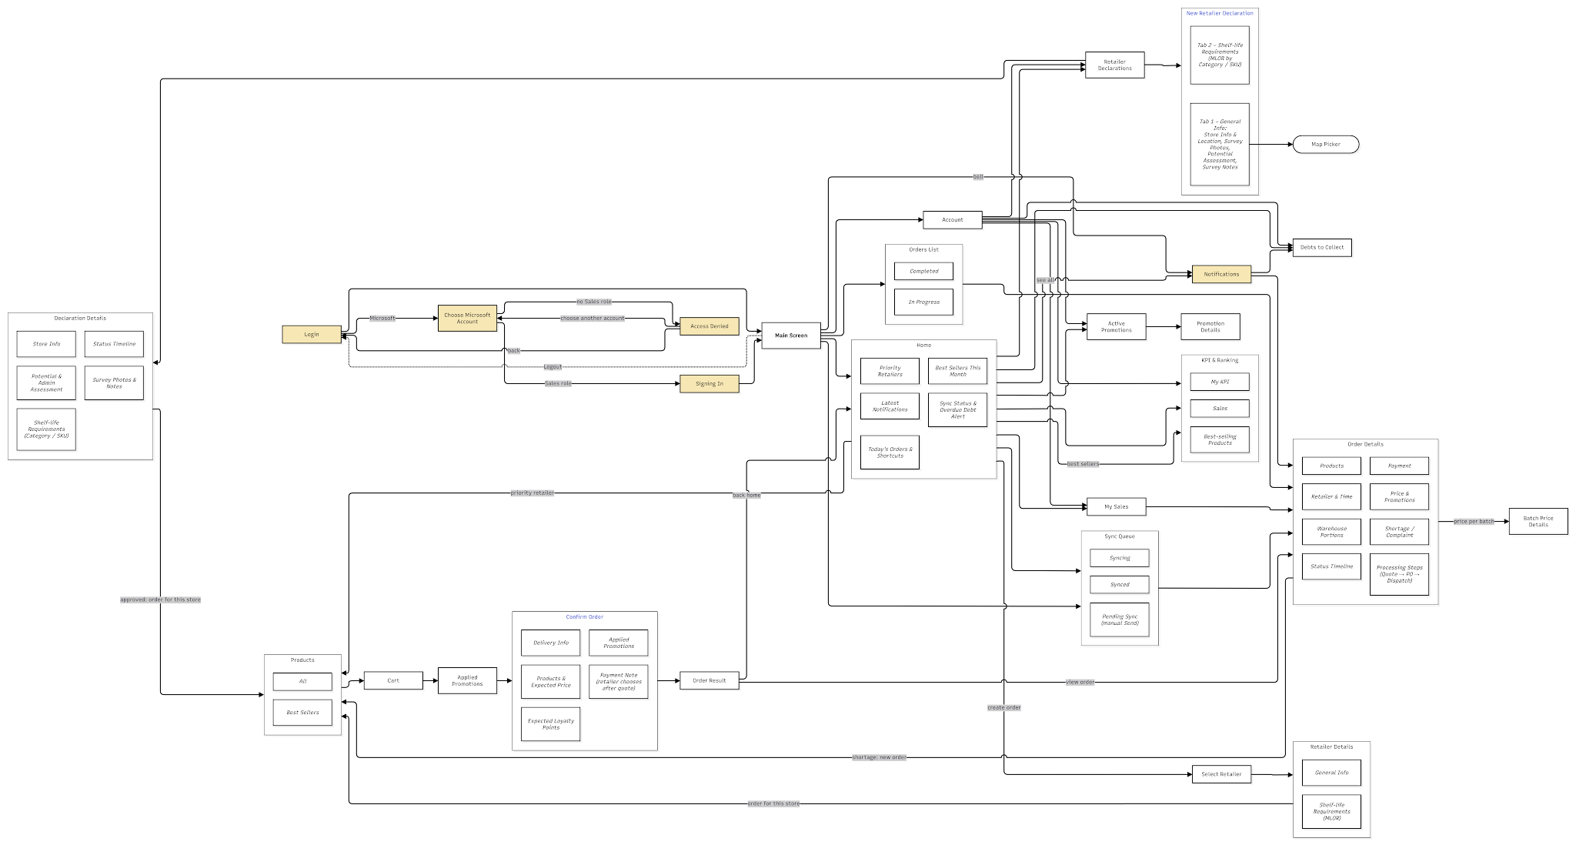

Figure 3.2. Sales App Screen Flow Diagram
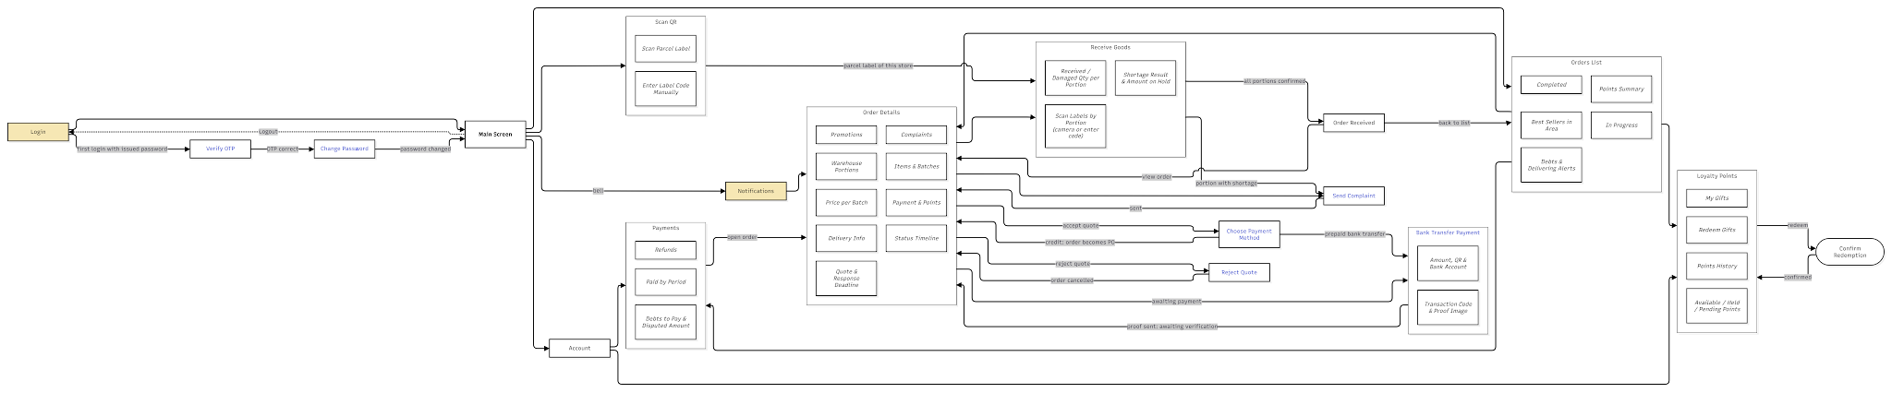

Figure 3.3. Retailer App Screen Flow Diagram
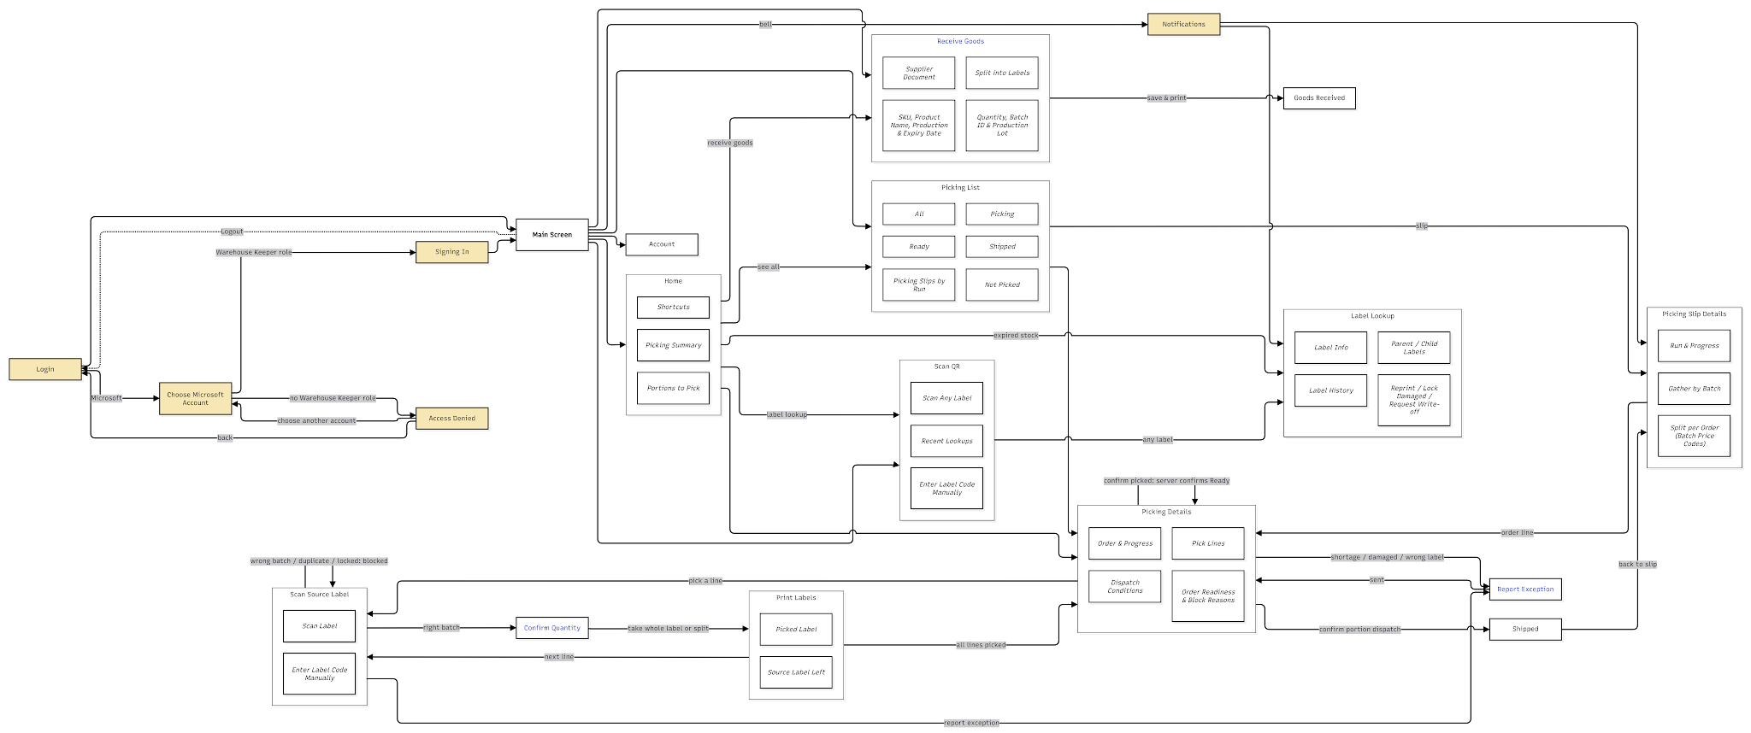

Figure 3.4. Warehouse Keeper App Screen Flow Diagram

3.1.2 Screen Descriptions
# | Feature | Screen | Description
1 | Authentication | Login (Web Portal) | Administrator, Operator, Sales Manager and Warehouse Keeper sign in with email and password, or with Microsoft Entra ID. A link opens Forgot Password.
2 | Authentication | Forgot Password, Check Email, Set New Password (Web Portal) | The user enters the registered email, opens the reset link sent by email and sets a new password (at least 8 characters, letters and digits, different from the old one).
3 | Authentication | Microsoft Sign-in Pop-up (Web Portal) | Pop-up opened over the Login screen by Sign in with Microsoft Entra ID. The user chooses a company account; an account with an FSCM role signs in to the Web Portal with that role and the pop-up closes. An account without a role is denied in the pop-up and can choose another account or close the pop-up.
4 | Authentication | Login (Mobile App) | Shared login of the Mobile App with two tabs. Staff: company email and password, or Sign in with Microsoft; the app opens the Sales or Warehouse part according to the role of the account. Customer: phone number and password; opens the Retailer part. Wrong password and locked account show an error message.
5 | Authentication | Microsoft Sign-in Pop-up (Mobile App) | Pop-up opened over the Staff tab by Sign in with Microsoft. The user chooses a company account; an account with the Sales or Warehouse Keeper role signs in to its part of the app and the pop-up closes. Other accounts are denied in the pop-up and can choose another account or close the pop-up.
6 | Authentication | Verify OTP, Change Password (Mobile – Retailer) | First login on the Customer tab with the issued password: the Retailer enters the 6-digit OTP sent by SMS, then sets a new password (at least 8 characters, letters and digits, different from the issued password, entered twice) before opening the Orders List.
7 | Authentication | PostLogin (Web Portal) | Main layout after sign-in: sidebar menu filtered by role, notification bell and Logout.
8 | Authentication | Main Screen (Mobile App) | Bottom tab bar with the notification bell, depending on the role. Sales: Home, Orders, Sync, Account. Warehouse Keeper: Home, Picking, Scan QR, Receive Goods, Account. Retailer: Orders, Scan QR, Account. Logout returns to the shared Login.
9 | Authentication | Users List | Lists user accounts with search and filters by role and status (UC-02, UC-55)
10 | Authentication | User Details | Shows account information, role and scope; opens Edit or deactivates the account (UC-56).
11 | Authentication | Create / Edit User | Form with two sections: Account Info (name, role, phone or email, status) and Role Scope (warehouse, sales group or retailer). The Administrator role cannot be assigned (UC-54, UC-57).
12 | Retailer Registration & Assessment | Retailer Declarations (Mobile – Sales) | Lists retailers declared by the Sales with search and filters Pending, Approved and Rejected.
13 | Retailer Registration & Assessment | New Retailer Declaration (Mobile – Sales) | Form with two tabs: General Info (store, contact, location, survey photos, potential assessment, notes) and Shelf-life Requirements (MLOR in % by category, with SKU values overriding their category). Submitted for Admin approval (UC-15).
14 | Retailer Registration & Assessment | Map Picker | Pop-up to pick a store or warehouse location on a map, or take the current GPS position.
15 | Retailer Registration & Assessment | Declaration Details (Mobile – Sales) | Shows Store Info, Potential & Admin Assessment, Shelf-life Requirements, Survey Photos & Notes and Status Timeline; an approved store can be ordered for directly.
16 | Retailer Registration & Assessment | Retailers List | Lists retailers and pending declarations with filters by area, potential class, priority and status; Import Retailers opens a pop-up (UC-08, UC-13, UC-44).
17 | Retailer Registration & Assessment | Retailer / Declaration Details | Tabs General Info, Shelf-life Requirements (effective MLOR per SKU and its source) and Debts. A pending declaration is approved or rejected here (UC-43, UC-64).
18 | Retailer Registration & Assessment | Approve & Assess Potential | Form to confirm the potential class (A/B/C) and priority, then approve; approval assigns the 8-digit retailer code and app account.
19 | Retailer Registration & Assessment | Reject Declaration | Form to enter the reason for rejecting a declaration; the Sales sees the reason.
20 | Retailer Registration & Assessment | Add / Edit Retailer | Form with four sections: General Info, Location & Status, Potential & Credit (payment term), Admin Assessment & Priority (UC-43).
21 | Retailer Registration & Assessment | Edit MLOR by Category / SKU | Form to change the retailer MLOR in % per category and per specific SKU.
22 | Retailer Registration & Assessment | Select Retailer (Mobile – Sales) | Lists retailers of the assigned area sorted by priority, with search and filters; retailers outside the area are locked.
23 | Retailer Registration & Assessment | Retailer Details (Mobile – Sales) | Tabs General Info and Shelf-life Requirements of a retailer; starts an order or proposes an MLOR update to the Administrator.
24 | Product & Category Management | Category Tree | Hierarchical product categories with their sub-categories and products (UC-59, UC-61).
25 | Product & Category Management | Add / Edit Category | Form with code, name, parent category, status and description (UC-60, UC-62, UC-63).
26 | Product & Category Management | Products (SKU) | Lists SKUs with filters by category and status (Draft, On sale, Discontinued).
27 | Product & Category Management | SKU Details | Shows product information, shelf life, near-expiry threshold, default MLOR and stock by batch. A Draft is edited or published; an on-sale SKU is discontinued or copied into a new version.
28 | Product & Category Management | Add / Edit SKU, Create New Version | Form with two sections: Product Info and Shelf Life & MLOR. Only a Draft can be edited; a price change of an on-sale SKU creates a new version.
29 | Product & Category Management | Products (Mobile – Sales) | Products for the selected retailer in tabs All and Best Sellers, with price, maximum quantity, MLOR for that retailer and promotion hints.
30 | Promotion & Batch Discount | Promotions List | Lists promotions with filters by type and status (UC-07, UC-47).
31 | Promotion & Batch Discount | Promotion Details | Shows conditions, eligible retailers, validity and the orders the promotion was applied to; it can be paused or edited (UC-46, UC-48).
32 | Promotion & Batch Discount | Create Promotion | Form for Type 1 (per SKU: minimum quantity and % discount) or Type 2 (product group), eligible retailers and validity (UC-49).
33 | Promotion & Batch Discount | Expiry Discounts | Lists expiry discount rules by Category or SKU: range of % shelf life left at the pricing point (run time), discount in % (below 100%), validity and status (UC-58).
34 | Promotion & Batch Discount | Add / Edit Discount Rule | Form to set scope (Category or SKU), range of % shelf life left at the pricing point, discount in % only (below 100%), validity and status; overlapping ranges are rejected.
35 | Promotion & Batch Discount | Active Promotions, Promotion Details (Mobile – Sales) | Running promotions and the products they apply to.
36 | Purchase Order & Offline Sync | Home (Mobile – Sales) | Sync status, overdue debt alert, Create Order, today's orders, shortcuts, priority retailers, best sellers and latest notifications (UC-25, UC-75).
37 | Purchase Order & Offline Sync | Cart (Mobile – Sales) | Selected lines with quantities, prices and promotion per line; expected base price only.
38 | Purchase Order & Offline Sync | Applied Promotions (Mobile – Sales) | Shows the promotion applied to each line and the expected base price.
39 | Purchase Order & Offline Sync | Confirm Order (Mobile – Sales) | Sections Delivery Info, Products & Expected Price, Applied Promotions, a payment note and Expected Loyalty Points. Sales chooses neither a receive date nor a payment method: the Retailer chooses Prepaid bank transfer or Credit after receiving the quotation. Submits online or saves the order on the device as a draft when offline (UC-21).
40 | Purchase Order & Offline Sync | Order Result (Mobile – Sales) | Shows the order code, status Pending review and the expected value.
41 | Purchase Order & Offline Sync | Orders List (Mobile – Sales) | Orders of the Sales and the group in tabs In Progress and Completed, with search and filters (UC-24).
42 | Purchase Order & Offline Sync | Order Details (Mobile – Sales) | Sections Retailer & Time, Processing Steps (Submit, Review, Run, Quotation, Acceptance · PO, Dispatch, Receipt), Products, Price & Promotions, Warehouse Portions, Payment, Shortage / Complaint and Status Timeline. A pending order can be cancelled; a short order offers Create New Order (UC-78, UC-79).
43 | Purchase Order & Offline Sync | Batch Price Details (Mobile – Sales) | Approved price per batch: list price, promotion, base price, % shelf life left at the pricing point, expiry discount (%) and final price.
44 | Purchase Order & Offline Sync | Sync Queue (Mobile – Sales) | Offline draft orders in tabs Pending Sync, Syncing and Synced. Drafts are never sent automatically: Sales taps Send All Drafts when the network is available; an order whose base price changed shows the old and new price with Confirm New Price & Send or Delete (UC-80, UC-81).
45 | Purchase Order & Offline Sync | Orders List | Lists all orders with server acceptance time, status, payment and value; Approve and Reject per row; a button opens the daily 12:00 allocation runs (UC-05).
46 | Purchase Order & Offline Sync | Order Details | Sections Order Info, Products, Promos & Expected Price, Batch Allocation & Price per Batch, Quotation & PO (quotation version, response deadline, PO number), Warehouse Portions & Readiness, Payments, Status Timeline and Cancel / Reject Evidence. An order awaiting payment shows the transfer proof and Verify Payment & Create PO (UC-10, UC-12, UC-14).
47 | Purchase Order & Offline Sync | Reject / Cancel Order | Pop-up to choose or enter the reason and attach evidence; shows the impact of cancellation (stock released, refund needed).
48 | FEFO–MLOR Allocation | Daily Allocation Runs (12:00) | Lists daily runs with number of orders, complete / short, total value, version and status (Not run, Plan pending, Approved, Closed).
49 | FEFO–MLOR Allocation | Allocation Run Details | Tabs Orders in Run, Batch & Price Plan, Weighted vs Strict FEFO, Report by Warehouse and Version History. The Administrator approves goods and prices, requests recalculation or closes the run (UC-85).
50 | FEFO–MLOR Allocation | Allocation Trace | Pop-up with one tab per order line showing steps B1–B5: candidate batches, distance and ETA checks, MLOR, scores and allocation.
51 | FEFO–MLOR Allocation | Request Recalculation | Form to enter the reason for a new plan version.
52 | Warehouse Receiving & Batch Inventory | Goods Receipts | Lists goods receipts by warehouse, date and status (UC-06).
53 | Warehouse Receiving & Batch Inventory | Receipt Details | Shows receipt lines with production date and expiry, batches and QR labels; the Administrator approves a pending receipt (UC-11).
54 | Warehouse Receiving & Batch Inventory | Create Receipt | Form with warehouse, supplier document and lines (SKU, expiry date, batch, lot, quantity, number of labels) (UC-04).
55 | Warehouse Receiving & Batch Inventory | Receive Goods (Mobile – Warehouse) | Mobile form: supplier document, SKU, production and expiry date, quantity, auto-generated Batch ID, production lot and number of labels.
56 | Warehouse Receiving & Batch Inventory | Goods Received (Mobile – Warehouse) | Confirms the receipt and lists the printed QR labels.
57 | Warehouse Receiving & Batch Inventory | Batches List | Lists batches by warehouse with expiry, % shelf life left, on-hand, reserved, locked and available quantities (UC-30).
58 | Warehouse Receiving & Batch Inventory | Batch Details | Sections Batch Info & Stock, Locked Stock, Orders Holding Batch and History; batch stock can be locked or a disposal record created (UC-33).
59 | Warehouse Receiving & Batch Inventory | Lock Damaged / Expired Stock | Form to lock a quantity of a batch with reason and note.
60 | Warehouse Receiving & Batch Inventory | Scan QR (Mobile – Warehouse) | Scans any label, or accepts the label code typed manually when the label cannot be read; shows recent lookups.
61 | Warehouse Receiving & Batch Inventory | Label Lookup (Mobile – Warehouse) | Shows the batch, current quantity, parent / child labels and history of a label; the keeper can reprint the label, lock a damaged label or request a write-off.
62 | Warehouse Receiving & Batch Inventory | Expired Disposal | Lists disposal (write-off) records with status (UC-65, UC-68).
63 | Warehouse Receiving & Batch Inventory | Disposal Details | Shows batches, quantities, reason and value; the Administrator approves or rejects a pending record (UC-70).
64 | Warehouse Receiving & Batch Inventory | Create Disposal Record | Form listing expired and locked batches; the user selects batches, method and reason. Batches still reserved for orders cannot be selected (UC-66).
65 | Picking & Retailer Receipt | Picking List | Lists picking slips per run with keeper, number of portions, quantity and progress.
66 | Picking & Retailer Receipt | Picking Details | Tabs Gather by Batch, Split per Order Line and Exceptions of a picking slip; an open exception is marked as resolved here.
67 | Picking & Retailer Receipt | Home (Mobile – Warehouse) | Picking summary (not picked, picking, shipped), shortcuts and portions to pick.
68 | Picking & Retailer Receipt | Picking List (Mobile – Warehouse) | Picking slips by run and portions with filters All, Not Picked, Picking, Ready and Shipped.
69 | Picking & Retailer Receipt | Picking Slip Details (Mobile – Warehouse) | Sections Run & Progress, Gather by Batch and Split per Order with batch price codes (PB / BG).
70 | Picking & Retailer Receipt | Picking Details (Mobile – Warehouse) | Sections Order & Progress, Order Readiness & Block Reasons, Pick Lines and Dispatch Conditions (UC-31).
71 | Picking & Retailer Receipt | Scan Source Label (Mobile – Warehouse) | Scans the source label or accepts the label code typed manually; shows an error for a wrong batch, duplicate or locked label (UC-32).
72 | Picking & Retailer Receipt | Confirm Quantity (Mobile – Warehouse) | Form to enter the picked quantity; taking part of a label creates a child label.
73 | Picking & Retailer Receipt | Print Labels (Mobile – Warehouse) | Shows the picked (child) label and the source label that stays on the shelf, with print and reprint.
74 | Picking & Retailer Receipt | Report Exception (Mobile – Warehouse) | Form to report shortage, damage or wrong label for a line with quantity, note and photo; the portion cannot become Ready until handled.
75 | Picking & Retailer Receipt | Shipped (Mobile – Warehouse) | Shows that the portion is dispatched, with dispatch time and portion status.
76 | Picking & Retailer Receipt | Orders List (Mobile – Retailer) | Points summary, best sellers in the area, debt and delivering alerts, and orders in tabs In Progress and Completed (UC-22, UC-27, UC-84).
77 | Picking & Retailer Receipt | Order Details (Mobile – Retailer) | Sections Quotation & Response Deadline (Accept / Reject), Warehouse Portions, Items & Batches, Price per Batch, Promotions, Payment & Points, Complaints, Delivery Info and Status Timeline. An order awaiting payment opens Bank Transfer Payment (UC-83).
78 | Picking & Retailer Receipt | Scan QR (Mobile – Retailer) | Scans a parcel label, or accepts the label code typed manually, to open Receive Goods for that order; a label of another store shows an error.
79 | Picking & Retailer Receipt | Receive Goods (Mobile – Retailer) | Labels grouped by warehouse portion, scanned by camera or entered by code; after scanning all labels of a portion the retailer enters received and damaged quantities and confirms the portion; the screen then shows the shortage and the amount on hold (UC-26).
80 | Picking & Retailer Receipt | Order Received (Mobile – Retailer) | Confirms all portions are received and shows the paid amount and any amount on hold.
81 | Picking & Retailer Receipt | Send Complaint (Mobile – Retailer) | Form: portion, line / batch, reason, quantity, note and photos (at least a photo or a note); a second complaint for the same batch is not allowed (UC-29).
82 | Picking & Retailer Receipt | Account (Mobile – Retailer) | Store profile, loyalty points, payments and debts, assigned Sales, change password and logout (UC-28).
83 | Picking & Retailer Receipt | Complaints List | Lists complaints with disputed amount and status (UC-17).
84 | Picking & Retailer Receipt | Complaint Details | Shows portion, batch, shipped / received / short / damaged quantities, net price of the batch, disputed amount, evidence and the effect if accepted.
85 | Picking & Retailer Receipt | Accept & Adjust Amount, Reject Complaint | Forms to propose acceptance (Operator), approve the financial adjustment (Administrator) or reject with a reason.
86 | Payment & Loyalty | Debts List | Receivables of deferred-payment orders with due date, disputed amount and status; a tab opens Refunds.
87 | Payment & Loyalty | Collect Payment, Verify Payment & Create PO | Collect Payment records a collection for a credit order. Verify Payment & Create PO checks the transaction code and proof of a prepaid bank transfer against the quoted amount; on confirmation the order becomes a PO (UC-16, UC-23).
88 | Payment & Loyalty | Refunds List, Refund Details | Refund obligations from paid cancellations and accepted complaints, with amount, transfers and history.
89 | Payment & Loyalty | Record Refund Transfer & Evidence, Return Refund Request | Forms to record a manual transfer with evidence, and for the Administrator to return an unverified request.
90 | Payment & Loyalty | Debts to Collect (Mobile – Sales) | Unpaid orders of the assigned retailers with overdue filter, disputed amount and Record Collected.
91 | Payment & Loyalty | Payments (Mobile – Retailer) | Tabs Paid by Period, Debts to Pay & Disputed Amount, and Refunds (UC-34–UC-36).
92 | Payment & Loyalty | Choose Payment Method (Mobile – Retailer) | Opened by Accept Quotation: the Retailer chooses Prepaid – bank transfer or Credit (shown only when the retailer has a payment term) and confirms. Credit turns the order into a PO; prepaid opens Bank Transfer Payment.
93 | Payment & Loyalty | Reject Quotation (Mobile – Retailer) | Form to choose the reason for rejecting the quotation; the order is cancelled and its reserved stock released.
94 | Payment & Loyalty | Bank Transfer Payment (Mobile – Retailer) | Shows the amount, QR code and bank account; the Retailer enters the transaction code and attaches the proof image, then sends it. The order waits for the distributor to verify the transfer.
95 | Payment & Loyalty | Loyalty Points (Mobile – Retailer) | Available, held and pending points; tabs Redeem Gifts, My Gifts and Points History with the source of each entry (UC-82).
96 | Payment & Loyalty | Confirm Redemption (Mobile – Retailer) | Pop-up to choose the gift quantity and confirm; the total points are held until the request is approved.
97 | Payment & Loyalty | Loyalty List, Points & History | Retailers with their current points; the details show the points history (UC-76).
98 | Payment & Loyalty | Gift Redemption Requests | Lists gift requests; the Administrator / Operator approves, rejects or completes them (UC-77).
99 | Payment & Loyalty | Gift Catalog, Add / Edit Gift | Gifts with points, stock and status; a gift with no stock is shown as Out of stock.
100 | Sales Groups & Reporting | Dashboard | Administrator indicators: orders, net revenue, pending items, orders by status, revenue by Sales and best sellers (UC-01).
101 | Sales Groups & Reporting | KPI Sales List | Tabs KPI Sales, Ranking, Best-selling Products, Group Orders, Group Retailers and Basic Report (UC-09, UC-20, UC-71–UC-73, UC-75).
102 | Sales Groups & Reporting | KPI Details, KPI Targets & Weights | KPI result of one Sales; form to set targets and weights.
103 | Sales Groups & Reporting | Regions & Sales Groups | Lists regions and groups with members, retailers and manager (UC-18, UC-41).
104 | Sales Groups & Reporting | Group Details | Members, retailers and orders of a group (UC-19).
105 | Sales Groups & Reporting | Add / Edit Sales Group, Transfer Sales, Create Region | Forms to maintain groups and members, move a Sales to another group and create a region (UC-40, UC-42).
106 | Sales Groups & Reporting | My Sales (Mobile – Sales) | Order count and revenue after promotions for a chosen period, by retailer and by order (UC-72).
107 | Sales Groups & Reporting | KPI & Ranking (Mobile – Sales) | Tabs My KPI, Sales ranking and Best-selling Products (UC-09, UC-71, UC-73).
108 | System Configuration & Notifications | Warehouses List, Warehouse Details | Warehouses with type, location, keeper, minimum stock and status; details show the service radius on a map (UC-51).
109 | System Configuration & Notifications | Add / Edit Warehouse | Form with Warehouse Info + Map Picker and Assignment (UC-50, UC-53).
110 | System Configuration & Notifications | Warehouse Network Map | Pop-up map of warehouses and retailers.

3.1.3 Screen Authorization

Screen | Admin | Operator | Sales Manager | Warehouse Keeper | Sales | Retailer
Login, Forgot Password, Microsoft Entra ID Login (Web Portal) | X | X | X | X
Login – Staff tab, Microsoft Sign-in (Mobile App) |  |  |  | X | X
Login – Customer tab, Verify OTP, Change Password (Mobile App) |  |  |  |  |  | X
Notifications | X | X | X | X | X | X
Dashboard | X
Users List, User Details | X
Create / Edit / Deactivate User | X
Retailer Declarations, Declaration Details (Mobile – Sales) |  |  |  |  | X
New Retailer Declaration |  |  |  |  | X
Retailers List, Retailer / Declaration Details | X | X
Approve & Assess / Reject Declaration | X
Add / Edit Retailer, Edit MLOR, Import | X
Select Retailer, Retailer Details (Mobile – Sales) |  |  |  |  | X
Category Tree, Products (SKU), SKU Details | X
Create / Edit / Publish SKU and Category | X
Promotions List, Promotion Details | X
Create / Edit / Pause Promotion | X
Expiry Discounts | X
Add / Edit Discount Rule | X
Create Order screens, Active Promotions (Mobile – Sales) |  |  |  |  | X
Orders List, Order Details, Batch Price Details (Mobile – Sales) |  |  |  |  | X
Cancel Pending Order, Create New Order |  |  |  |  | X
Sync Queue (Mobile – Sales) |  |  |  |  | X
Orders List, Order Details (Web Portal) | X | X
Approve / Reject Order | X | X
Cancel Order (exception after picking started: Admin) | X | X
Daily Allocation Runs (12:00), Run Details, Allocation Trace | X | X
Run, Approve Plan, Request Recalculation, Close Run | X
Goods Receipts, Receipt Details, Create Receipt | X |  |  | X
Approve Receipt | X
Receive Goods (Mobile – Warehouse) |  |  |  | X
Batches List, Batch Details | X | X |  | X
Lock / Unlock Stock | X |  |  | X
Scan QR, Label Lookup (Mobile – Warehouse) |  |  |  | X
Reprint Label, Lock Label, Request Write-off |  |  |  | X
Expired Disposal, Disposal Details, Create Disposal Record | X |  |  | X
Approve / Reject Disposal | X
Picking List, Picking Details (Web Portal) | X | X |  | X
Resolve Exception | X |  |  | X
Picking screens (Mobile – Warehouse) |  |  |  | X
Scan and Split Label, Report Exception |  |  |  | X
Confirm Picked, Confirm Portion Dispatch |  |  |  | X
Orders List, Order Details, Account (Mobile – Retailer) |  |  |  |  |  | X
Scan QR and Receive Goods |  |  |  |  |  | X
Send Complaint |  |  |  |  |  | X
Accept / Reject Quotation, Choose Payment Method, Send Transfer Proof |  |  |  |  |  | X
Complaints List, Complaint Details | X | X
Propose Acceptance / Reject Complaint | X | X
Approve Financial Adjustment | X
Debts List, Refunds | X | X
Collect Payment, Verify Payment & Create PO, Record Refund Transfer | X | X
Verify / Return Refund | X
Debts to Collect (Mobile – Sales) |  |  |  |  | X
Record Collected |  |  |  |  | X
Payments, Loyalty Points (Mobile – Retailer) |  |  |  |  |  | X
Redeem Gift, Cancel Pending Request |  |  |  |  |  | X
Loyalty List, Points & History | X | X
Gift Redemption Requests | X | X
Approve / Reject / Complete Request | X | X
Gift Catalog, Add / Edit Gift | X
Regions & Sales Groups, Group Details | X |  | X
Add / Edit Group, Transfer Sales, Create Region | X |  | X
KPI Sales List, KPI Details | X |  | X
KPI Targets & Weights | X
Home, My Sales, KPI & Ranking (Mobile – Sales) |  |  |  |  | X
Warehouses List, Warehouse Details, Network Map | X
Add / Edit / Deactivate Warehouse | X
System Config, Edit Config | X
Assign Vehicle, Start Delivery, Record Delivery Failure | X | X
Data Access (all screens)
Query All Data | X | X
Query Own Data |  |  |  |  | X | X
Query Managed Data |  |  | X | X | X
Add New Data | X | X | X | X | X | X
Update All Data | X
Update Own Data |  |  |  | X | X | X
Update Managed Data |  | X | X | X

3.1.4 Non-Screen Functions

# | Feature | System Function | Description
1 | Authentication | Account Authentication | Trigger: the user selects Login. Checks sign-in by email and password (Web Portal and Staff tab of the Mobile App) or by phone number and password (Customer tab of the Mobile App), then loads the role and data scope and shows only the menus of that role.
2 | Authentication | Microsoft Entra ID Sign-in | Trigger: the user chooses an account in the Microsoft pop-up. Authenticates the company account with Microsoft Entra ID and maps it to the FSCM role assigned by the Administrator. An account without a role, or on the Mobile App an account without the Sales or Warehouse Keeper role, is denied access.
3 | Authentication | Role-based Mobile Workspace | Trigger: successful sign-in on the Mobile App. After sign-in on the Mobile App, opens the part of the app for the role of the account (Sales, Warehouse Keeper or Retailer) and shows only its tabs and screens; logout clears the session and returns to the shared Login.
4 | Authentication | Password Reset Link | Trigger: the user submits Forgot Password. Sends a reset link to the registered email; the new password needs at least 8 characters with letters and digits, differs from the old one, and old sessions are signed out.
5 | Authentication | Retailer First-Login Verification | Trigger: first Customer sign-in with the issued password. When a Retailer signs in for the first time on the Customer tab with the issued password, sends a 6-digit SMS OTP valid for 5 minutes (resend after 45 seconds) and requires a new password (at least 8 characters, letters and digits, different from the issued password) before access; later sign-ins skip this step.
6 | Retailer Registration & Assessment | Potential Classification | Trigger: Sales submits a retailer declaration. Suggests potential class A, B or C from forecast revenue and purchasing capacity; the Administrator confirms the class and priority.
7 | Retailer Registration & Assessment | Retailer Code Assignment | Trigger: the Administrator approves a declaration. On approval of a declaration, assigns the 8-digit retailer code and creates the Retailer account for the Customer tab of the Mobile App.
8 | Retailer Registration & Assessment | Sales Area Restriction | Trigger: Sales opens the retailer list or starts an order. Locks retailers outside the area of the Sales group so that no order can be created for them.
9 | Purchase Order & Offline Sync | Order Quantity Limit | Trigger: Sales enters or changes a line quantity. Limits each SKU line to available stock minus the safety buffer, rounded down to a multiple of 10 cartons. Creating an order does not hold stock.
10 | Purchase Order & Offline Sync | Promotion Calculation | Trigger: the cart changes, and again when the server accepts the order. Applies Type 1 (per SKU) and Type 2 (product group) promotions on the list price; each line receives only the promotion with the highest discount. Paused or expired promotions are not applied.
11 | Purchase Order & Offline Sync | Offline Order Synchronization | Trigger: Sales taps Send in the Sync Queue. Saves offline orders on the device as drafts with a request code; drafts are sent only when Sales taps Send, never automatically, and a failed send is retried the same way. Retrying with the same request code never creates a duplicate order. If the base price or MLOR changed, the Sales confirms before the order is accepted. The server acceptance time sets the order priority.
12 | FEFO–MLOR Allocation | Daily Order Consolidation (12:00) | Trigger: schedule, every day at 12:00. At 12:00 Vietnam time collects valid orders received by the server and approved before the cutoff, ordered by server acceptance time, then order code. Orders received or approved at or after the cutoff wait for the next run.
13 | FEFO–MLOR Allocation | Effective MLOR Resolution | Trigger: each order line is evaluated in a run. For each order line uses the MLOR the retailer declared for that SKU; if none, the MLOR of its category; if none, the product default.
14 | FEFO–MLOR Allocation | Batch Allocation (B1–B5) | Trigger: after daily consolidation, or when the Administrator requests recalculation. B1 takes usable, unexpired and unlocked batches; B2 keeps warehouses within the 20 km service radius and batches whose shelf life left at ETA meets the MLOR (ETA from the transit table by distance band); B3 scores S = 0.5·fE + 0.3·fD + 0.2·fQ; B4 allocates greedily from a shared run pool without holding stock; B5 marks the order complete or short. A short order receives no allocation; there are no transfers between warehouses.
15 | FEFO–MLOR Allocation | Expiry Discount Pricing | Trigger: batches are chosen for an order line. After the batches are chosen, applies the expiry discount rule matching the % shelf life left at the pricing point, that is the run time and not the ETA (a SKU rule overrides a Category rule; discount in % only, below 100%) and stores list price, promotion, base price, rule, discount and final price per batch line in a price version (BG).
16 | FEFO–MLOR Allocation | Proposal Approval, Reservation and Quotation | Trigger: the Administrator approves a plan version. Holds no stock before approval. When the Administrator approves goods and prices of a plan version, the system revalidates it, reserves the stock and sends each Retailer a versioned quotation with a response deadline (default 1 day, not later than the last delivery date that still meets MLOR). No PO and no picking slip exist yet. A recalculation creates a new version.
17 | FEFO–MLOR Allocation | Quotation Expiry | Trigger: schedule, when a quotation deadline passes. Cancels a sales order whose quotation was not accepted, or whose prepaid transfer was not submitted and verified, by the deadline and releases its reserved stock; choosing a payment method late does not extend the deadline.
18 | FEFO–MLOR Allocation | PO Conversion and Picking Release | Trigger: the Retailer chooses Credit, or the Operator confirms a prepaid transfer. Checks that Credit is allowed by the retailer payment term (a newly registered retailer has none), converts the sales order into a PO and creates one picking slip per warehouse with duplicate protection. Only POs are picked.
19 | FEFO–MLOR Allocation | Algorithm Evaluation | Trigger: a run or recalculation finishes. For each run compares the weighted result with strict FEFO on the same eligible batches (number of warehouses, average distance and shelf life left at ETA).
20 | Warehouse Receiving & Batch Inventory | Batch and Label Generation | Trigger: a goods receipt is saved and approved. Creates the batch code from warehouse, SKU and expiry date (production date must be before expiry and not in the future), adds later receipts with the same values to that batch and generates one QR label per pallet.
21 | Warehouse Receiving & Batch Inventory | Label Split | Trigger: the keeper confirms fewer cartons than a label holds. When fewer cartons are picked than a label holds, creates a child label linked to the parent and updates the parent quantity without reprinting it.
22 | Warehouse Receiving & Batch Inventory | Expired Batch Detection | Trigger: schedule, daily before the 12:00 run. Daily marks batches past their expiry date as expired and excludes expired and locked stock from allocation.
23 | Warehouse Receiving & Batch Inventory | Write-off Posting | Trigger: the Administrator approves a disposal record. Deducts on-hand stock of a disposal record only after Administrator approval; a batch still reserved for orders cannot be written off.
24 | Picking & Retailer Receipt | Portion Ready Confirmation | Trigger: the keeper confirms picking of a portion. When the keeper confirms picking, the server checks the picked quantities against the plan before the portion becomes Ready; an open exception blocks it.
25 | Picking & Retailer Receipt | Dispatch Readiness Check | Trigger: the keeper requests dispatch of a portion. Allows dispatch only when every warehouse portion of the PO is Ready and no exception is open; a prepaid order is already verified as paid when it becomes a PO.
26 | Picking & Retailer Receipt | Dispatch Posting | Trigger: the keeper confirms dispatch. On dispatch confirmation, deducts on-hand and reserved stock and sets the labels to In transit; the order becomes Shipped when all portions are dispatched.
27 | Picking & Retailer Receipt | Receipt Validation | Trigger: the retailer scans a label or confirms a portion. Accepts only labels of orders delivered to that store; records received and damaged quantities per portion, calculates shortage and the amount on hold at the batch price, and marks the order Delivered only after all portions are received.
28 | Picking & Retailer Receipt | Order Completion | Trigger: receipt, payment or complaint resolution of a delivered order. Shows the order as Completed once it is delivered, fully settled and has no open complaint or pending refund.
29 | Picking & Retailer Receipt | Complaint Adjustment | Trigger: the Administrator approves a complaint adjustment. For a complaint accepted by the Administrator, adjusts the receivable or creates a manual refund obligation equal to the affected quantity × the actual net price of that batch line; no goods are returned to stock automatically.
30 | Payment & Loyalty | Debt Due Date and Status | Trigger: full receipt, a recorded payment, and a daily schedule for overdue status. Sets the due date to delivery date plus the retailer term and keeps the status up to date (Not fully received, Not collected, Overdue, Dispute pending, Collected); disputed amounts are separated from payable debt.
31 | Payment & Loyalty | Loyalty Point Posting | Trigger: an order is fully received and settled with no open complaint. Posts 1 point per 100,000 VND once, after full receipt of all portions, full settlement and no unresolved complaint; later corrections are recorded as separate entries and redemption is blocked while the balance is negative.
32 | Payment & Loyalty | Gift Redemption Points | Trigger: a gift request is created, approved, rejected or cancelled. Holds the points of a gift request, deducts them on approval and releases them when the request is rejected or cancelled.
33 | Sales Groups & Reporting | Net Revenue and KPI Calculation | Trigger: an order status, payment or adjustment changes. Calculates revenue after promotions, expiry discounts and approved adjustments, excluding rejected, cancelled and unsynchronized orders; ranking and KPI use this figure and best sellers are counted in cartons.
34 | System Configuration & Notifications | Operational Notifications | Trigger: a business event, or a reminder time such as the 11:30 cutoff reminder. Creates notifications per role (orders to approve, cutoff reminder, plan to approve, quotation sent to the Retailer, transfer proof to verify, blocked dispatch, declarations, overdue debts, refunds, complaints, gift requests, expired stock, picking slips, KPI updates); each opens the related screen.
35 | System Configuration & Notifications | Status Timeline and Audit | Trigger: any status change. Records every status change of orders, runs, portions, complaints, refunds and redemptions with actor and time.

3.1.5 Entity Relationship Diagram

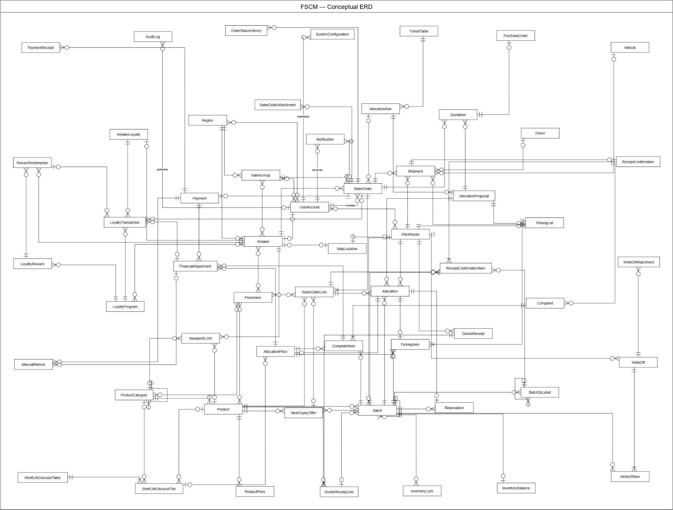
Figure 4. FSCM Conceptual Entity Relationship diagram
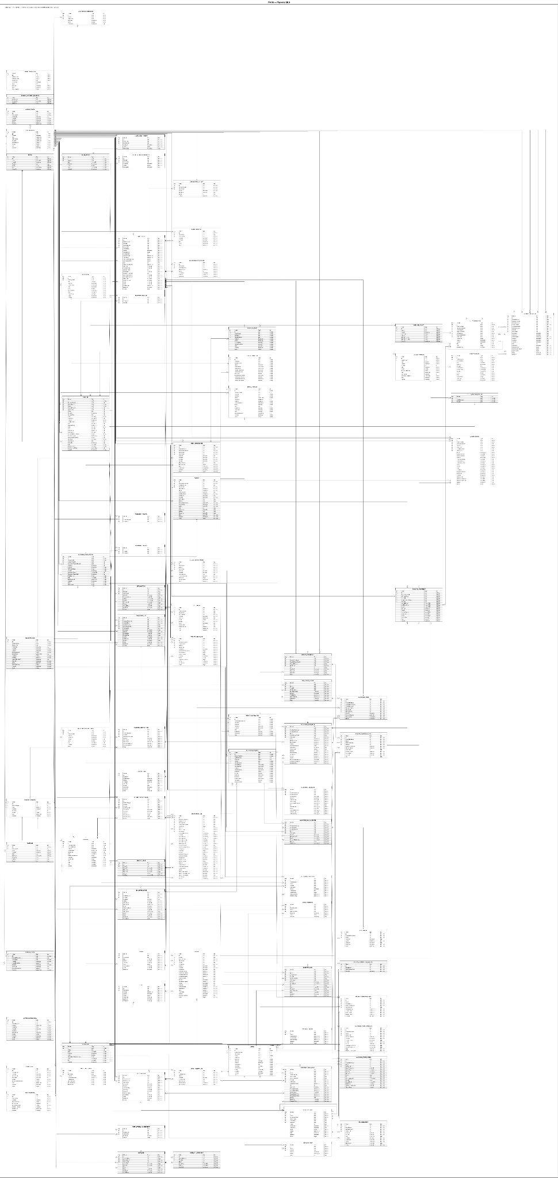
Figure 5. FSCM Physical Entity Relationship diagram

Entities Description
# | Entity | Description
1 | UserAccount | Stores the identity, contact details, identity provider, active state and role of a system user. Business records reference this entity to identify the person who creates, approves, confirms or reviews an action. Role is an attribute of the account.  Physical table: USER_ACCOUNT
2 | Warehouse | Represents a distributor warehouse and its service capacity. Receipts, batches, inventory locks, picking lists and shipments are scoped to a warehouse. UserWarehouseAssignment controls authorized warehouse access, while MapLocation supplies geographic information.  Physical table: WAREHOUSE
3 | UserWarehouseAssignment | Associates a user account with a warehouse and records assignment dates and active status. It implements the direct UserAccount to Warehouse association shown in the conceptual ERD and supports access to warehouse operations.  Physical table: USER_WAREHOUSE_ASSIGNMENT
4 | Region | Defines a sales territory using a code, name and active state. Retailers and sales groups belong to a region. UserRegionAssignment separately records which users are assigned to that territory.  Physical table: REGION
5 | UserRegionAssignment | Associates a user account with a sales region, including assignment dates and active status. It resolves the conceptual relationship between users and regions without introducing a separate business actor.  Physical table: USER_REGION_ASSIGNMENT
6 | SalesGroup | Represents a sales team within a region. SalesGroupMember records its users, while RetailerSalesAssignment records its retailer coverage. Sales orders retain their sales group reference for responsibility and reporting.  Physical table: SALES_GROUP
7 | SalesGroupMember | Records membership of a user account in a sales group, including active status and assignment dates. It implements the conceptual many-to-many relationship between UserAccount and SalesGroup.  Physical table: SALES_GROUP_MEMBER
8 | Retailer | Represents a retail customer served by the distributor. It stores business and contact details, regional ownership, activation and review information, potential-customer assessment and credit terms. Orders, MLOR rules, loyalty records and map locations reference the retailer.  Physical table: RETAILER
9 | RetailerSalesAssignment | Links a retailer to a sales group and records the active assignment period. It implements the conceptual sales coverage relationship and provides the association needed to determine the responsible sales group.  Physical table: RETAILER_SALES_ASSIGNMENT
10 | ProductCategory | Classifies products using a category hierarchy through ParentCategoryId. Categories also define promotion eligibility, retailer MLOR rules and shelf-life discount tiers. Category membership provides a shared grouping for catalog management and reporting.  Physical table: PRODUCT_CATEGORY
11 | Product | Represents a sellable SKU with its name, unit, category, shelf life, near-date threshold and lifecycle state. It also carries the target default MLOR ratio. ReplacesProductId preserves a link to a predecessor product when a replacement SKU is introduced.  Physical table: PRODUCT
12 | ProductPrice | Stores a product price and its effective period. Multiple historical prices can belong to one product. Sales order lines preserve the selected price reference and price-period snapshots so later price changes do not obscure the original pricing basis.  Physical table: PRODUCT_PRICE
13 | RetailerProductMlor | Stores an effective retailer shelf-life requirement for a product or product category, including ratio, minimum hours and rule version. Product-specific rules, category rules and the product default provide the inputs for resolving the MLOR used on an order line.  Physical table: RETAILER_PRODUCT_MLOR
14 | TransitTable | Defines a versioned set of delivery-distance assumptions, an effective period and the maximum serving distance. TransitTableBand supplies its distance ranges and estimated delivery timing. AllocationRun preserves the transit table version used for allocation.  Physical table: TRANSIT_TABLE
15 | TransitTableBand | Stores one distance band within a transit table, including distance limits, handling minutes, transit minutes and estimated cost. These values support estimated arrival and shelf-life eligibility calculations. The detailed band records refine the TransitTable concept in the conceptual ERD.  Physical table: TRANSIT_TABLE_BAND
16 | GoodsReceipt | Represents a warehouse receiving document with creator, approver, receiving time, status and receipt code. Its lines identify the goods received. Physical request identifiers and hashes support safe handling of repeated submissions.  Physical table: GOODS_RECEIPT
17 | GoodsReceiptLine | Stores a received product, source lot code, production date, expiration date and quantity for a goods receipt. Batch records can reference the originating line to preserve the relationship between the receiving document and warehouse stock.  Physical table: GOODS_RECEIPT_LINE
18 | Batch | Represents a product lot or stock segment in a warehouse. It records production and expiration dates, quantity, expiry state and stock state. ParentBatchId and RootBatchId preserve lineage when stock segments are split; receipt-line references retain the receiving origin.  Physical table: BATCH
19 | BatchQrLabel | Identifies a batch quantity through a QR code and records label status, generation, invalidation and warehouse context. Parent and root label references preserve label lineage. QrLabelEvent records label activity, and receipt records retain the labels scanned by the retailer.  Physical table: BATCH_QR_LABEL
20 | QrLabelEvent | Records an event affecting a QR label, including event type, prior and resulting status, quantity, time, operator and reference code. It provides the detailed label history represented more generally by BatchQrLabel in the conceptual ERD.  Physical table: QR_LABEL_EVENT
21 | InventoryBalance | Stores the current physical, reserved and available quantities of a batch. Its unique batch reference allows at most one balance record per batch. Inventory locks are recorded separately, and InventoryTransaction preserves the movements behind the current balance.  Physical table: INVENTORY_BALANCE
22 | InventoryLock | Records a quantity of a batch locked from use, together with warehouse, product, reason, status and the users responsible for locking and release. It can flag stock that requires resolution. A lock restricts usability without representing a physical stock-out.  Physical table: INVENTORY_LOCK
23 | InventoryTransaction | Preserves an inventory movement with physical and reserved quantity changes and resulting balances. It references the affected batch, warehouse and product, and can retain the originating goods receipt and line. Source identifiers and reference codes support movement reconciliation.  Physical table: INVENTORY_TRANSACTION
24 | Promotion | Defines a promotion with a validity period, promotion type, minimum quantity, discount percentage and active state. PromotionProduct, PromotionCategory and PromotionRetailer define eligibility. OrderPromotion preserves the promotion actually applied to an order line.  Physical table: PROMOTION
25 | PromotionProduct | Associates a promotion with an eligible product. This junction entity implements the direct Promotion to Product relationship in the conceptual ERD and supports promotions restricted to selected SKUs.  Physical table: PROMOTION_PRODUCT
26 | PromotionCategory | Associates a promotion with an eligible product category. It implements the conceptual category eligibility relationship while preserving the exact promotion and category references in the detailed models.  Physical table: PROMOTION_CATEGORY
27 | PromotionRetailer | Associates a promotion with an eligible retailer. It implements the conceptual customer eligibility relationship and enables a promotion to be limited to selected retail customers.  Physical table: PROMOTION_RETAILER
28 | OrderPromotion | Records a promotion applied to a sales order line, including discount results and snapshots of the promotion identity, type, validity and minimum quantity. IsServerFinal distinguishes the authoritative reconciliation result from earlier pricing information.  Physical table: ORDER_PROMOTION
29 | NearExpiryOffer | Defines a target offer version for one product, with validity dates, discount terms, an optional offer price, minimum shelf-life ratio and approval details. BatchPromotion identifies its eligible batches. Accepted order lines preserve the offer identity, version and accepted terms.  Physical table: NEAR_EXPIRY_OFFER
30 | BatchPromotion | Links a named batch to a NearExpiryOffer and records assignment, removal and active status. Its logical label is Offer Batch. In the current target it uses NearExpiryOfferId; it is the association behind the conceptual NearExpiryOffer to Batch relationship.  Physical table: BATCH_PROMOTION
31 | ShelfLifeDiscountTable | Defines a versioned shelf-life discount policy with an effective period, active state and creator. Its tiers specify the remaining-life ranges and discount rules. Allocation prices preserve the applied table version for later explanation and review.  Physical table: SHELF_LIFE_DISCOUNT_TABLE
32 | ShelfLifeDiscountTier | Defines a discount for a range of remaining shelf-life percentages within a discount table. A tier carries its scope, optional product or category reference, discount type and discount value. AllocationPlanPrice references the selected tier and preserves the pricing result.  Physical table: SHELF_LIFE_DISCOUNT_TIER
33 | SalesOrder | Represents an order for a retailer, its responsible sales group and creating user. It stores order status, payment terms, delivery information, totals and offline synchronization information. Lines, attachments, allocation, quotations, shipments, payment and status history reference the order.  Physical table: SALES_ORDER
34 | SalesOrderLine | Stores an ordered SKU and quantity with authoritative product price, discount, amount and resolved MLOR information. For a near-expiry line it also preserves the accepted offer version, price, shelf-life terms, accepting user and time. Allocation snapshots reference the original line.  Physical table: SALES_ORDER_LINE
35 | SalesOrderAttachment | Stores file evidence associated with a sales order, including attachment type, storage URL, filename, content type and uploader. It supports order-related evidence such as documents or cancellation attachments without embedding the file bytes in the order record.  Physical table: SALES_ORDER_ATTACHMENT
36 | OrderStatusHistory | Records each order status transition with the previous and new status, change time, responsible user and reason. It provides an auditable order timeline independently of the order's current status.  Physical table: ORDER_STATUS_HISTORY
37 | SalesOrderQuote | Represents a quotation revision for an order and allocation proposal, including total amount, issue and expiry times, acceptance details and status. Its conceptual name is Quotation. PurchaseOrder references the accepted quotation when the retailer purchase document is issued.  Physical table: SALES_ORDER_QUOTE
38 | PurchaseOrder | Records the retailer purchase document linked to a sales order and quotation, with document code, payment method, issuing user, issue time and status. It belongs to the sales quotation acceptance flow; it does not represent a supplier procurement order.  Physical table: PURCHASE_ORDER
39 | AllocationRun | Represents one allocation execution for a business date and cutoff. It preserves algorithm settings, transit and ETA schedule versions, execution status and timing. Order, line and stock snapshots establish the run inputs, while AllocationPlanVersion stores the resulting proposal revisions.  Physical table: ALLOCATION_RUN
40 | AllocationRunOrder | Snapshots an order admitted to an allocation run, including retailer, acceptance time, delivery deadline, priority and shortage result. It implements the detailed link between AllocationRun and SalesOrder and groups the run's line snapshots.  Physical table: ALLOCATION_RUN_ORDER
41 | AllocationRunLine | Snapshots an order line within an allocation run, including product, demand, price, resolved MLOR and accepted near-expiry offer version. Allocation fragments, price results and explanation records refer to this stable input when proposals are recalculated.  Physical table: ALLOCATION_RUN_LINE
42 | AllocationRunStock | Snapshots a warehouse batch available to an allocation run, including product, expiration, quantity and inventory version. SnapshotQuantity and RemainingQuantity provide the stock basis used while constructing proposal versions without changing the historical run input.  Physical table: ALLOCATION_RUN_STOCK
43 | AllocationPlanVersion | Represents an allocation proposal revision for a run. It stores revision identity, fulfillment and shortage totals, final pricing amount, approval information and recalculation requests. Allocation fragments, price results and explanation records belong to the proposal revision.  Physical table: ALLOCATION_PLAN_VERSION
44 | AllocationRunAllocation | Records a quantity assigned from one batch and warehouse to a run line within a proposal. It preserves selection sequence, score, estimated arrival and remaining shelf life. The conceptual name is Allocation and the logical label is Allocation Fragment.  Physical table: ALLOCATION_RUN_ALLOCATION
45 | AllocationPlanPrice | Stores the price result for a proposal, run line, batch and warehouse. It preserves list and base prices, shelf-life discount, final unit price, quantity, amount, rule version and explanation. Picking splits and complaint adjustments reference this retained pricing basis.  Physical table: ALLOCATION_PLAN_PRICE
46 | AllocationLineTrace | Explains a proposal's allocation outcome for one run line, including demand, allocated and short quantities, shelf-life requirement, distance limit and scoring weights. Candidate and score records provide the supporting eligibility and selection detail.  Physical table: ALLOCATION_LINE_TRACE
47 | AllocationTraceCandidate | Records a batch and warehouse considered for a line during an allocation stage. It preserves estimated arrival, required and remaining shelf life, pass or fail result and reason. Snapshot codes make the candidate history readable after master data changes.  Physical table: ALLOCATION_TRACE_CANDIDATE
48 | AllocationTraceScore | Records the ranking and weighted score of a batch and warehouse considered during allocation. It preserves iteration, component scores, remaining demand, rank and selected quantity, allowing the proposal's selection decisions to be explained.  Physical table: ALLOCATION_TRACE_SCORE
49 | Reservation | Records a stock commitment against an allocation fragment and batch, with quantity, reservation time, consumption or release time and status. The current target references AllocationRunAllocation directly. It does not require a separate StockHold entity.  Physical table: RESERVATION
50 | RunPickingList | Represents a warehouse picking document for an allocation run and proposal. It stores assignment, issue, start and completion details and exceptions. It implements the PickingList concept and groups gather items used to prepare shipment quantities.  Physical table: RUN_PICKING_LIST
51 | RunPickingGather | Aggregates the quantity to gather for a product and batch on a warehouse picking list. It records required and picked quantities, batch and SKU snapshots and status. RunPickingSplit allocates the gathered quantity back to the individual order portions.  Physical table: RUN_PICKING_GATHER
52 | RunPickingSplit | Assigns a gathered quantity to an order and line, linking the gather item, allocation fragment, run line and retained allocation price. It stores planned and picked quantities. Together with RunPickingGather it implements the conceptual PickingItem.  Physical table: RUN_PICKING_SPLIT
53 | Shipment | Represents a warehouse portion of a sales order prepared from a run picking list. It stores optional driver and vehicle assignments, dispatch and receipt milestones, quantities and exceptions. Assignment snapshots preserve transport details even if driver or vehicle master data changes.  Physical table: SHIPMENT
54 | Driver | Stores a driver's code, name, phone, license information, warehouse and active state. Shipment may reference a driver and preserve the driver's assignment details as snapshots for shipment history.  Physical table: DRIVER
55 | Vehicle | Stores a warehouse vehicle's identifying and capacity information and active state. Shipment may reference the assigned vehicle and preserve plate number and vehicle type snapshots for the shipment record.  Physical table: VEHICLE
56 | ReceiptConfirmation | Records a retailer user's receipt confirmation for one shipment and sales order, including time, status and notes. Its shipment reference is unique, allowing at most one confirmation per shipment. Receipt items and scanned QR labels support reconciliation of the delivered portion.  Physical table: RECEIPT_CONFIRMATION
57 | ReceiptConfirmationItem | Records the expected, received, missing and damaged quantities for a batch and sales order line within a receipt confirmation. It retains a QR label reference and scan time so the reported receipt can be traced to the shipped goods.  Physical table: RECEIPT_CONFIRMATION_ITEM
58 | ReceiptConfirmationQrLabel | Records a QR label scanned for a receipt confirmation and the scan time. It is labelled Receipt QR Scan in the logical ERD and refines the conceptual receipt confirmation with a distinct record of scanned labels.  Physical table: RECEIPT_CONFIRMATION_QR_LABEL
59 | ReceiptDiscrepancy | Represents a retailer complaint associated with an order and receipt confirmation. It records the reporting retailer user, reviewing user, status, notes and review or resolution times. Its conceptual and logical name is Complaint; affected batches are recorded in its items.  Physical table: RECEIPT_DISCREPANCY
60 | ReceiptDiscrepancyItem | Identifies an affected batch in a complaint with expected and actual quantities, issue type, evidence and notes. Shipment and AllocationPlanPrice references retain the affected delivery portion and final unit price used when assessing a financial adjustment.  Physical table: RECEIPT_DISCREPANCY_ITEM
61 | Payment | Represents the order's payment obligation and its approved allocation proposal. It stores amount, adjusted and confirmed amounts, payment and collection methods, due date, confirmation and approval references. ManualPayment and ManualRefund record actual money movements separately from the obligation.  Physical table: PAYMENT
62 | ManualPayment | Records a manually evidenced payment receipt for a payment obligation and sales order. It stores amount, method, transaction reference, evidence, confirmation details and status. Its conceptual and logical name is Payment Receipt.  Physical table: MANUAL_PAYMENT
63 | FinancialAdjustment | Records a target financial adjustment for an accepted complaint item, payment, shipment and allocation price. It preserves accepted quantity, actual net unit price, amount, rounding rule, evidence and approval. Related refunds and loyalty corrections retain references to this adjustment.  Physical table: FINANCIAL_ADJUSTMENT
64 | ManualRefund | Tracks a manual refund through creation, external transfer, evidence submission and verification. It references the payment and order, and optionally a FinancialAdjustment. Amount, recipient, transaction reference, transfer time and responsible users preserve the refund trail for complaints or order cancellations.  Physical table: MANUAL_REFUND
65 | RetailerLoyalty | Stores a retailer's current and held loyalty points and lifetime earned and redeemed totals. Its retailer reference is unique. LoyaltyTransaction provides the detailed movements behind these summary values; held points relate to loyalty redemption rather than an inventory hold stage.  Physical table: RETAILER_LOYALTY
66 | LoyaltyTransaction | Records a loyalty point movement with points, resulting balance, type, program and retailer loyalty account. Optional order, reward redemption, financial adjustment, original transaction and expiry references preserve the source and correction history of the point movement.  Physical table: LOYALTY_TRANSACTION
67 | LoyaltyProgram | Defines a loyalty program, its validity, active state, earning conversion, minimum redemption points and point expiry policy. LoyaltyProgramRetailer records eligible retailers, and LoyaltyReward defines the rewards offered by the program.  Physical table: LOYALTY_PROGRAM
68 | LoyaltyProgramRetailer | Associates a retailer with a loyalty program. It implements the direct LoyaltyProgram to Retailer relationship in the conceptual ERD and separates program eligibility from the retailer's point balance and transaction history.  Physical table: LOYALTY_PROGRAM_RETAILER
69 | LoyaltyReward | Defines a reward within a loyalty program, including type, required points, available quantity, description and benefit information. RewardRedemption records a retailer's request and fulfillment history for the selected reward.  Physical table: LOYALTY_REWARD
70 | RewardRedemption | Records a retailer's reward redemption with reward quantity, required-point snapshot, redeemed points and status. It preserves the requesting, approving, delivering and completing users and times, with optional order and loyalty transaction references for reconciliation.  Physical table: REWARD_REDEMPTION
71 | WriteOff | Represents a warehouse write-off document with creator, approver, approval time, reason and status. WriteOffItem records the batches and quantities to remove, while WriteOffAttachment stores evidence supporting review of the inventory removal.  Physical table: WRITE_OFF
72 | WriteOffItem | Stores the affected batch, quantity and reason within a write-off document. It allows one document to account for multiple batch-level removals while retaining the exact stock affected by each item.  Physical table: WRITE_OFF_ITEM
73 | WriteOffAttachment | Stores image or file evidence for a write-off document, including file information and upload time. It supports review and traceability of the reason for removing inventory.  Physical table: WRITE_OFF_ATTACHMENT
74 | MapLocation | Stores normalized address and map-provider information with coordinates and a version. A location belongs to a warehouse or retailer. MapDistanceCache references location versions so cached warehouse-to-retailer distances can be associated with the addresses used to calculate them.  Physical table: MAP_LOCATION
75 | SystemConfiguration | Stores a versioned system setting with key, value, value type, effective date, active state and updating user. It preserves configurable business parameters independently of individual orders or allocation proposals.  Physical table: SYSTEM_CONFIGURATION
76 | Notification | Stores a user-facing message, title, type, read state and optional order or related-entity reference. The physical model also links a notification to OutboxMessage for message-processing correlation; that transport reference is omitted from the logical business view.  Physical table: NOTIFICATION
77 | AuditLog | Records a user's action on an entity with time, reason and old and new values. It supports review of administrative and operational changes without replacing the business-specific histories retained by orders, inventory movements and QR labels.  Physical table: AUDIT_LOG
78 | AccountToken | Stores a hashed account token with purpose, expiry, consumption time and user reference. It supports account-related token workflows as a physical persistence entity and is omitted from the conceptual and logical business views.  Physical table: ACCOUNT_TOKEN
79 | UserCredential | Stores credential data associated with a user account. Its unique account reference allows at most one credential record per account. Credential persistence is separated from the business identity represented by UserAccount.  Physical table: USER_CREDENTIAL
80 | RefreshToken | Stores a hashed refresh token with its user, creation and expiry information, revocation details and an optional replacement-token reference. It supports authentication session renewal and token history at the physical persistence level.  Physical table: REFRESH_TOKEN
81 | BusinessDocumentSequence | Maintains the last issued number for each document type and business date. Its composite primary key consists of BusinessDate and DocumentType. It supports document numbering without introducing a separate business document concept.  Physical table: BUSINESS_DOCUMENT_SEQUENCE
82 | IdempotencyKey | Stores a scoped request key, status, creation and expiry times and related user and order references. It supports recognition of repeated requests so duplicate submissions can be handled without creating duplicate business records.  Physical table: IDEMPOTENCY_KEY
83 | ExpirySweepRun | Records an expiry-processing execution with business date, start and completion times, status, error and counts of scanned, expired and updated batches. It provides an operational history for scheduled batch-expiry maintenance.  Physical table: EXPIRY_SWEEP_RUN
84 | MapDistanceCache | Caches warehouse-to-retailer distance and duration results with provider status, expiry and the origin and destination location versions. It supports reuse of map calculations while retaining the geographic inputs to which each cached result applies.  Physical table: MAP_DISTANCE_CACHE
85 | OutboxMessage | Stores a business event pending processing, with aggregate identity, event type, payload, status, retry count, processing time and last error. It supports reliable event processing and provides the physical correlation referenced by Notification.  Physical table: OUTBOX_MESSAGE

3.2 Authentication & User Account

3.2.1 Login with System Account
● Function type: Screen function (see 3.1.2).
● Function trigger:
o Open Login page (on the Mobile App, choose the Staff or Customer tab).
o Enter account credentials and select Login.
● Function description: Authenticates users before allowing access to role-specific FSCM functions.
● Screen layout: see Figures 6 – 7 (captured from the approved prototype FSCM_Prototype_Prod_v1.1).
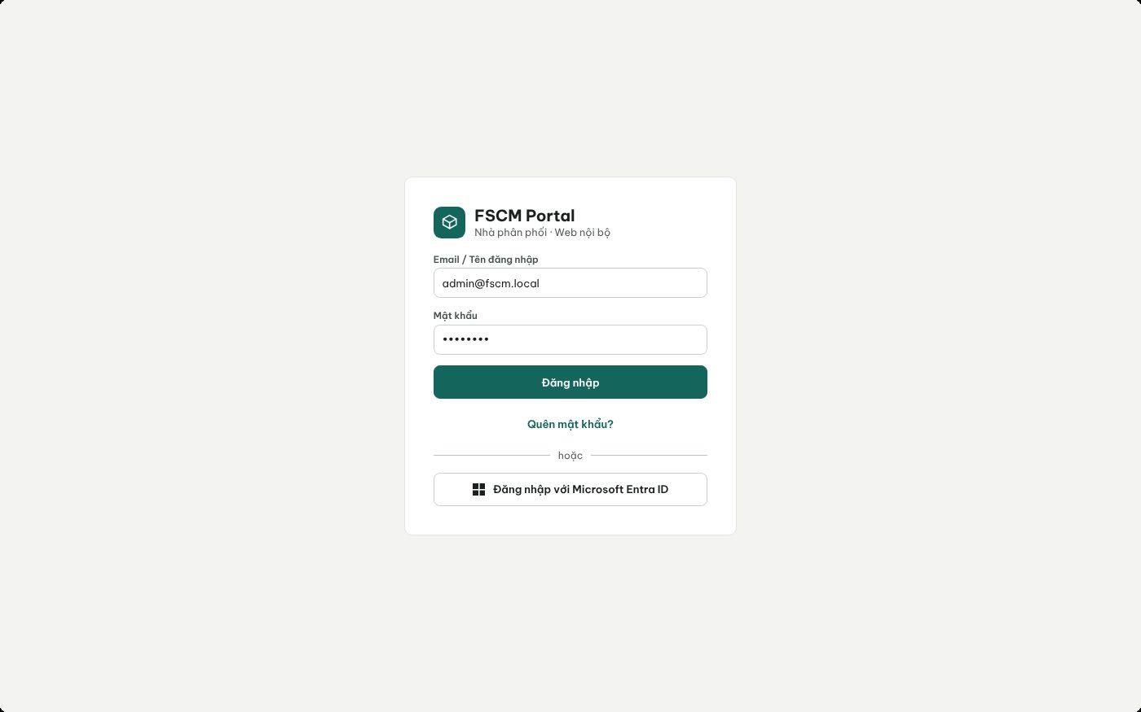
Figure 6. Web Portal – Login (system account or Microsoft Entra ID) (FSCM_Prototype_Prod_v1.1)
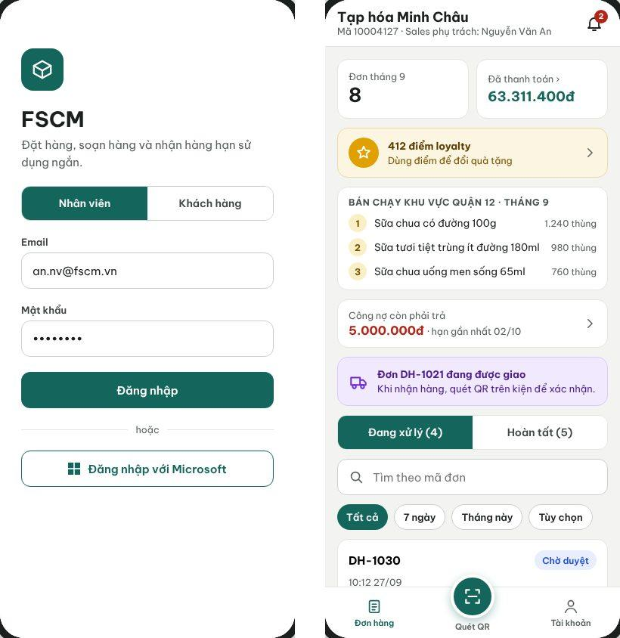
Figure 7. Mobile App – Staff/Customer login tabs and Retailer workspace opened after sign-in (FSCM_Prototype_Prod_v1.1)
● Function Details:
o Actors: Primary – Administrator, Operator, Sales Manager, Warehouse Keeper, Sales (email + password on the Web Portal or the Staff tab); Retailer (phone number + password on the Customer tab). System – Account Authentication, Retailer First-Login Verification (3.1.4).
o Fields:
▪ Web Portal and Staff tab of the Mobile App: email and password. Customer tab of the Mobile App: phone number and password.
o Data Processing:
▪ Validate credentials and account status through the configured authentication service.
▪ Load authorized role and data scope; open the corresponding interface (on the Mobile App, the Sales, Warehouse or Retailer part).
▪ Reject invalid or inactive credentials without granting access.
▪ On the Customer tab, a first sign-in with the issued password requires OTP verification and a password change before access.
o Business Rules:
▪ Permissions depend on the assigned role and warehouse/sales-area scope.
▪ Session policy (configurable defaults): access token 60 minutes; refresh token 8 hours sliding on the Web Portal and 7 days on the Mobile App; tokens are revoked when the account is deactivated or its password changes; 5 consecutive failed sign-ins lock the account for 15 minutes (MSG004, MSG005, MSG007). Microsoft sign-in is specified in 3.2.2 and is not available on the Customer tab.
o Acceptance Criteria:
AC ID | Acceptance criterion (Given / When / Then) | Ref.
AC-3.2.1-01 | Given an Active staff account, when the user enters the correct email and password, then the system opens only the workspace and data scope of that role within 2 s (NFR-P02). | BR-01, BR-03
AC-3.2.1-02 | Given a wrong password or an inactive account, when the user selects Login, then access is denied with MSG004 or MSG005 and no token is issued. | MSG004, MSG005
AC-3.2.1-03 | Given 5 consecutive failed attempts within 15 minutes, when a sixth attempt is made, then the account is temporarily locked for 15 minutes even if the password is correct. | NFR-S03
AC-3.2.1-04 | Given a Retailer signing in on the Customer tab for the first time with the issued password, when the password is accepted, then the app requires a 6-digit OTP and a new password before any order data is shown. | 3.1.4 #5
AC-3.2.1-05 | Given a valid session, when the account is deactivated by the Administrator, then the next API call is rejected with MSG007 and the user is returned to Login. | BR-77
o Traceability: UC-37, UC-38 | BR-01, BR-03, BR-77 | CR-01, CR-24 | Screens: Login (Web Portal, Mobile App)

3.2.2 Login with Microsoft Account
● Function type: Screen function (see 3.1.2).
● Function trigger:
o Open Login page.
o Select Login with Microsoft.
o Choose a company account in the Microsoft sign-in pop-up.
● Function description: Allows a user to authenticate with a company Microsoft account (Microsoft Entra ID) through a sign-in pop-up opened over the Login screen of the Web Portal and the Staff tab of the Mobile App.
● Screen layout: see Figure 8 (captured from the approved prototype FSCM_Prototype_Prod_v1.1).
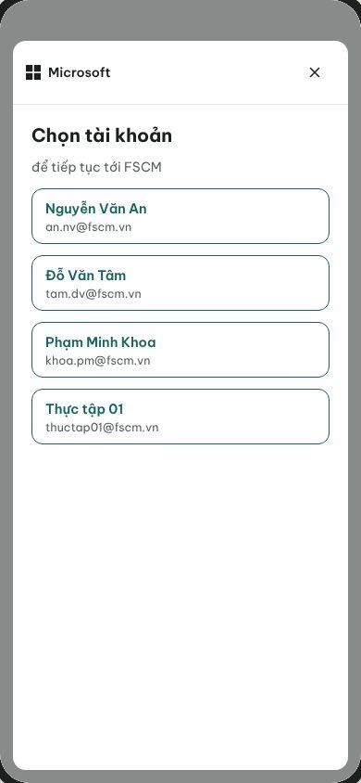
Figure 8. Microsoft account pop-up opened over the Login screen (FSCM_Prototype_Prod_v1.1)
● Function Details:
o Actors: Primary – staff users (Administrator, Operator, Sales Manager, Warehouse Keeper, Sales). External – Microsoft Entra ID. Retailers cannot use Microsoft sign-in.
o Data Processing:
▪ Open the Microsoft sign-in pop-up over the Login screen; the user chooses a company account.
▪ Verify the returned identity and link it to an eligible FSCM user account.
▪ On success, close the pop-up, load the authorized role and data scope and open the corresponding interface.
▪ Deny access if no permitted user account or role exists for that application; the error is shown in the pop-up with Choose another account and Close.
o Business Rules:
▪ Supported method is listed in UC-39.
▪ Account linking: the verified Entra ID email/UPN must match (case-insensitively) the email of an existing Active FSCM staff account; the first successful match stores the Entra object ID on that account. No just-in-time provisioning – an unmatched identity is denied (MSG006) and nothing is created. Only the company tenant configured for FSCM is accepted.
o Acceptance Criteria:
AC ID | Acceptance criterion (Given / When / Then) | Ref.
AC-3.2.2-01 | Given a company Entra ID account whose email matches an Active staff account, when the user chooses it in the pop-up, then the pop-up closes and the workspace of the linked role opens. | BR-01
AC-3.2.2-02 | Given an Entra ID account with no matching Active FSCM account, when the user chooses it, then access is denied in the pop-up with Choose another account and Close, and no FSCM account is created. | BR-02, BR-77
AC-3.2.2-03 | Given an account from a tenant other than the configured company tenant, when it is returned to FSCM, then the token is rejected and the attempt is logged. | NFR-S01
AC-3.2.2-04 | Given the Customer tab of the Mobile App, when the Login screen is shown, then the Microsoft option is not displayed. | BR-04
o Traceability: UC-37, UC-39 | BR-01, BR-02, BR-77 | CR-01, CR-24 | Screens: Login, Microsoft pop-up

3.2.3 Manage User Accounts
● Function type: Screen function (see 3.1.2).
● Function trigger:
o Open User Management.
o Select Create, View, Update or Delete/Deactivate.
● Function description: Maintains system user accounts subject to role-based creation restrictions.
● Screen layout: see Figures 9 – 10 (captured from the approved prototype FSCM_Prototype_Prod_v1.1).
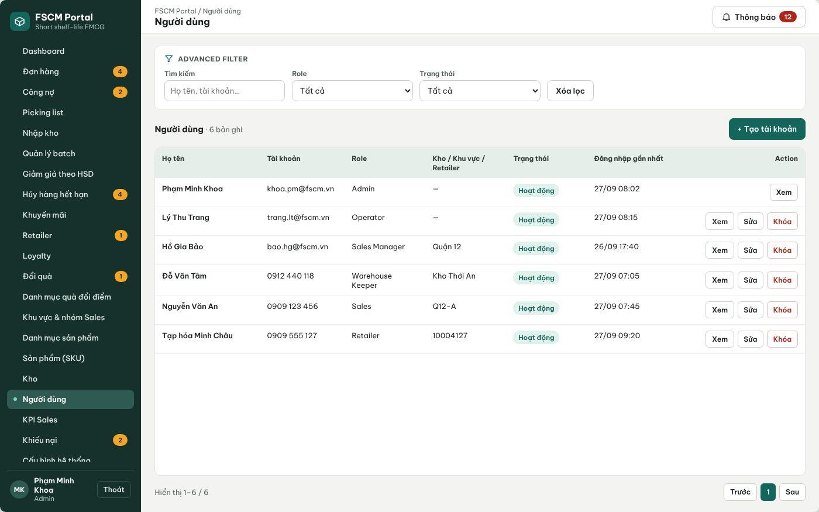
Figure 9. User Management – account list with role and scope (FSCM_Prototype_Prod_v1.1)
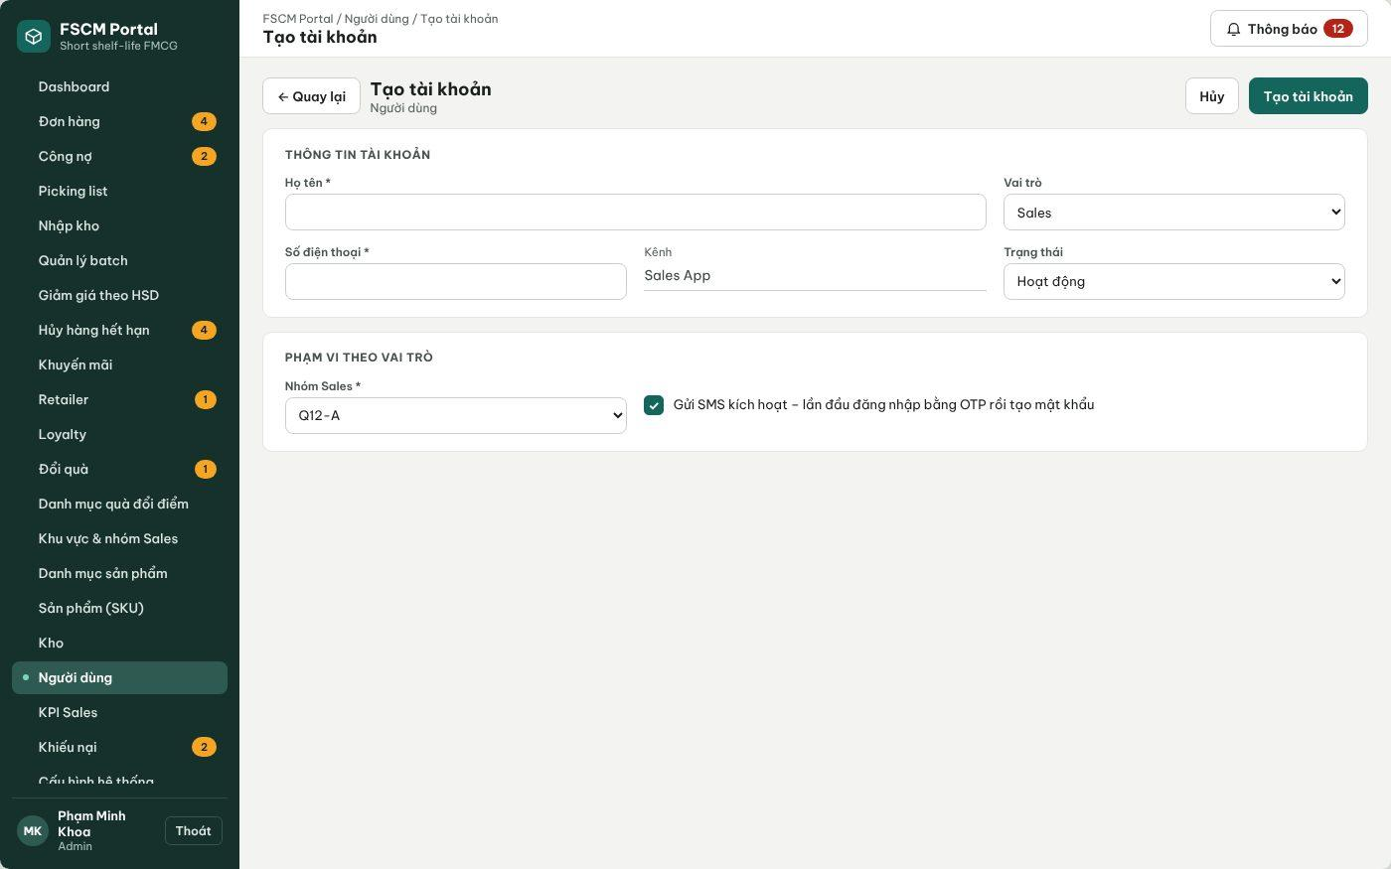
Figure 10. User Management – Create account with SMS activation (FSCM_Prototype_Prod_v1.1)
● Function Details:
o Actors: Primary – Administrator. System – Retailer Code Assignment (creates Retailer accounts on approval, 3.3.2).
o Fields:
▪ User identity; assigned role; active status; authorized warehouse / sales scope when applicable.
o Data Processing:
▪ Validate the administrator permission and proposed role.
▪ Create or update permitted account fields and assignments.
▪ Enforce deactivation/deletion constraints; record critical actions.
o Business Rules:
▪ Administrators must not freely create restricted actor types without following their approved registration flow.
▪ Role matrix (BR-77): the Administrator may create Operator, Sales Manager, Warehouse Keeper and Sales accounts. Retailer accounts are created only by approving a retailer declaration (3.3.2). Administrator accounts are never created or assigned through the UI (BR-02). A Warehouse Keeper needs at least one warehouse, a Sales account exactly one sales group and a Sales Manager at least one region. An account referenced by any business record is deactivated (Locked), never deleted.
o Acceptance Criteria:
AC ID | Acceptance criterion (Given / When / Then) | Ref.
AC-3.2.3-01 | Given the Create account form, when the Administrator opens the Role list, then Administrator and Retailer are not selectable. | BR-02, BR-77
AC-3.2.3-02 | Given a Warehouse Keeper or Sales account without its required warehouse or sales group, when Save is selected, then the account is not created and MSG001 is shown. | BR-03
AC-3.2.3-03 | Given an account that has created or approved any order, receipt, payment or audit record, when Delete is requested, then the system offers only Deactivate and the history remains attributable. | BR-58, BR-77
AC-3.2.3-04 | Given a valid new staff account, when it is saved, then an activation SMS/e-mail is sent, the action is written to the audit log and the user must set a password at first sign-in. | BR-58
AC-3.2.3-05 | Given an API request from a non-Administrator to create a user, when it reaches the server, then it is rejected with MSG006 regardless of the UI. | CR-01, CR-02
o Traceability: UC-02, UC-54 – UC-57 | BR-01 – BR-03, BR-58, BR-77 | CR-01, CR-02, CR-21 | Screens: User Management

3.3 Retailer Registration & Assessment

3.3.1 Register Retailer and Collect Assessment
● Function type: Screen function (see 3.1.2).
● Function trigger:
o Open an assigned retailer/prospect workflow.
o Enter store details and assessment, then submit.
● Function description: Records retailer registration and prospect information collected by Sales for later review.
● Screen layout: see Figure 11 (captured from the approved prototype FSCM_Prototype_Prod_v1.1).
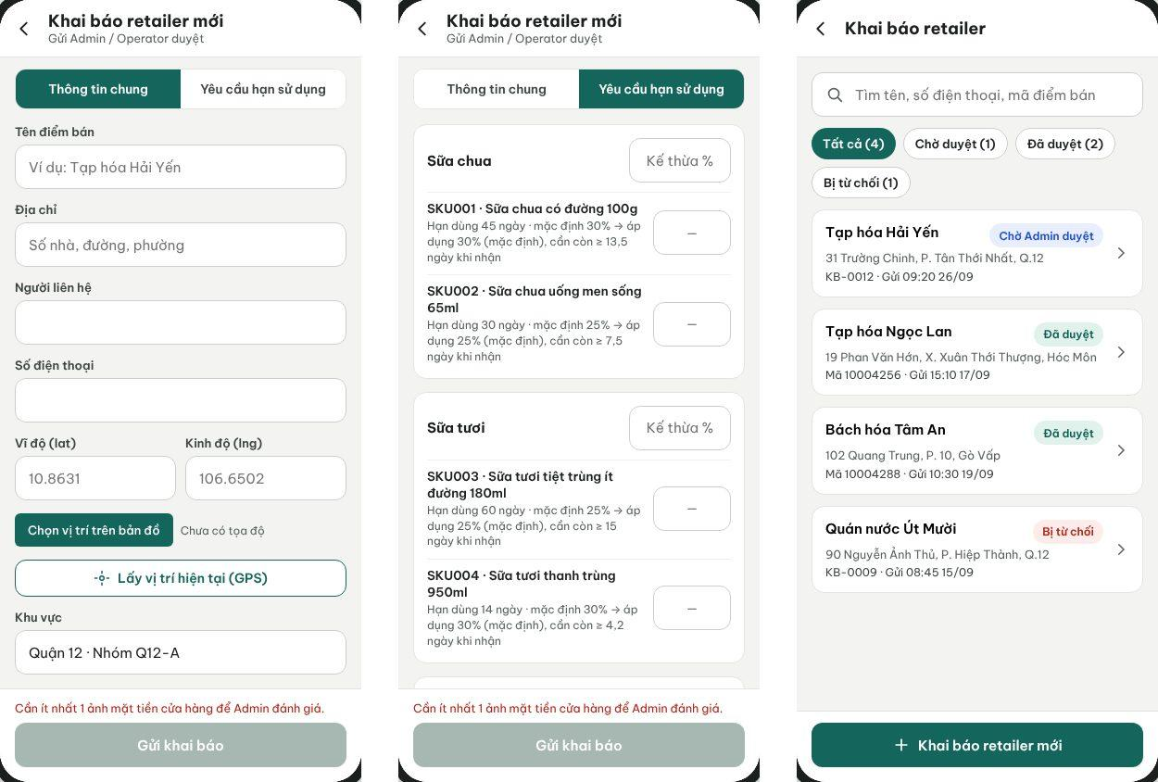
Figure 11. Sales App – Declare retailer: General Information, Shelf-life Requirements and declaration list (FSCM_Prototype_Prod_v1.1)
● Function Details:
o Actors: Primary – Sales (declares a retailer through General Information and Shelf-life Requirements tabs). Secondary – Operator may enter a declaration on behalf of Sales. System – Potential Classification (3.1.4).
o Fields:
▪ Retailer/store identification and contact information.
▪ Store size, potential revenue estimate, purchasing capacity and assessment notes.
o Data Processing:
▪ Validate required retailer information and prevent duplicate registrations according to configured criteria.
▪ Save the prospect/retailer record together with its assessment fields.
▪ Submit for authorized review before enabling restricted order operations.
o Business Rules:
▪ Assessment information is kept with the Retailer data model.
▪ Mandatory fields: store name, contact person, phone number, address with map location (GPS or map pick), sales area/group, store size, forecast monthly revenue, purchasing capacity and at least one storefront photo. Shelf-life tab: optional Category and SKU MLOR ratios, each strictly between 0 and 1; an SKU entry overrides its Category (BR-11). Duplicate check: same phone number, or the same normalized name and address, among Pending or Active retailers (MSG009). Repeated submission of the same declaration returns the existing record.
o Acceptance Criteria:
AC ID | Acceptance criterion (Given / When / Then) | Ref.
AC-3.3.1-01 | Given a declaration missing any mandatory field or storefront photo, when Sales submits it, then submission is blocked and the missing fields are marked with MSG001. | BR-12
AC-3.3.1-02 | Given an existing Pending or Active retailer with the same phone number, when Sales submits a new declaration, then it is rejected with MSG009 and no second record is created. | BR-12
AC-3.3.1-03 | Given Category 'Sữa chua' = 30% and SKU002 = 25%, when the declaration is saved, then SKU002 resolves to 25% and other yogurt SKUs to 30%. | BR-11
AC-3.3.1-04 | Given an MLOR value of 0% or 100%, when it is entered, then it is rejected with MSG002. | BR-11
AC-3.3.1-05 | Given a valid submission, when the server accepts it, then its status is Pending approval, it cannot receive orders and the Administrator is notified (MSG010). | BR-12, BR-20
o Traceability: UC-15, UC-87 | BR-11, BR-12, BR-20 | CR-01 | Screens: Declare Retailer, Declarations List

3.3.2 Review Retailer Registration and Assessment
● Function type: Screen function (see 3.1.2).
● Function trigger:
o Open pending retailer requests or assessments.
o Review supporting information and record a decision.
● Function description: Reviews retailer activation requests and prospect potential for future prioritization.
● Screen layout: see Figure 12 (captured from the approved prototype FSCM_Prototype_Prod_v1.1).
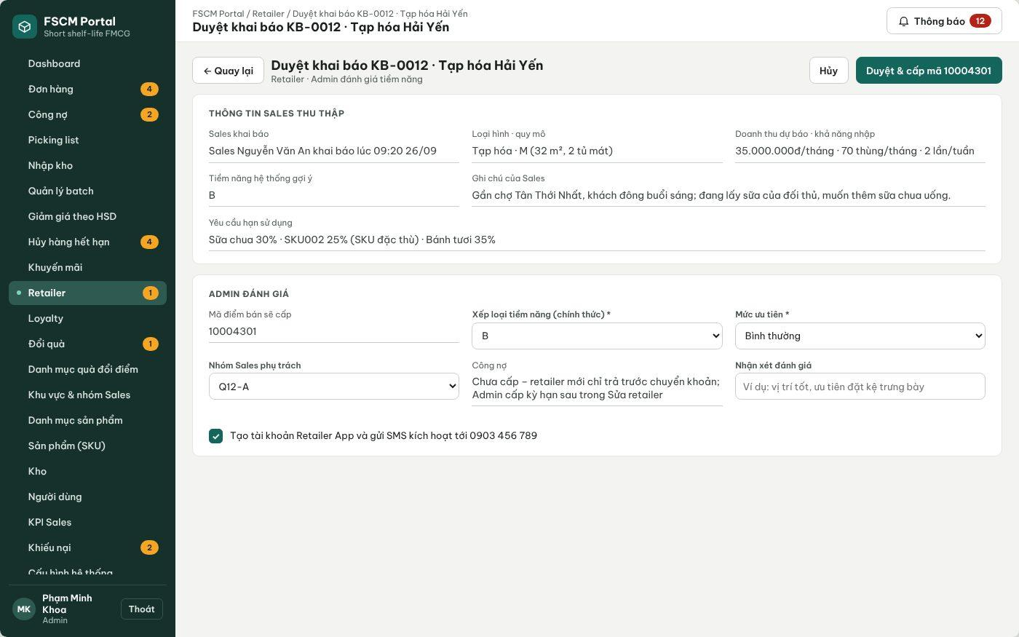
Figure 12. Web Portal – Review declaration and assess potential (FSCM_Prototype_Prod_v1.1)
● Function Details:
o Actors: Primary – Administrator (final decision). Secondary – Operator may pre-check a declaration and add review notes but cannot approve or reject. System – Retailer Code Assignment (3.1.4).
o Fields:
▪ Retailer details; assessment values; decision; optional notes.
o Data Processing:
▪ Retrieve pending retailer and assessment information.
▪ Record approval or rejection and update the relevant status.
▪ Make the outcome available to permitted users and maintain traceability.
o Business Rules:
▪ Only authorized reviewers may approve registration.
▪ Assessment: the system suggests potential A/B/C (3.1.4 #6); the Administrator confirms the official class, priority (High / Normal / Watch), responsible sales group and payment term (none, 7, 14 or 30 days; a new retailer defaults to none – BR-13). No numeric scoring threshold is applied in the MVP. Only the Administrator finalizes; rejection requires a reason.
o Acceptance Criteria:
AC ID | Acceptance criterion (Given / When / Then) | Ref.
AC-3.3.2-01 | Given a Pending declaration, when the Administrator approves it, then an 8-digit retailer code is assigned, the Category/SKU MLOR becomes official, the Retailer account is created and an activation SMS is sent (MSG011). | BR-12
AC-3.3.2-02 | Given an Operator account, when it opens a Pending declaration, then Approve and Reject are not available and a direct API call is rejected with MSG006. | BR-12, CR-01
AC-3.3.2-03 | Given a Reject decision without a reason, when it is submitted, then it is blocked with MSG001; with a reason, Sales receives MSG012 and the reason. | BR-12
AC-3.3.2-04 | Given an approved retailer without a payment term, when its first quotation is accepted, then only Prepaid – bank transfer can be chosen. | BR-13, BR-51
AC-3.3.2-05 | Given Approve is submitted twice, when the second request arrives, then the same retailer code is returned and no duplicate account is created. | BR-06
o Traceability: UC-13, UC-64 | BR-06, BR-12, BR-13 | CR-01, CR-21 | Screens: Retailer List, Review Declaration

3.3.3 Manage Retailer Profile
● Function type: Screen function (see 3.1.2).
● Function trigger:
o Open Retailer Management.
o Create, view, update or deactivate an eligible retailer record.
● Function description: Maintains retailer identity, assigned coverage and assessment information.
● Screen layout: see Figure 13 (captured from the approved prototype FSCM_Prototype_Prod_v1.1).
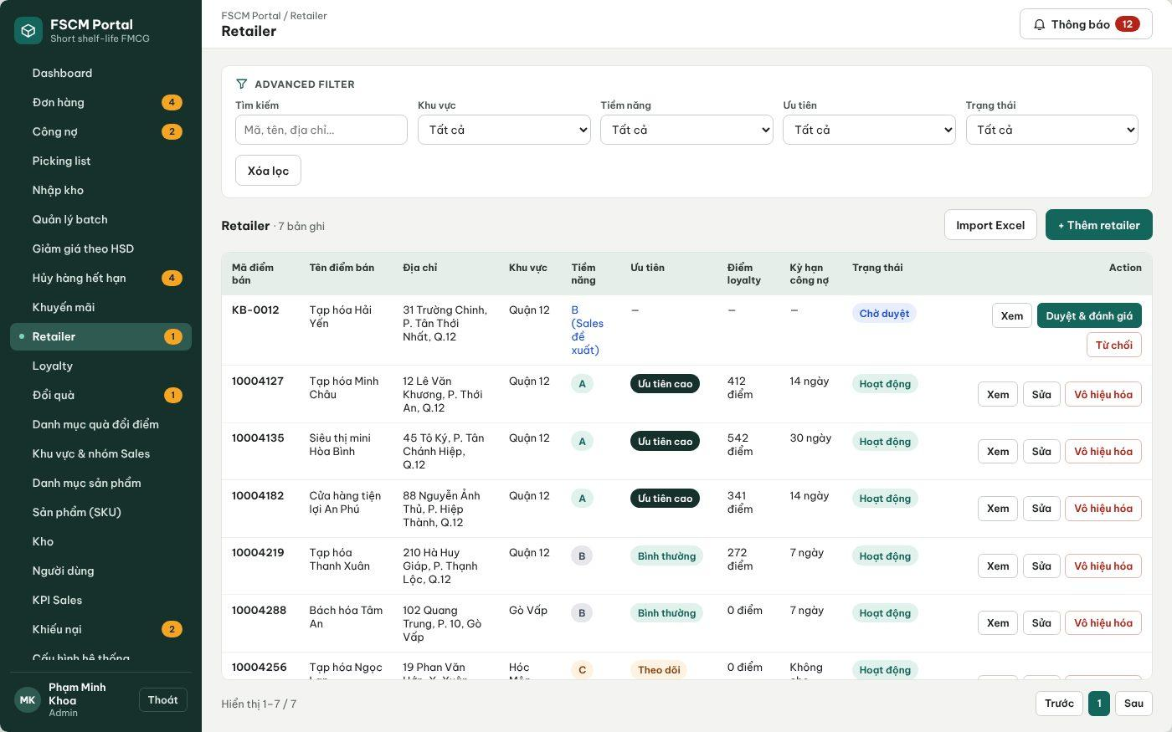
Figure 13. Web Portal – Retailer list with potential, priority, loyalty and payment term (FSCM_Prototype_Prod_v1.1)
● Function Details:
o Actors: Primary – Administrator. Secondary – Sales Manager and Sales view retailers of their scope (read-only).
o Fields:
▪ Retailer profile; status; region / sales-group assignment; assessment information.
o Data Processing:
▪ Check permission and any active order dependencies.
▪ Save valid changes and preserve relevant order history.
o Business Rules:
▪ Retailer management must not bypass the approval workflow.
▪ A retailer with any order, payment, complaint or loyalty record can only be deactivated (Locked); hard deletion is allowed only for a Rejected declaration with no orders. Deactivation is blocked while the retailer has an order that is not Completed or Cancelled, an outstanding balance or a pending refund. Changes to MLOR or payment term apply only to later orders (BR-57).
o Acceptance Criteria:
AC ID | Acceptance criterion (Given / When / Then) | Ref.
AC-3.3.3-01 | Given a retailer with historical orders, when the Administrator selects Delete, then the system blocks deletion and offers Deactivate. | BR-70
AC-3.3.3-02 | Given a retailer with an order in Delivering status, when Deactivate is selected, then it is rejected with the blocking order listed. | BR-70
AC-3.3.3-03 | Given the payment term changes from 7 to 14 days, when it is saved, then existing orders keep their stored due dates and only later orders use 14 days. | BR-52, BR-57
AC-3.3.3-04 | Given a Sales user outside the retailer's sales group, when the retailer profile API is called, then MSG006 is returned. | BR-03
o Traceability: UC-08, UC-43 – UC-45 | BR-03, BR-12, BR-13, BR-57, BR-70 | CR-01, CR-10 | Screens: Retailer List, Retailer Details

3.4 Product & Category Management

3.4.1 Manage Product Category Tree
● Function type: Screen function (see 3.1.2).
● Function trigger:
o Open Product Category Management.
o Create, update, move or delete a category.
● Function description: Maintains hierarchical product categories for browsing and reporting.
● Screen layout: see Figure 14 (captured from the approved prototype FSCM_Prototype_Prod_v1.1).
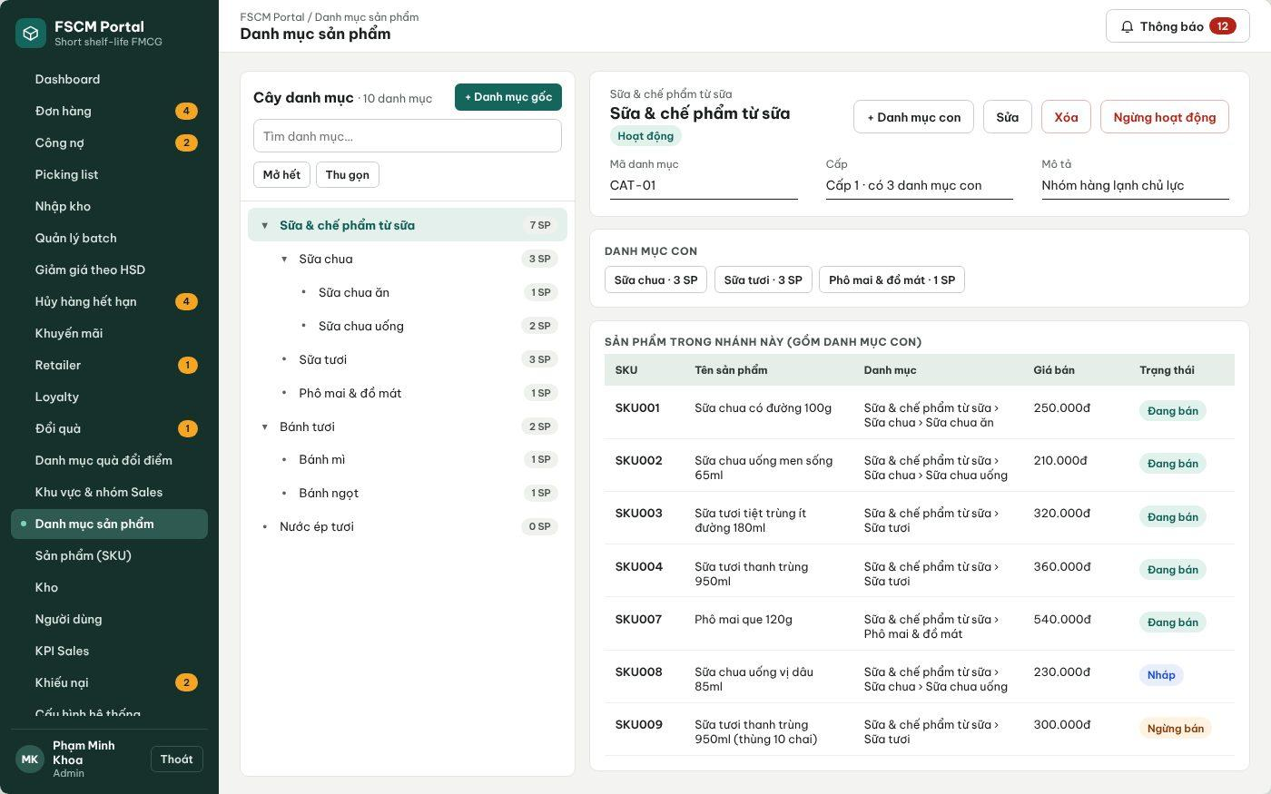
Figure 14. Web Portal – Product category tree (FSCM_Prototype_Prod_v1.1)
● Function Details:
o Actors: Primary – Administrator.
o Fields:
▪ Category name; parent category; category status (if configured).
o Data Processing:
▪ Validate selected parent and prevent circular parent-child relationships.
▪ Persist the category tree change and refresh product/category views.
▪ Prevent deletion when dependent products or children require retention.
o Business Rules:
▪ A category can have a parent category.
▪ The tree has at most 3 levels and products are assigned only to leaf categories. A category can be deleted only when it has no child category, no product (including Inactive), no promotion, discount rule or retailer MLOR reference; otherwise it can only be deactivated (MSG015). Moving a category is rejected if it would create a cycle or exceed 3 levels; references by ID remain valid after a move.
o Acceptance Criteria:
AC ID | Acceptance criterion (Given / When / Then) | Ref.
AC-3.4.1-01 | Given a category with a child or a product, when Delete is selected, then deletion is blocked with MSG015 and Deactivate is offered. | CR-06
AC-3.4.1-02 | Given a level-3 category, when the Administrator adds a child to it, then the action is rejected because the tree is limited to 3 levels. | CR-06
AC-3.4.1-03 | Given category A is the parent of B, when A is moved under B, then the move is rejected as circular. | CR-06
AC-3.4.1-04 | Given a non-leaf category, when a product is assigned to it, then assignment is rejected. | CR-06
o Traceability: UC-59 – UC-63 | BR-07, BR-11 | CR-06 | Screens: Product Category

3.4.2 Create and Publish Product
● Function type: Screen function (see 3.1.2).
● Function trigger:
o Open Product Management.
o Create a product in Draft status and submit for publication.
● Function description: Maintains SKU information using the Draft, Published and Inactive lifecycle.
● Screen layout: see Figures 15 – 16 (captured from the approved prototype FSCM_Prototype_Prod_v1.1).
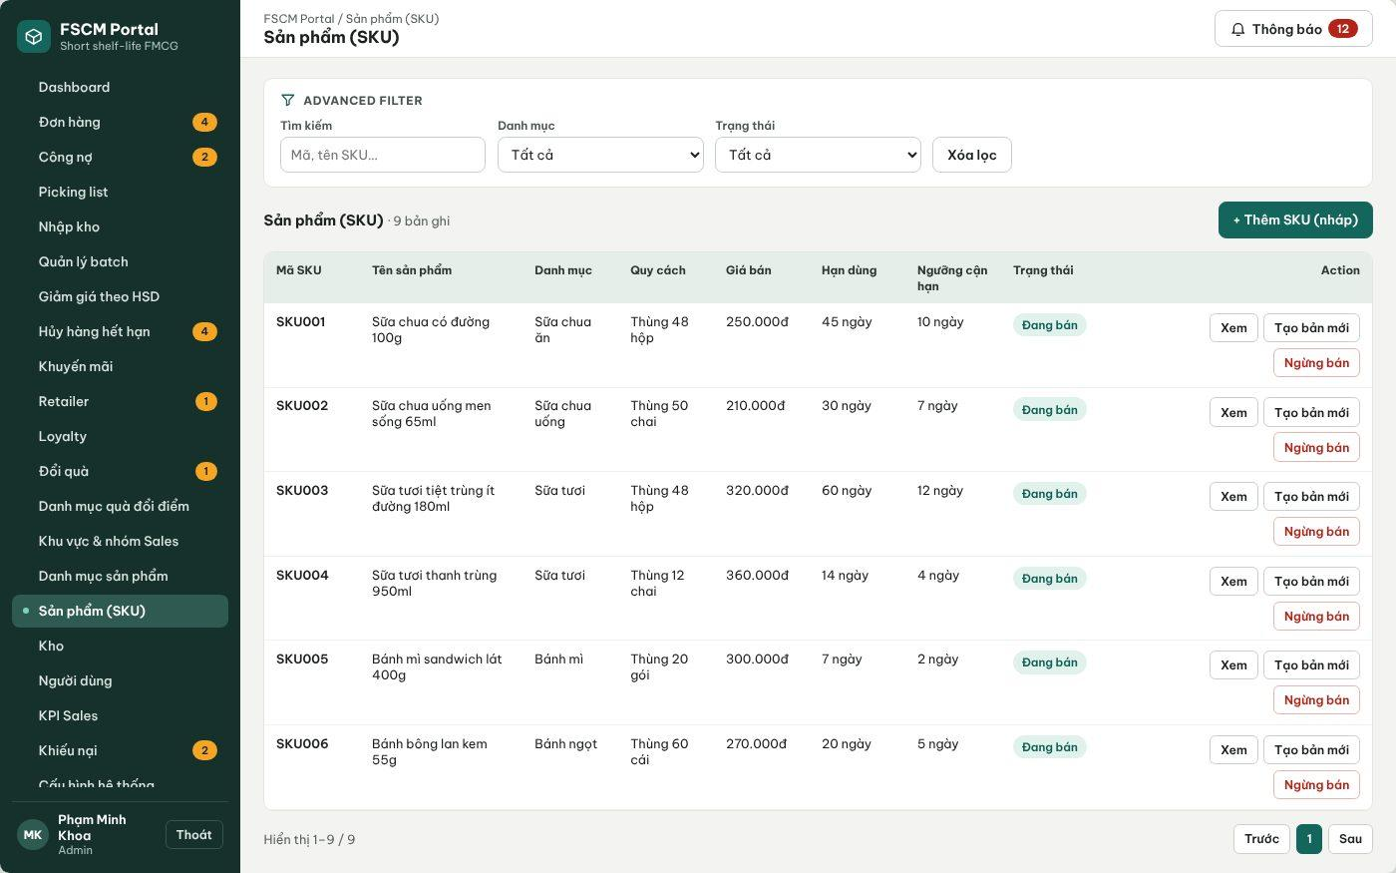
Figure 15. Web Portal – Product (SKU) list with Draft / Published / Inactive status (FSCM_Prototype_Prod_v1.1)
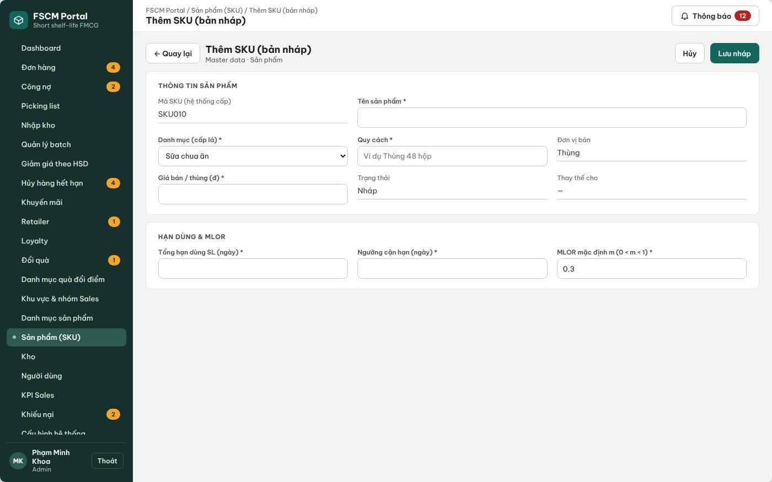
Figure 16. Web Portal – Create SKU (Draft) (FSCM_Prototype_Prod_v1.1)
● Function Details:
o Actors: Primary – Administrator.
o Fields:
▪ Product identity / SKU; category; selling price; shelf-life information; lifecycle status.
o Data Processing:
▪ Validate mandatory fields and category references.
▪ Save a new product as Draft.
▪ Publish the product once required information is complete.
o Business Rules:
▪ Once Published, product details and public price are locked.
▪ To change a published product or price, mark the prior product Inactive and create a new product.
o Acceptance Criteria:
AC ID | Acceptance criterion (Given / When / Then) | Ref.
AC-3.4.2-01 | Given a Draft product with all mandatory fields (SKU, name, leaf category, packing, price, total shelf life, near-expiry threshold, default MLOR), when Publish is selected, then the status becomes Published and MSG014 is shown. | BR-07
AC-3.4.2-02 | Given a Published product, when any locked field is edited, then the change is rejected with MSG013. | BR-07
AC-3.4.2-03 | Given a Published product, when Create new version is used and the new version is published, then the old product becomes Inactive, historical orders keep their snapshots and the new SKU has no stock or transactions. | BR-07, BR-19
AC-3.4.2-04 | Given a Draft or Inactive product, when Sales searches the catalog or a goods receipt is created, then it is not available. | BR-08
o Traceability: UC-88, UC-90 | BR-06 – BR-08, BR-19 | CR-06, CR-10 | Screens: Product (SKU) List, Create SKU

3.4.3 View Product Catalog and Best-Selling Products
● Function type: Screen function (see 3.1.2).
● Function trigger:
o Open Catalog or a permitted dashboard.
o Filter by product/category or open top-selling list.
● Function description: Shows eligible catalog products and supported best-selling product information.
● Screen layout: see Figure 17 (captured from the approved prototype FSCM_Prototype_Prod_v1.1).
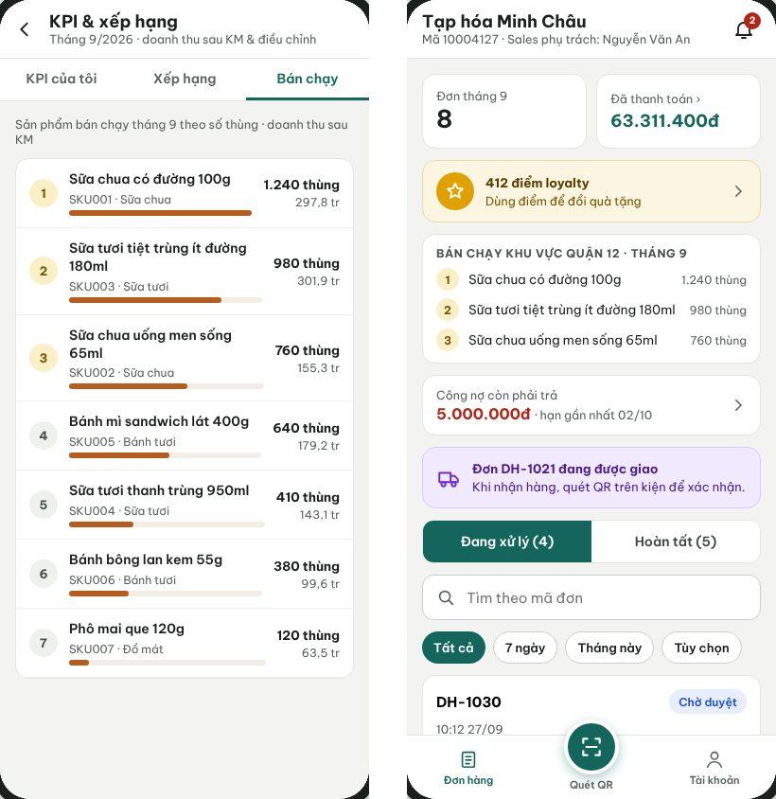
Figure 17. Sales App best-selling tab and Retailer home with area best sellers (FSCM_Prototype_Prod_v1.1)
● Function Details:
o Actors: Primary – Sales, Retailer, Administrator. Secondary – Sales Manager (best-selling products of the team).
o Fields:
▪ Product name; category; public price; available stock visibility where authorized; sales ranking.
o Data Processing:
▪ Read publishable/active products within permitted visibility.
▪ Calculate best-selling rank from eligible recorded order data and show the result.
o Business Rules:
▪ Do not expose Draft or Inactive items as purchasable products.
▪ Best-selling rank: total delivered quantity (cartons) per SKU in the selected period (default: current month; options Today, 7 days, This month, Custom), counting only Delivered or Completed orders net of approved adjustments; ties are broken by net revenue, then SKU code. Scope follows the viewer: own area for Sales/Retailer, team for Sales Manager, whole distributor for Administrator.
o Acceptance Criteria:
AC ID | Acceptance criterion (Given / When / Then) | Ref.
AC-3.4.3-01 | Given orders in Cancelled, Rejected or Insufficient stock status, when the ranking is calculated, then their quantities are excluded. | BR-56
AC-3.4.3-02 | Given two SKUs with equal quantity, when ranked, then the one with higher net revenue is listed first, and if equal, the lower SKU code. | BR-56
AC-3.4.3-03 | Given a Sales user, when the best-selling list is opened, then only data of the user's sales area is aggregated. | BR-03
AC-3.4.3-04 | Given an Inactive product, when the catalog is shown, then it is not offered for ordering but may still appear in historical rankings. | BR-08
o Traceability: UC-71, UC-89 | BR-03, BR-08, BR-56 | CR-01 | Screens: Product Catalog, KPI & Ranking, Dashboard

3.5 Promotion & Batch Discount Management

3.5.1 Manage Promotion Rules
● Function type: Screen function (see 3.1.2).
● Function trigger:
o Open Promotion Management.
o Create, inspect, edit or delete an eligible promotion.
● Function description: Maintains discount configurations applying to products, categories, retailers or eligible batches.
● Screen layout: see Figures 18 – 20 (captured from the approved prototype FSCM_Prototype_Prod_v1.1).
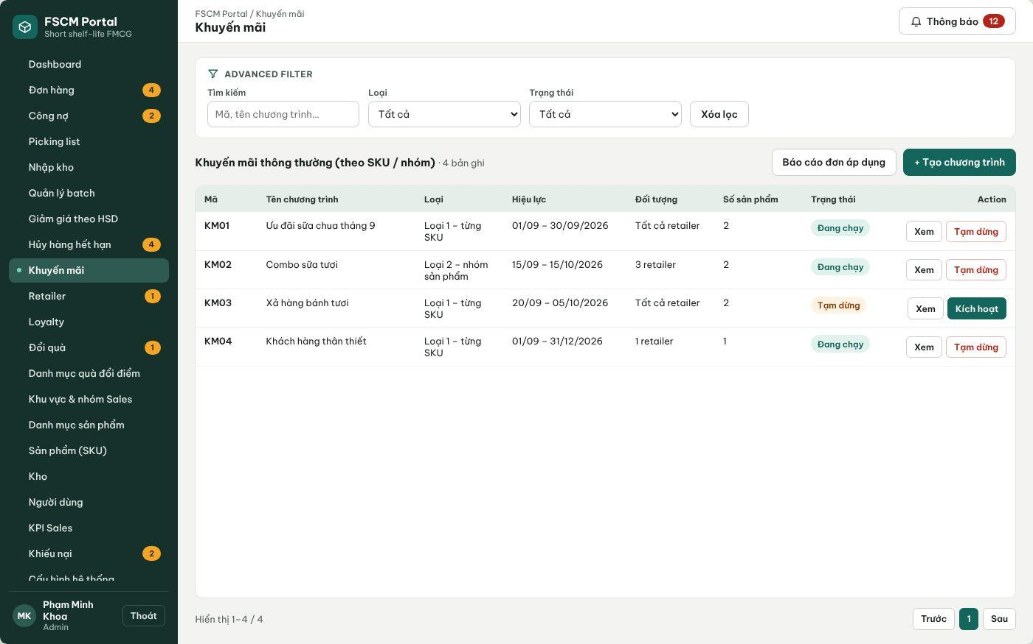
Figure 18. Web Portal – Ordinary promotions (Type 1 per SKU, Type 2 product group) (FSCM_Prototype_Prod_v1.1)
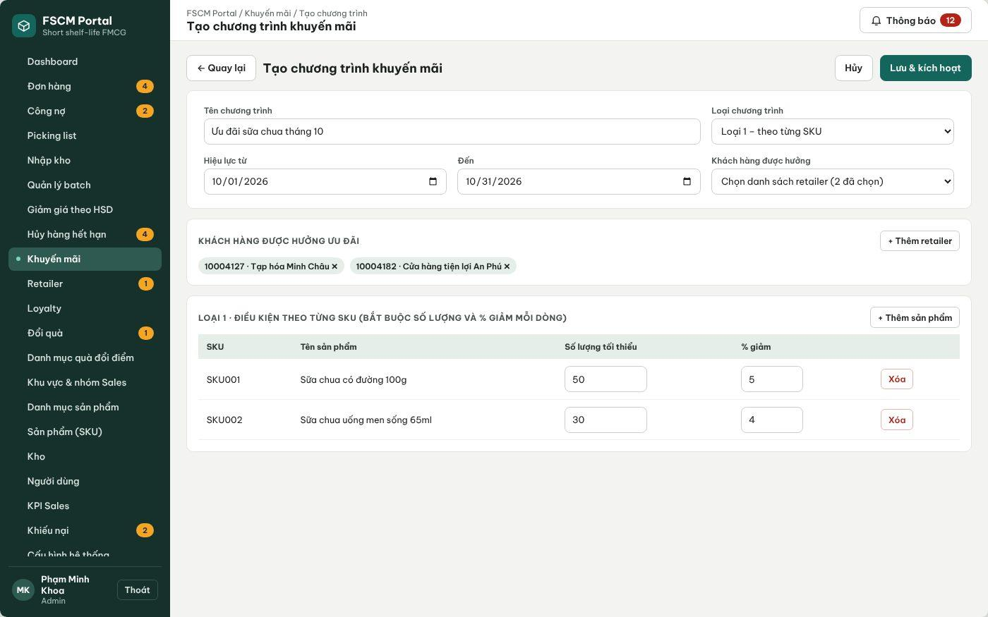
Figure 19. Web Portal – Create promotion (FSCM_Prototype_Prod_v1.1)
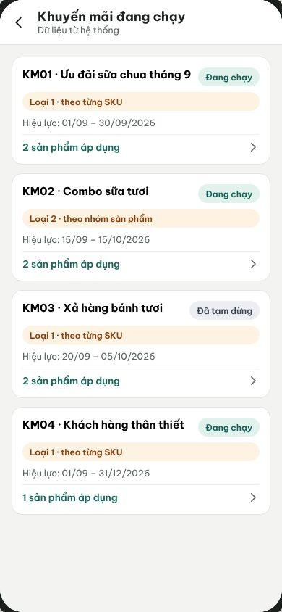
Figure 20. Sales App – Running promotions (FSCM_Prototype_Prod_v1.1)
● Function Details:
o Actors: Primary – Administrator. Secondary – Sales views running promotions (read-only).
o Fields:
▪ Promotion code and name; validity period; discount configuration; eligible scope.
o Data Processing:
▪ Validate effective period and configuration.
▪ Store eligibility and the official promotion rules.
▪ Restrict updates/deletion when historical orders must retain the original promotion result.
o Business Rules:
▪ Order financial reporting uses revenue after promotions.
▪ Ordinary campaigns retain the retailer–SKU MLOR. Near-expiry offers with a separately accepted MLOR follow BR-59–BR-65; no unaccepted offer condition is applied automatically.
o Acceptance Criteria:
AC ID | Acceptance criterion (Given / When / Then) | Ref.
AC-3.5.1-01 | Given a Type 2 group promotion '10 cartons of A+B → 10%', when one order contains A: 6 and B: 4, then the threshold is met; quantities from different orders or retailers are never combined. | BR-14, BR-15
AC-3.5.1-02 | Given two valid promotions on the same line, when the server prices the order, then only the one with the largest discount amount is applied; ties are resolved by the lower promotion code. | BR-14
AC-3.5.1-03 | Given a paused or expired promotion, when an order is accepted or synchronized, then it is not applied and Sales sees MSG035 if the estimate changes. | BR-14, BR-15
AC-3.5.1-04 | Given a discount of 100% or a fixed-amount discount, when it is saved, then it is rejected (percentage only, strictly below 100%). | BR-79
AC-3.5.1-05 | Given a promotion already used by an order, when it is edited, then historical orders keep the applied promotion snapshot. | BR-19
o Traceability: UC-07, UC-46 – UC-49 | BR-14, BR-15, BR-17, BR-19, BR-79 | CR-10 | Screens: Promotions, Create Promotion, Sales Promotions

3.5.2 Scan and Apply Near-Expiry Batch Promotion
● Function type: Screen function (see 3.1.2).
● Function trigger:
o Open Batch Promotion / eligible inventory view.
o Scan or select near-expiry stock and configure a discount.
● Function description: Creates a near-expiry offer for selected eligible batches with an explicit price, validity and minimum remaining shelf life on receipt.
● Screen layout: no separate mock-up – near-expiry batches are selected from Batch Management (Figure 34 in 3.8.2); the offer form itself is not in FSCM_Prototype_Prod_v1.1.
● Function Details:
o Actors: Primary – Administrator. Secondary – Operator (inspect only). Status: conditional – near-expiry offers with an accepted MLOR are not in the Registration scope; see 5.5, item R-07.
o Fields:
▪ Eligible batches; discount/offer price; minimum remaining shelf-life ratio at receipt; validity; version; approval status.
o Data Processing:
▪ Retrieve batch expiry, status and remaining available quantity.
▪ Determine the near-expiry candidates using the configured threshold.
▪ Administrator confirms the offer before publication. Preserve accepted versions on order lines; an update does not silently rewrite customer conditions.
o Business Rules:
▪ An offer can cover multiple named eligible batches. Each allocated batch must meet the line’s effective MLOR and the same accepted price/conditions.
▪ Only the Administrator configures or disables the offer. The customer’s line acceptance does not change retailer master MLOR; Sales cannot enter an arbitrary replacement ratio.
o Acceptance Criteria:
AC ID | Acceptance criterion (Given / When / Then) | Ref.
AC-3.5.2-01 | Given a batch whose remaining shelf life is below the product near-expiry threshold, when the nightly job runs, then the batch is shown as Near-expiry and becomes a candidate for an offer. | BR-43
AC-3.5.2-02 | Given an offer draft, when the Administrator has not confirmed it, then it is not visible to Sales (MSG036). | BR-16
AC-3.5.2-03 | Given a confirmed offer that is later changed, when it is saved, then a new version is created and lines already accepted keep their version. | BR-19, BR-62
AC-3.5.2-04 | Given an offer ratio of 0 or 1, when it is saved, then it is rejected because the ratio must be strictly between 0 and 1. | BR-60
o Traceability: UC-58 | BR-16, BR-43, BR-59 – BR-65 | CR-15 | Screens: Batch Management (near-expiry filter)

3.5.3 Select and Accept a Near-Expiry Offer
● Function type: Screen function (Create Order – Near-expiry offers view). Status: conditional, see 5.5, item R-07.
● Function trigger:
o Sales opens Create Order for an assigned retailer and switches to the Near-expiry offers view.
o Sales records that the customer accepts the offer-specific MLOR and price, then adds the line.
● Function description: Records the customer's explicit acceptance of a near-expiry offer as a separate order line; no stock is held at selection.
● Screen layout: No approved mock-up – the near-expiry offer view is not present in FSCM_Prototype_Prod_v1.1 (see 5.5, item R-07).
● Function Details:
o Actors: Primary – Sales (records the customer's acceptance). Secondary – Administrator configures offer conditions (3.5.2). The Retailer does not create the order.
o Fields:
▪ Offer code/version; offer price; minimum remaining shelf life on receipt; retailer's normal MLOR; validity; indicative quantity; acceptance checkbox; recorded-by user and time.
o Data Processing:
▪ Standard products show the retailer's normal MLOR; offer cards show the offer price, minimum life on receipt, validity and indicative quantity.
▪ Enable Add only after Sales records that the customer agreed to the offer-specific MLOR; the confirmation is never preselected. Sales cannot enter an arbitrary lower ratio or modify master MLOR.
▪ Keep the offer as a separate cart/order line, even when the same SKU also appears as a standard line. Store offer/version, accepted price/MLOR, recorded-by user and time. Offline caches retain these fields and are revalidated by the server.
▪ Stock is not held at selection. If the run cannot fulfil the accepted offer and effective MLOR, report a shortage; do not silently switch to ordinary stock or raise the price.
o Business Rules:
▪ BR-59 – BR-65 apply. Offer lines use the accepted offer price and are not given a second shelf-life tier discount (BR-80).
o Acceptance Criteria:
AC ID | Acceptance criterion (Given / When / Then) | Ref.
AC-3.5.3-01 | Given the acceptance checkbox is not ticked, when Sales selects Add, then the line is not added and MSG051 is shown. | BR-60, BR-65
AC-3.5.3-02 | Given SKU001 already in the cart as a standard line, when an SKU001 offer line is added, then two separate lines exist with different MLOR and price. | BR-29, BR-62
AC-3.5.3-03 | Given an offer that expires before the order is synchronized, when the server validates it, then the line is flagged with MSG052 and Sales must remove it or confirm new conditions. | BR-63, BR-64
AC-3.5.3-04 | Given an accepted offer line, when the run cannot find enough eligible offer batches, then the whole order is Insufficient stock in run and no standard-price stock is substituted. | BR-36, BR-63
o Traceability: UC-86 | BR-29, BR-36, BR-59 – BR-65, BR-80 | CR-15 | Screens: Create Order (offer view – not prototyped)

3.5.4 Manage Shelf-Life Discount Rules and Batch Pricing
● Function type: Screen function (Shelf-life Discount Rules – Web Portal). Pricing during the run is automatic – see Expiry Discount Pricing in 3.1.4.
● Function trigger:
o The Administrator opens Shelf-life Discount Rules and creates, edits, pauses or activates a rule.
o The daily run selects batches for an order line (pricing is then applied automatically).
● Function description: Maintains discount tiers by remaining shelf-life percentage for a Category or SKU and applies the matching tier to each allocated batch after batch selection, so that the quotation shows a traceable price per batch. Added in v1.8 to cover the Registration requirement 'apply the configured remaining-shelf-life discount after selecting batches'.
● Screen layout: see the figure below.
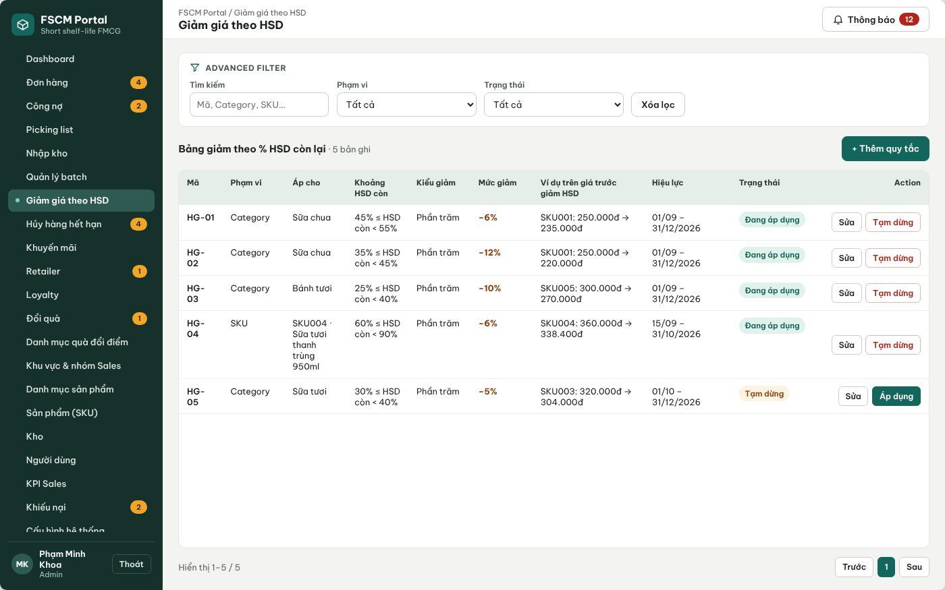
Figure 21. Web Portal – Shelf-life discount rules by remaining shelf-life range (FSCM_Prototype_Prod_v1.1)
● Function Details:
o Actors: Primary – Administrator (rules, approval of final prices in 3.7.2). System – Expiry Discount Pricing. Secondary – Sales and Retailer view the resulting per-batch prices on quotations and order details.
o Fields:
▪ Rule code (HG-nn); scope (Category or SKU); target; remaining shelf-life range [from %, to %); discount percent; validity; status (Active / Paused).
o Data Processing:
▪ Validate that ranges of the same scope and target do not overlap and that 0 < discount < 100%.
▪ At the run pricing point, compute each allocated batch's remaining shelf-life percentage, pick the SKU rule first, else the Category rule (nearest ancestor), else no discount.
▪ Final unit price = base price after ordinary promotion × (1 − tier discount); amounts are rounded to whole VND per batch line; the base price, promotion, tier rule, discount amount and final price are stored per allocated batch.
o Business Rules:
▪ BR-79 and BR-80 apply. A discount never makes an ineligible batch eligible and is not a scoring weight (BR-18).
o Acceptance Criteria:
AC ID | Acceptance criterion (Given / When / Then) | Ref.
AC-3.5.4-01 | Given rule HG-02 (Sữa chua, 35% ≤ remaining < 45%, −12%) and an allocated SKU001 batch with 40% remaining at the pricing point, when the run prices the line at a base price of 250,000 VND, then the batch unit price is 220,000 VND and the rule code is stored on the allocation. | BR-79
AC-3.5.4-02 | Given an SKU rule and a Category rule that both match, when the price is calculated, then only the SKU rule is applied. | BR-79
AC-3.5.4-03 | Given an ordinary promotion of 10% and a tier of 20%, when the final price is calculated, then the result is base × 0.9 × 0.8 (28% effective), not 30%. | BR-79
AC-3.5.4-04 | Given two ranges 40–55% and 50–60% for the same Category, when the second rule is saved, then it is rejected as overlapping. | BR-79
AC-3.5.4-05 | Given a batch with a large tier discount that fails the line MLOR, when the run evaluates it, then the batch is still excluded. | BR-18, BR-31
o Traceability: UC-58 (pricing part), UC-85 | BR-17 – BR-19, BR-79, BR-80 | CR-10 | Screens: Shelf-life Discount Rules; Non-screen: Expiry Discount Pricing

3.6 Purchase Order & Offline Synchronization

3.6.1 Create Purchase Order for Retailer
● Function type: Screen function (see 3.1.2).
● Function trigger:
o Open an assigned retailer and Create Purchase Order.
o Select products/quantities and submit or save locally when offline.
● Function description: Creates an order with separate standard and near-expiry-offer lines, pending order review and daily allocation. No stock is held on submission.
● Screen layout: see Figure 22 (captured from the approved prototype FSCM_Prototype_Prod_v1.1).
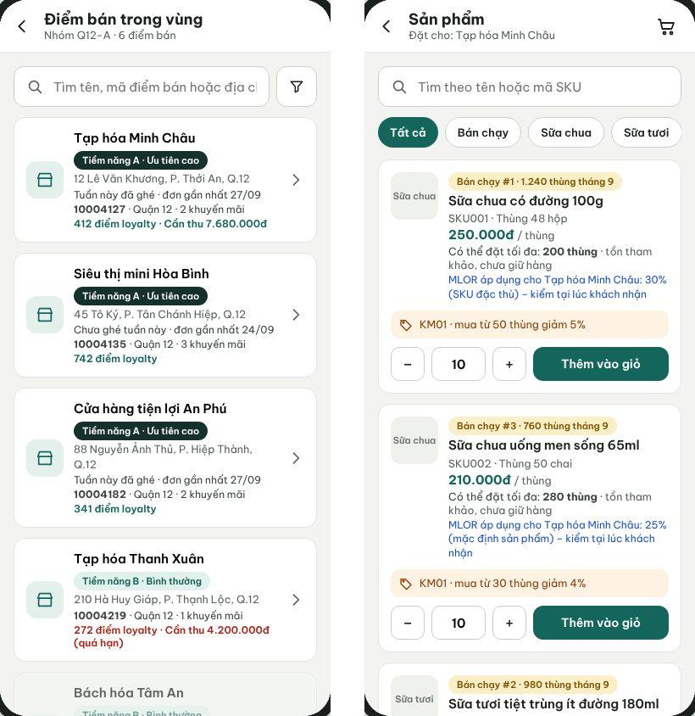
Figure 22. Sales App – Select retailer in area and add products to the order (FSCM_Prototype_Prod_v1.1)
● Function Details:
o Actors: Primary – Sales. System – Promotion Calculation, Order Quantity Limit, Sales Area Restriction (3.1.4).
o Fields:
▪ Retailer; line ID; SKU/quantity; line type; selected offer/version/price; effective MLOR; customer acceptance. Sales chooses neither a receive date nor a payment method; the Retailer chooses the payment method after the quotation (3.6.6).
o Data Processing:
▪ Validate retailer/sales assignment and product eligibility.
▪ Validate the line type and offer acceptance. Standard lines use ordinary campaign prices and default MLOR; offer lines use accepted offer conditions. Availability is indicative; no batch is promised.
▪ Queue offline orders with offer/version and acceptance details. Keep standard and offer lines separate even when their SKU is the same.
o Business Rules:
▪ Sales can create an order only within permitted retailer coverage.
▪ Published product information and prices cannot be edited in place.
o Acceptance Criteria:
AC ID | Acceptance criterion (Given / When / Then) | Ref.
AC-3.6.1-01 | Given an active retailer in the Sales user's area, when Sales submits an order online, then the server stores the server acceptance time and DH code, status Pending review, and no batch, Reserved quantity or payment is created (MSG026). | BR-20, BR-22, BR-24
AC-3.6.1-02 | Given a retailer outside the Sales area or not Active, when an order is submitted through the app or the API, then it is rejected with MSG006. | BR-20
AC-3.6.1-03 | Given an order, when it is created, then it carries no payment method and no receive date chosen by Sales. | BR-21
AC-3.6.1-04 | Given estimated prices on the device, when the server accepts the order, then prices and promotions are recalculated by the server and any difference is shown (MSG035). | BR-15
AC-3.6.1-05 | Given standard and offer lines of the same SKU, when the order is saved, then they remain separate lines with their own MLOR and price. | BR-29, BR-62
o Traceability: UC-21 | BR-11, BR-15, BR-20 – BR-24, BR-29 | CR-08, CR-10 | Screens: Select Retailer, Create Order

3.6.2 Synchronize Offline Purchase Orders
● Function type: Screen function (Sync Queue). Sales sends drafts manually; server validation of each sent order runs automatically – see Offline Order Synchronization in 3.1.4.
● Function trigger:
o Sales opens the Sync Queue while draft orders exist and the network is available.
o Sales taps Send; drafts are never sent automatically.
● Function description: Uploads locally saved orders and exposes their synchronization status.
● Screen layout: see Figure 23 (captured from the approved prototype FSCM_Prototype_Prod_v1.1).
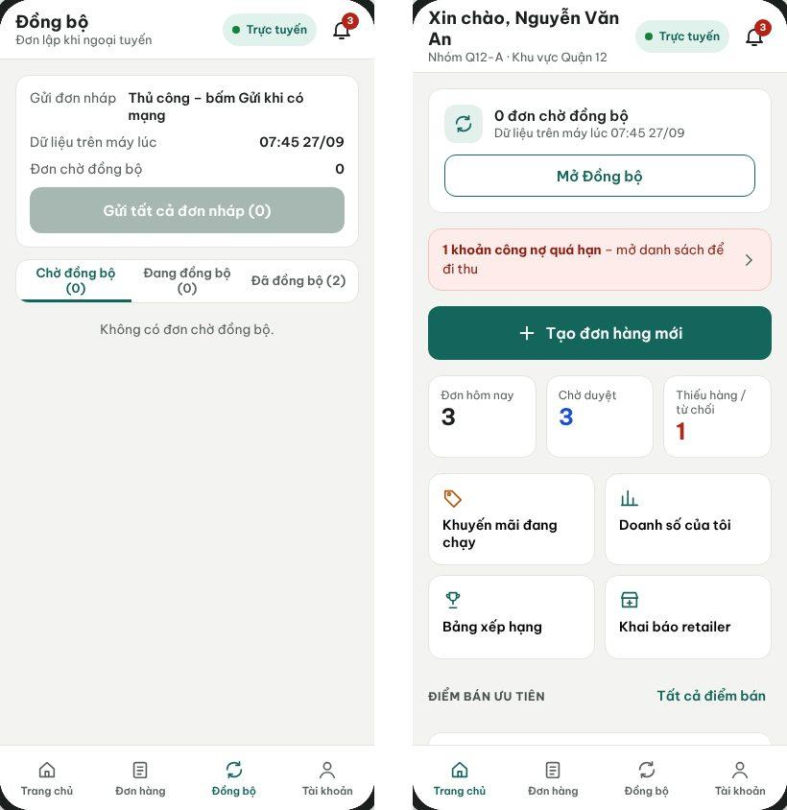
Figure 23. Sales App – Sync Queue (manual send) and home with sync status (FSCM_Prototype_Prod_v1.1)
● Function Details:
o Actors: Primary – Sales. System – Offline Order Synchronization (3.1.4).
o Fields:
▪ Local order identifier; sync status; server order reference / error.
o Data Processing:
▪ Transmit queued orders to the backend with idempotency protection.
▪ Revalidate retailer, product, prices, offer validity/version and acceptance. Accept valid orders for review without allocating or rejecting them solely for current stock shortage; shortage is determined by the daily run.
▪ Display accepted/rejected/conflict outcomes without silently overwriting local data.
o Business Rules:
▪ Server validation determines accepted conditions. Price is confirmed through the run; no silent price increase, offer substitution or MLOR reduction is allowed.
▪ Drafts are sent only when Sales taps Send. A failed send is retried manually with the same request code and never creates a duplicate order.
o Acceptance Criteria:
AC ID | Acceptance criterion (Given / When / Then) | Ref.
AC-3.6.2-01 | Given 3 offline drafts and restored connectivity, when Sales does not tap Send, then no draft is transmitted. | BR-23
AC-3.6.2-02 | Given a draft sent and the response lost, when Sales retries with the same request code, then exactly one order exists on the server and the same DH code is returned. | BR-23, CR-11, CR-12
AC-3.6.2-03 | Given a price or promotion changed after the draft was cached, when the draft is sent, then the server returns the changed conditions (MSG035) and the order is accepted only after Sales confirms them. | BR-15, BR-17
AC-3.6.2-04 | Given a draft accepted at 12:00 or later, when the run of that day starts, then the order is not included and waits for the next run; its priority is the server acceptance time, not the device time. | BR-24, BR-27
AC-3.6.2-05 | Given a network failure while sending, when the request does not complete, then the draft stays in Pending sync and the app never shows it as accepted (MSG034). | NFR-O02
o Traceability: UC-80, UC-81 | BR-15, BR-23, BR-24, BR-27 | CR-11, CR-12 | Screens: Sync Queue

3.6.3 Process Purchase Order Request
● Function type: Screen function (see 3.1.2).
● Function trigger:
o Open pending purchase order requests.
o Review and approve or reject the order.
● Function description: Reviews the commercial validity of an order before the daily cutoff; this is separate from approval of an allocation run.
● Screen layout: see Figure 24 (captured from the approved prototype FSCM_Prototype_Prod_v1.1).
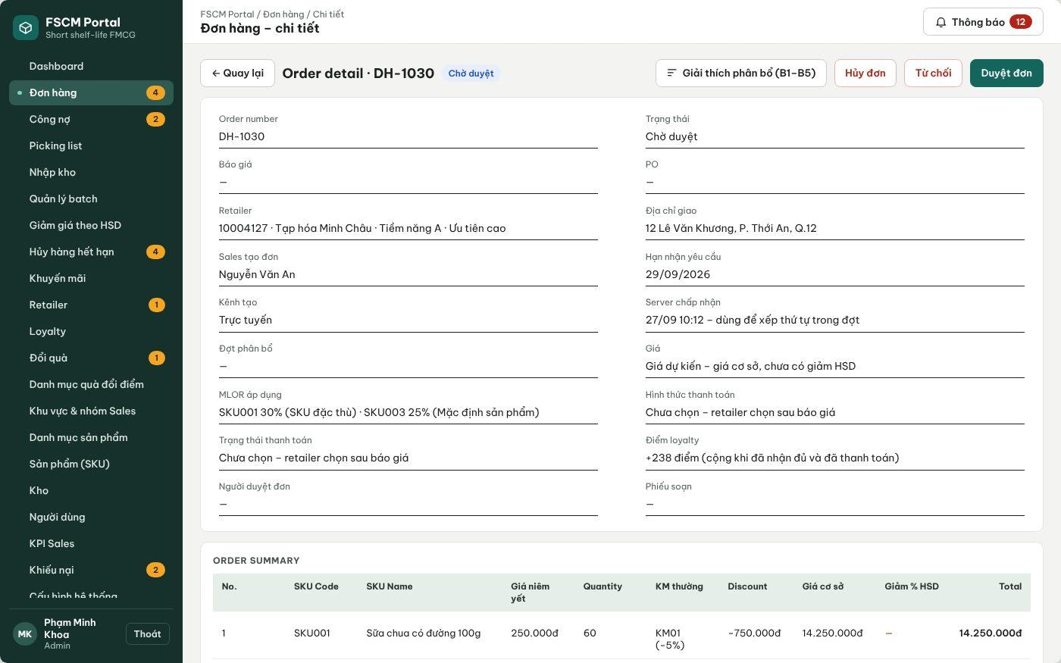
Figure 24. Web Portal – Order details with Approve / Reject before cutoff (FSCM_Prototype_Prod_v1.1)
● Function Details:
o Actors: Primary – Administrator, Operator (commercial review before cutoff). Secondary – Sales receives the result.
o Fields:
▪ Order lines, standard/offer conditions, payment eligibility, reviewer decision and reason.
o Data Processing:
▪ Validate retailer, order conditions, offer acceptance and assigned authority; no allocation or stock commitment is performed here.
▪ Approval changes the order to Awaiting allocation; no stock is reserved and no picking list is created.
▪ Rejection records a reason and notifies Sales; there is no order-submission hold to release.
o Business Rules:
▪ Only orders received and reviewed before cutoff are eligible for that run. Administrator run approval is required later under 3.7.2.
▪ The order and allocation-run review stages must be shown separately in status history.
o Acceptance Criteria:
AC ID | Acceptance criterion (Given / When / Then) | Ref.
AC-3.6.3-01 | Given an order in Pending review, when the reviewer approves it before 12:00, then its status becomes Awaiting allocation and Available stock is unchanged. | BR-22, BR-25, BR-41
AC-3.6.3-02 | Given a rejection without a reason, when it is submitted, then it is blocked; with a reason, Sales is notified with MSG028. | BR-25, BR-58
AC-3.6.3-03 | Given orders pending at 11:30, when the reminder time is reached, then Administrators and Operators receive a cutoff reminder. | BR-25
AC-3.6.3-04 | Given an order approved at 12:00 or later, when today's run starts, then it is not included. | BR-27
AC-3.6.3-05 | Given the status timeline of the order, when it is opened, then order review and allocation-run approval appear as separate entries with actor and time. | BR-58
o Traceability: UC-10, UC-12 | BR-22, BR-25, BR-27, BR-41, BR-58 | CR-13, CR-21 | Screens: Order List, Order Details

3.6.4 Cancel Purchase Order with Evidence
● Function type: Screen function (see 3.1.2).
● Function trigger:
o Open an eligible order and select Cancel.
o Enter the reason, attach evidence and confirm.
● Function description: Cancels an eligible order while preserving supporting images or files for audit.
● Screen layout: see Figure 25 (captured from the approved prototype FSCM_Prototype_Prod_v1.1).
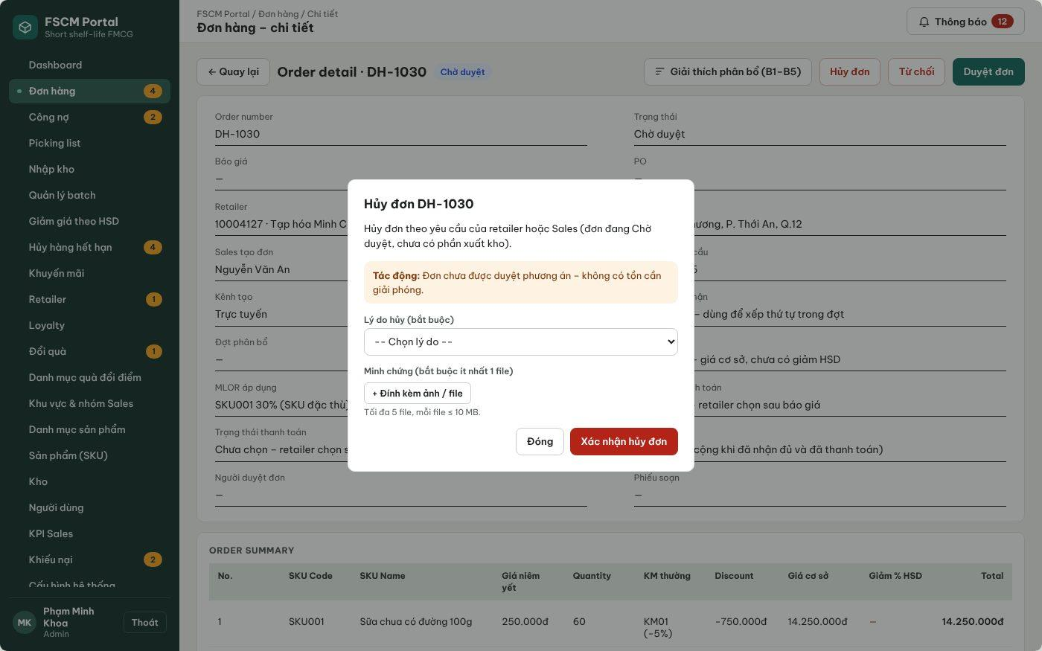
Figure 25. Web Portal – Cancel order with reason and evidence (FSCM_Prototype_Prod_v1.1)
● Function Details:
o Actors: Primary – Sales (before run inclusion). Secondary – Administrator/Operator (after reservation and before picking; Administrator only for warehouse exceptions before dispatch). System – Quotation Expiry (automatic cancellation).
o Fields:
▪ Order ID; cancellation reason; attachment(s).
o Data Processing:
▪ Verify permitted cancellation status and the user’s scope.
▪ Persist cancellation evidence metadata and file reference to object storage.
▪ Before run inclusion, cancel the order without stock movement. After reservation but before picking, release the reservation and affected picking/shipment records according to BR-26.
▪ A quotation rejected by the Retailer, or not accepted or not paid by its deadline, cancels the sales order automatically and releases its reserved stock (BR-51).
o Business Rules:
▪ Cancellation must be supported by evidence.
▪ Allowed states: Sales – Pending review or Awaiting allocation (before the run locks the order); Administrator/Operator – Awaiting quotation acceptance, Awaiting payment or PO before picking starts; Administrator – Needs handling before any shipment is dispatched (BR-26). Blocked in Allocating, Awaiting run approval and after any dispatch (MSG030). Evidence: 1 – 5 files, JPG/PNG/PDF, ≤ 5 MB each (MSG029, MSG049); reason at least 10 characters.
o Acceptance Criteria:
AC ID | Acceptance criterion (Given / When / Then) | Ref.
AC-3.6.4-01 | Given an order in Awaiting allocation, when Sales cancels it with a reason and one photo, then it becomes Cancelled, no stock movement occurs and the evidence is stored privately in Blob Storage. | BR-26, CR-14
AC-3.6.4-02 | Given an order locked in a running allocation run, when cancellation is requested, then it is rejected with MSG030. | BR-28
AC-3.6.4-03 | Given a prepaid order already verified and not yet picked, when the Operator cancels it, then the reservation is released and a full manual refund obligation is created. | BR-26, BR-66
AC-3.6.4-04 | Given an order with any dispatched shipment, when cancellation is requested, then it is blocked and the user is directed to the complaint/adjustment workflow. | BR-26
AC-3.6.4-05 | Given a 12 MB file or an .exe file, when it is attached, then it is rejected with MSG049. | NFR-S06
o Traceability: UC-78, UC-79 | BR-26, BR-28, BR-51, BR-66 | CR-14, CR-22 | Screens: Order Details – Cancel; Non-screen: Quotation Expiry

3.6.5 View Order Status and History
● Function type: Screen function (see 3.1.2).
● Function trigger:
o Open Order List or Order History.
o Select an order to inspect its status and timeline.
● Function description: Provides access to permitted historical orders, status transitions and fulfillment details.
● Screen layout: see Figures 26 – 27 (captured from the approved prototype FSCM_Prototype_Prod_v1.1).
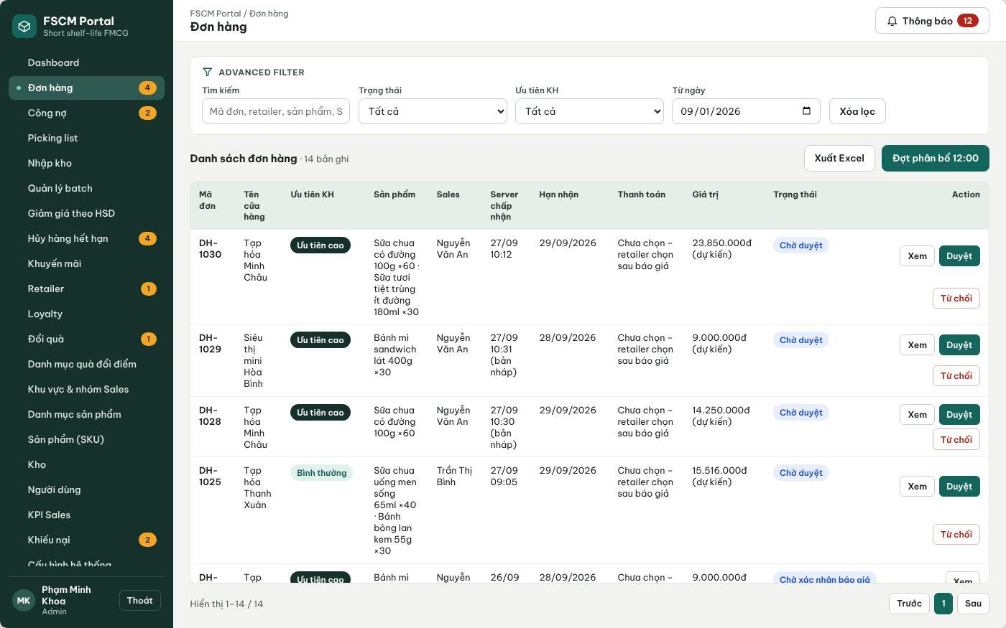
Figure 26. Web Portal – Order list with status filter and 12:00 run access (FSCM_Prototype_Prod_v1.1)
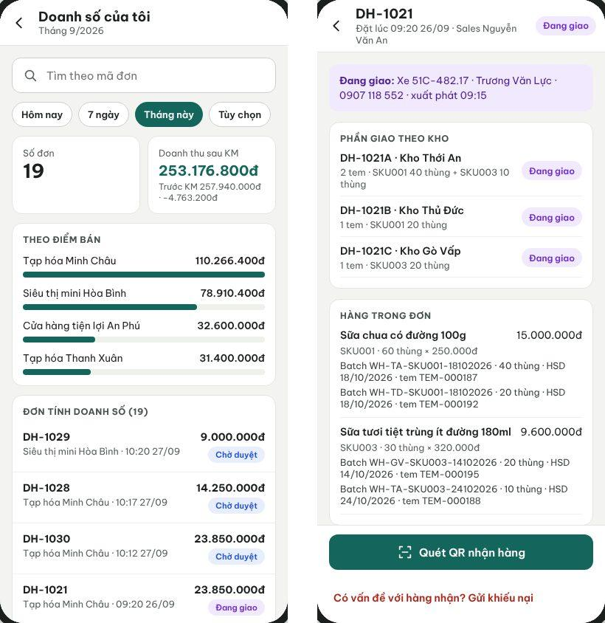
Figure 27. Sales App order history and Retailer order details with shipment status (FSCM_Prototype_Prod_v1.1)
● Function Details:
o Actors: Primary – Retailer (own orders), Sales (personal and sales-group orders), Sales Manager (team), Administrator and Operator (all orders).
o Fields:
▪ Order reference; items; prices after discount; status history; timestamps.
o Data Processing:
▪ Apply role-based visibility: own retailer / assigned sales scope / privileged management scope.
▪ Retrieve order records and display their recorded processing state.
o Business Rules:
▪ Do not expose unrelated retailers or orders to other Sales groups.
▪ Show Pending review, Awaiting allocation, Allocating, Awaiting run approval, Awaiting quotation acceptance, Awaiting payment, Converted to PO, Picking, Dispatched, Delivering, Delivered and Completed, plus rejected/short/cancelled/delivery failed/exception branches. Completed means delivered, fully settled and with no open complaint or pending refund.
o Acceptance Criteria:
AC ID | Acceptance criterion (Given / When / Then) | Ref.
AC-3.6.5-01 | Given a Sales user in group Q12-A, when the order list is requested, then only orders of the user and the group are returned; a request for another group's order returns MSG006. | BR-03
AC-3.6.5-02 | Given a Retailer, when the order list is opened, then only that retailer's orders are shown, with prices after discount and the status timeline. | BR-03, BR-04
AC-3.6.5-03 | Given an order delivered, fully settled and without open complaint or pending refund, when it is displayed, then its status is Completed; otherwise it remains Delivered. | BR-49
AC-3.6.5-04 | Given a product renamed by a new version, when an older order is opened, then the product name snapshot of the order is shown. | BR-19
o Traceability: UC-05, UC-22, UC-24, UC-83 | BR-03, BR-19, BR-49 | CR-10 | Screens: Order List, Order Details, Retailer Orders

3.6.6 Respond to Quotation and Choose Payment Method
● Function type: Screen function (Order Details, Choose Payment Method, Bank Transfer Payment – Mobile – Retailer; Verify Payment & Create PO – Web Portal). PO conversion and quotation expiry run automatically – see PO Conversion and Picking Release and Quotation Expiry in 3.1.4.
● Function trigger:
o Retailer opens the quotation notification or the Order Details of an order awaiting quotation acceptance.
o Accept or reject the quotation; after acceptance choose Prepaid – bank transfer or Credit.
● Function description: Lets the Retailer accept or reject the quotation sent after the Administrator approves the run, choose the payment method and send the transfer proof. The sales order becomes a purchase order (PO) only after this step, and only a PO is picked and delivered.
● Screen layout: see Figures 28 – 29 (captured from the approved prototype FSCM_Prototype_Prod_v1.1).
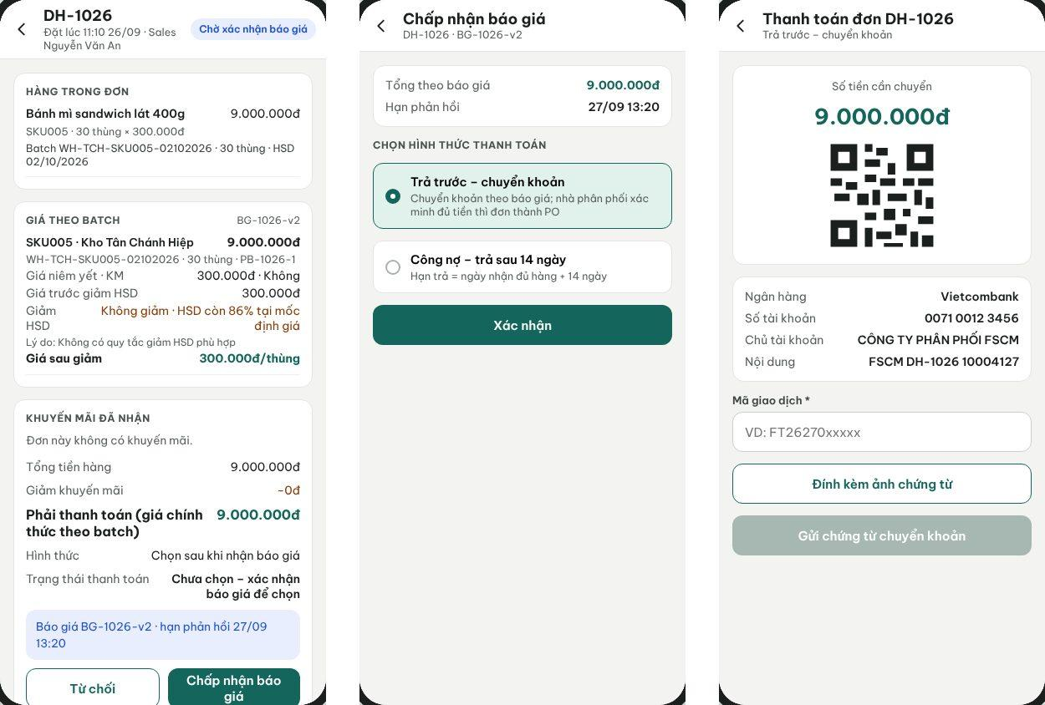
Figure 28. Retailer App – Quotation per batch, payment-method choice and bank-transfer proof (FSCM_Prototype_Prod_v1.1)
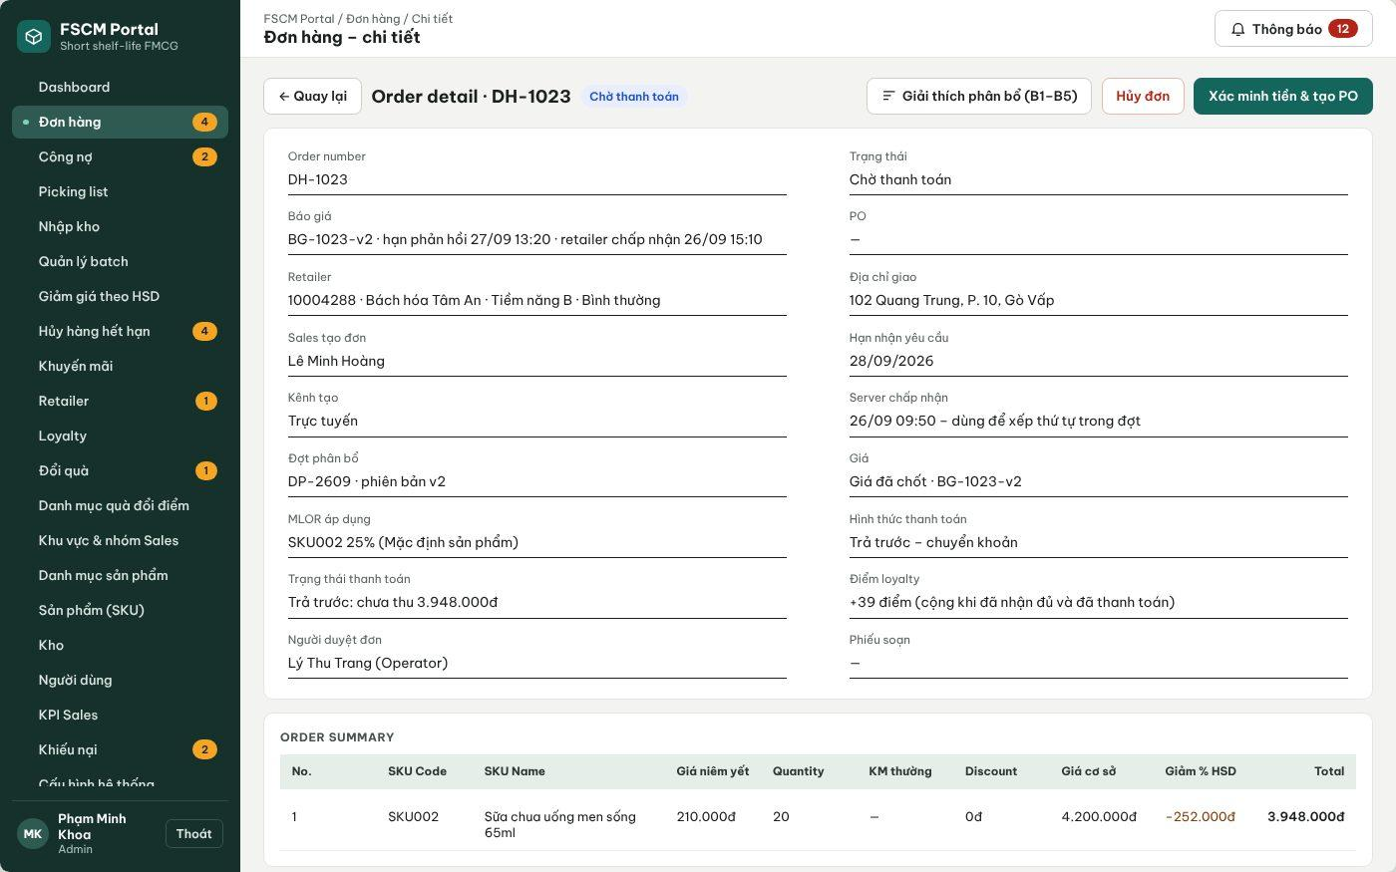
Figure 29. Web Portal – Verify payment and create PO (FSCM_Prototype_Prod_v1.1)
● Function Details:
o Actors: Primary – Retailer (accepts/rejects, chooses payment method, sends transfer proof). Secondary – Operator or Administrator verifies prepaid transfers. System – PO Conversion and Picking Release, Quotation Expiry (3.1.4).
o Fields:
▪ Quotation version and response deadline; final amount; payment method (Prepaid – bank transfer / Credit); transaction code; proof image; rejection reason.
o Data Processing:
▪ Accept the response only before the deadline (default 1 day from approval, never later than the last delivery date that still meets MLOR); choosing a payment method late does not extend it.
▪ Credit is offered only when the retailer has a payment term; choosing it converts the order into a PO at once.
▪ Prepaid: the Retailer sends the transaction code and proof image; the Operator verifies the funds against the quoted amount (Verify Payment & Create PO), then the order becomes a PO.
▪ On PO conversion create one picking slip per warehouse with duplicate protection. Rejection or expiry cancels the sales order and releases its reserved stock.
o Business Rules:
▪ COD and prepaid cash are not used. A newly registered retailer has no payment term and can only pay by prepaid bank transfer.
▪ Picking, dispatch and delivery apply only to POs (BR-45, BR-51, BR-66).
o Acceptance Criteria:
AC ID | Acceptance criterion (Given / When / Then) | Ref.
AC-3.6.6-01 | Given a quotation approved at 03/11 12:20 with n = 1 day and a latest valid delivery point of 04/11 12:00, when the deadline is computed, then it is 04/11 12:00. | BR-72
AC-3.6.6-02 | Given a retailer without a payment term, when the quotation is accepted, then only Prepaid – bank transfer is offered and a Credit request through the API is rejected. | BR-13, BR-73
AC-3.6.6-03 | Given Credit is chosen by an eligible retailer, when it is confirmed, then the order becomes a PO at once and one picking slip per warehouse is released exactly once. | BR-45, BR-51
AC-3.6.6-04 | Given Prepaid is chosen and proof is sent, when the Operator verifies 612,000 VND against a quotation of 612,000 VND, then the order becomes a PO; until then no picking slip exists. | BR-51, BR-66
AC-3.6.6-05 | Given the deadline passes without acceptance or verified payment, when the expiry job runs, then the sales order is cancelled, its reservation released, and money received later creates a refund obligation without reviving the order. | BR-51, BR-72
AC-3.6.6-06 | Given Accept is submitted twice, when the second request arrives, then one PO and one set of picking slips exist. | BR-38, BR-47
o Traceability: UC-34, UC-36, UC-16, UC-92 | BR-13, BR-45, BR-51, BR-66, BR-72, BR-73 | CR-13, CR-18 | Screens: Order Details, Choose Payment Method, Bank Transfer Payment, Verify Payment & Create PO

3.7 FEFO–MLOR Allocation & Availability

3.7.1 Allocate Inventory across Warehouses
● Function type: Non-screen function – runs automatically, no screen of its own (see Daily Order Consolidation (12:00) and Batch Allocation (B1–B5) in 3.1.4).
● Function trigger:
o The 12:00 daily job closes eligible orders or a proposal is sent back for recalculation.
● Function description: Prepares a tentative allocation across warehouses using hard eligibility checks followed by weighted scoring for each order line.
● Screen layout: Not applicable – non-screen function.
● Function Details:
o Actors: System – Daily Order Consolidation (12:00), Batch Allocation (B1–B5), Algorithm Evaluation (3.1.4). Secondary – Administrator triggers recalculation (3.7.2).
o Fields:
▪ Run/proposal revision; order priority; line ID/type; offer/version; effective MLOR; acceptance; batch/pool stock; distances; ETA/deadline; price.
o Data Processing:
▪ Group demand by SKU for candidate retrieval; process orders by server acceptance time and code using one shared tentative pool. Preserve distinct line conditions.
▪ Filter each line by SKU, expiry, pool stock, service distance, ETA/deadline and effective MLOR. Offer lines also require the accepted offer’s eligible batches and price/conditions.
▪ Score eligible batches S = 0.5fE + 0.3fD + 0.2fQ by default. Take min(pool stock, remaining line need); recalculate fQ and score after each take; break ties by batch code.
▪ Attempt direct one-level replacement under BR-35: at most 20 candidate alternative evaluations per short line, configurable finite limit. Log attempts and stop reason; no recursive chain. Return all tentative quantities if any line remains short.
o Business Rules:
▪ A higher MLOR or offer price does not change order priority. Tentative quantities are not Held or Reserved; Admin reviews the proposal before commitment.
▪ Distance-to-time mapping is configured using TransitTimeRule.
o Acceptance Criteria:
AC ID | Acceptance criterion (Given / When / Then) | Ref.
AC-3.7.1-01 | Given approved orders P1 (09:00), C1 (09:05), P2 (09:10) and SHORT (09:15), when the run starts at 12:00, then orders are processed in that order and one run AR-yyMMdd is created even if the job is triggered twice. | BR-24, BR-27, BR-28
AC-3.7.1-02 | Given SHORT needs B: 4 and only 2 eligible cartons remain, when the line cannot be filled, then all tentative quantities of SHORT (including line A) return to the pool and the order is Insufficient stock in run (MSG025). | BR-36, CR-09
AC-3.7.1-03 | Given P1 line A needs 6 and batches A1 (S = 0.823, pool 4) and A2 (S = 0.636), when the line is filled, then A1: 4 is taken, fQ and S are recalculated, and A2: 2 is taken. | BR-33, BR-34
AC-3.7.1-04 | Given a batch beyond Dmax = 20 km, expired, locked, or with EXP − ETA below the effective MLOR duration, when candidates are filtered, then it is excluded with a logged reason (MSG022 – MSG024). | BR-31, BR-61, BR-71
AC-3.7.1-05 | Given the run finishes, when its result is stored, then no OnHand or Reserved value has changed and a strict-FEFO comparison on the same eligible data is recorded. | BR-22, BR-41, NFR-D06
o Traceability: UC-85 (input) | BR-24, BR-27 – BR-36, BR-40, BR-71 | CR-07 – CR-09 | Non-screen: Daily Order Consolidation, Batch Allocation, Algorithm Evaluation

3.7.2 Review Run Proposals and Commit Reservations
● Function type: Screen function (Allocation Run Details). Revalidation, stock reservation and sending the quotation after approval run automatically – see Proposal Approval, Reservation and Quotation in 3.1.4.
● Function trigger:
o A complete daily proposal is ready for Administrator review.
● Function description: Reviews complete/short results and commits reservations only after revalidation of the approved proposal revision.
● Screen layout: see Figures 30 – 31 (captured from the approved prototype FSCM_Prototype_Prod_v1.1).
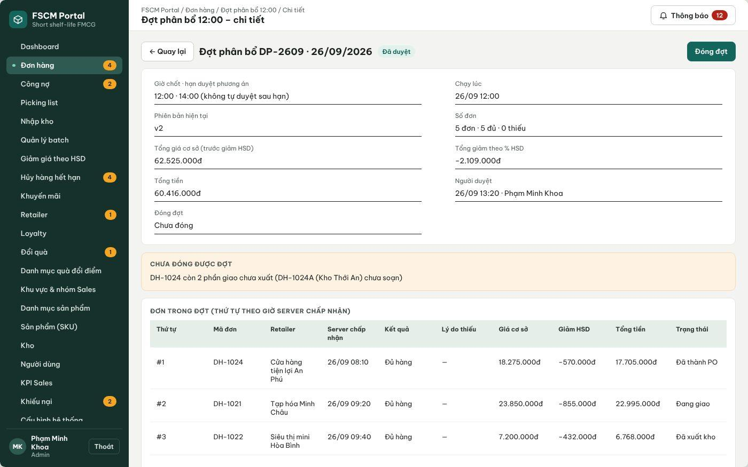
Figure 30. Web Portal – Allocation run details: complete/short orders, base price, shelf-life discount and totals (FSCM_Prototype_Prod_v1.1)
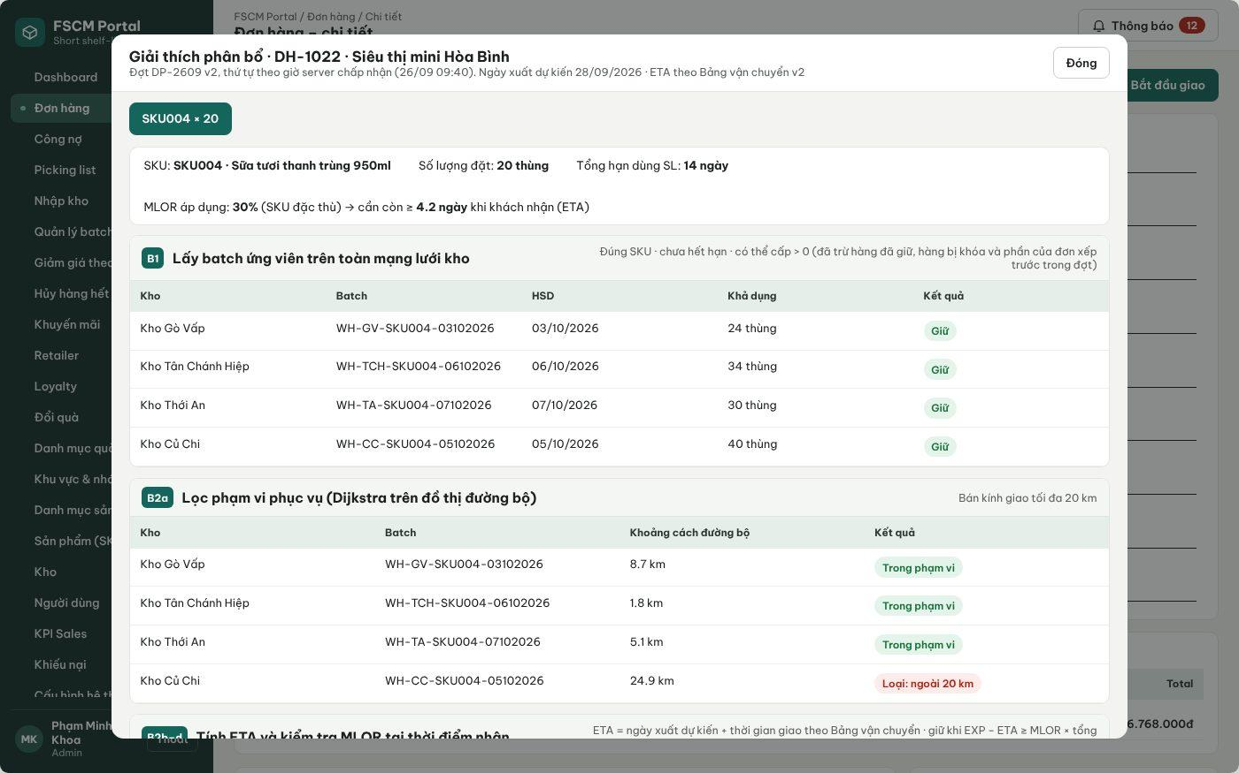
Figure 31. Web Portal – Allocation explanation per order line (B1–B5) (FSCM_Prototype_Prod_v1.1)
● Function Details:
o Actors: Primary – Administrator (approve or request recalculation; no other role may approve a run). System – Proposal Approval, Reservation and Quotation (3.1.4).
o Fields:
▪ Run code/revision, complete and short orders, selected batches/warehouses, line MLOR/offer/price, replacement trace, reviewer decision/reason.
o Data Processing:
▪ Administrator approves or requests recalculation. Recheck stock/version, batch status, ETA at approval time, effective MLOR, offer eligibility/validity and customer acceptance.
▪ If the plan or accepted conditions must change, create a revised proposal for review; never reserve a changed plan under an earlier approval.
▪ Atomically reserve all complete orders and record the approved revision. Then send each Retailer a versioned quotation with a response deadline; picking lists and shipments are released only when the order becomes a PO (3.6.6). On failure rollback and retry within the configured limit; repeated approval is idempotent.
o Business Rules:
▪ Available = OnHand − Reserved. Tentative proposals do not change availability. Reservation changes only on run commitment; physical stock changes on dispatch.
▪ Keep one daily run, revision history and finite retries. Reminders and review deadline are configuration; overdue proposals remain unapproved and require updated ETA checks.
o Acceptance Criteria:
AC ID | Acceptance criterion (Given / When / Then) | Ref.
AC-3.7.2-01 | Given a proposal revision under review, when the Administrator approves it and revalidation passes, then all complete orders are reserved in one transaction, Reserved increases by the proposed quantities and versioned quotations with deadlines are sent. | BR-37, BR-38, BR-41
AC-3.7.2-02 | Given stock or batch status changed after the proposal was made, when Approve is selected, then nothing is reserved, MSG053 is shown and a new revision must be reviewed. | BR-38, BR-64
AC-3.7.2-03 | Given Approve is pressed twice or retried after a timeout, when the requests are processed, then reservations and quotations exist once. | BR-38
AC-3.7.2-04 | Given no decision by 14:00, when the deadline passes, then the run stays unapproved, a reminder was sent at 13:30, and ETA is rechecked at approval time. | BR-37
AC-3.7.2-05 | Given an Operator account, when the approve endpoint is called, then MSG006 is returned. | BR-37, CR-01
o Traceability: UC-85 | BR-17, BR-37, BR-38, BR-40, BR-41, BR-64, BR-72 | CR-13 | Screens: Allocation Run List, Allocation Run Details; Non-screen: Proposal Approval, Reservation and Quotation

3.7.3 Estimate Receipt Time by Distance Band
● Function type: Non-screen function – runs automatically, no screen of its own (see Batch Allocation (B1–B5), step B2 in 3.1.4).
● Function trigger:
o A warehouse/batch is evaluated for an order.
● Function description: Calculates a configured approximate receipt time needed by service eligibility and MLOR verification.
● Screen layout: Not applicable – non-screen function.
● Function Details:
o Actors: System – Batch Allocation step B2 (3.1.4). Secondary – Administrator maintains the transit table (3.12.1).
o Fields:
▪ Service distance; configured band; transit/handling time estimate.
o Data Processing:
▪ Select matching admin-configured TransitTimeRule distance band.
▪ Compute estimated arrival from the applicable operational estimate.
▪ Use the estimate for checking MLOR and commitment eligibility.
o Business Rules:
▪ The estimate is not a guaranteed delivery time.
▪ Bands (BR-32): 0 – 10 km = 1 day; > 10 – 20 km = 2 days; > Dmax (default 20 km) = not served. Distance is the shortest road distance between warehouse and retailer locations (3.12.1). Dispatch slots, picking preparation and buffer times are SystemConfiguration values; the MVP uses one dispatch slot per day and no holiday calendar. The table version used is stored on the order line as a snapshot.
o Acceptance Criteria:
AC ID | Acceptance criterion (Given / When / Then) | Ref.
AC-3.7.3-01 | Given a retailer 10.0 km from a warehouse, when ETA is computed, then the 1-day band is used; at 10.1 km the 2-day band is used. | BR-32
AC-3.7.3-02 | Given a retailer 20.1 km away, when the warehouse is evaluated, then it is excluded as not served (MSG024). | BR-31, BR-32
AC-3.7.3-03 | Given the transit table is changed after an order was allocated, when the order is reviewed, then the stored table version remains on the order line. | BR-32, BR-57
o Traceability: UC-85 (input) | BR-31, BR-32, BR-57 | Non-screen: Batch Allocation (B2)

3.7.4 Effective Line MLOR and Offer Validation
● Function type: Non-screen function – runs automatically, no screen of its own (see Effective MLOR Resolution in 3.1.4).
● Function trigger:
o Each order line is evaluated in a run, at recalculation and again at run approval.
● Function description: Determines the effective MLOR of each order line and checks every candidate batch portion against it at the estimated time of receipt.
● Screen layout: Not applicable – non-screen function.
● Function Details:
o Actors: System – Effective MLOR Resolution, Batch Allocation (B3). Secondary – Administrator sees the result in the allocation explanation (3.7.2).
o Fields:
▪ Line type; retailer SKU MLOR; retailer Category MLOR; product default MLOR; accepted offer ratio and version; product shelf life SL; batch EXP; ETA.
o Data Processing:
▪ Determine the effective ratio before filtering: standard or ordinary-campaign line → retailer SKU ratio, else retailer Category ratio (nearest ancestor), else product default; explicitly accepted near-expiry-offer line → the Admin-configured ratio in that offer version.
▪ Check EXP − ETA ≥ effective ratio × SL. ETA includes waiting for the run/review, preparation, buffer, dispatch slots and transit. Do not compare days directly with a percentage.
▪ Filter offer lines to batches eligible for their chosen offer, price and validity, then score. At review-time ETA changes, repeat these checks and obtain renewed review if the proposal changes.
▪ Example: SL 100 days, remaining life 70 days, ETA in 2 days → 68% remaining on receipt. A standard MLOR of 80% rejects the batch; an accepted 60% offer MLOR passes the life check; other eligibility checks still apply. The discount percentage does not determine either ratio.
o Business Rules:
▪ BR-11, BR-18, BR-31, BR-59 – BR-64 apply.
o Acceptance Criteria:
AC ID | Acceptance criterion (Given / When / Then) | Ref.
AC-3.7.4-01 | Given retailer R2 with Category 30% and SKU_A 80%, when an SKU_A standard line is evaluated, then the effective MLOR is 80% and its source 'SKU' is stored. | BR-11
AC-3.7.4-02 | Given a retailer with no SKU or Category MLOR, when a line is evaluated, then the product default MLOR is used. | BR-11
AC-3.7.4-03 | Given SL = 20 days, MLOR = 30% and EXP − ETA = exactly 6.0 days, when the batch is checked, then it is eligible (equality passes); at 5.9 days it is rejected (MSG022). | BR-61
AC-3.7.4-04 | Given ETA moves later between proposal and approval so a batch no longer passes, when the Administrator approves, then the proposal is not reserved and a new revision is required. | BR-38, BR-61
AC-3.7.4-05 | Given an offer line without recorded acceptance, when it is evaluated, then the standard MLOR is not replaced by the offer ratio and the line is flagged (MSG051). | BR-60
o Traceability: UC-85, UC-86, UC-87 | BR-11, BR-18, BR-31, BR-59 – BR-64 | CR-08 | Non-screen: Effective MLOR Resolution

3.8 Warehouse Receiving & Batch Inventory

3.8.1 Create and Process Goods Receipt
● Function type: Screen function (see 3.1.2).
● Function trigger:
o Open Goods Receiving or a stock-in request.
o Enter or confirm received goods and batch details.
● Function description: Records warehouse stock-in with traceable product, batch, expiry and quantity information.
● Screen layout: see Figures 32 – 33 (captured from the approved prototype FSCM_Prototype_Prod_v1.1).
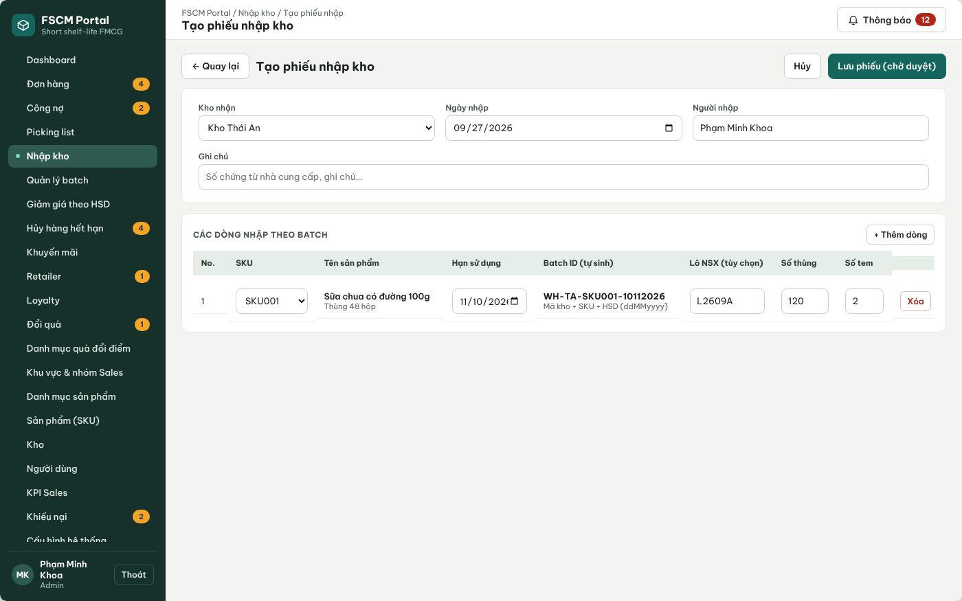
Figure 32. Web Portal – Create goods receipt (pending approval) (FSCM_Prototype_Prod_v1.1)
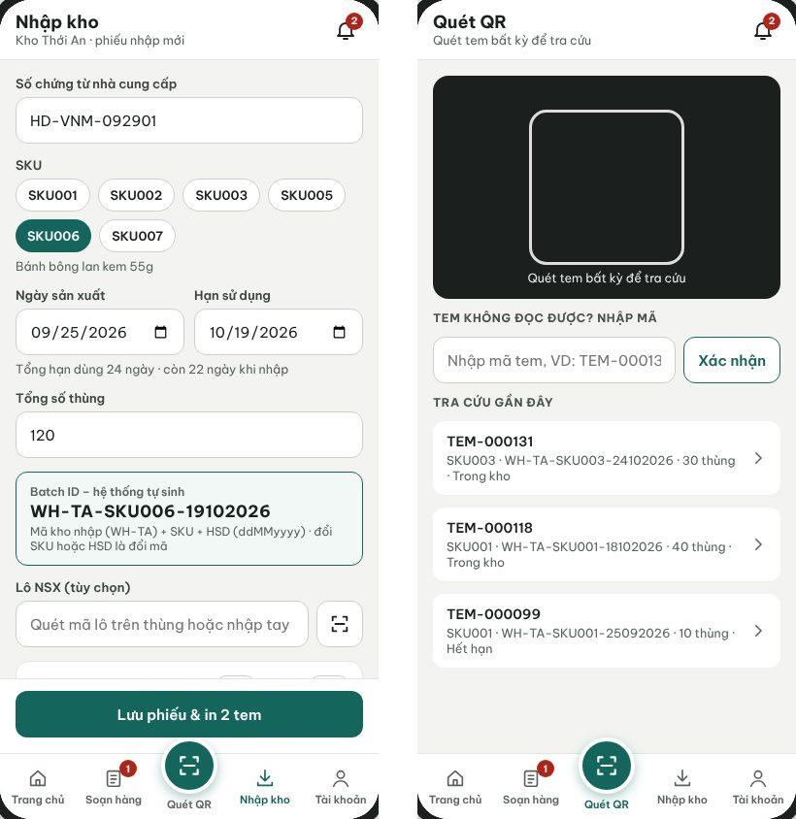
Figure 33. Warehouse App – Goods receipt with generated Batch ID and QR label lookup (FSCM_Prototype_Prod_v1.1)
● Function Details:
o Actors: Primary – Warehouse Keeper (creates receipts for assigned warehouses). Secondary – Administrator (creates receipts for any warehouse and approves). System – Batch and Label Generation (3.1.4).
o Fields:
▪ Warehouse; product name and SKU; batch identifier; expiration; received quantity.
o Data Processing:
▪ Validate the receiving request and input details.
▪ Create a receipt and receipt lines with the product name visible on the receiving slip.
▪ Post accepted quantities to batch-level inventory and preserve receipt history.
o Business Rules:
▪ Receiving and inventory balances must be traceable by Batch and warehouse.
▪ Workflow: Draft → Pending approval (submitted, MSG017) → Approved (MSG018) or Rejected with reason. OnHand changes only on approval, exactly once. The keeper records the actually counted quantity; a difference from the supplier document is entered as a note and only the counted quantity is posted. Production date must be before expiry and not in the future (MSG016). Receipts with the same warehouse, SKU and expiry are merged into one batch (BR-09).
o Acceptance Criteria:
AC ID | Acceptance criterion (Given / When / Then) | Ref.
AC-3.8.1-01 | Given a submitted receipt of 120 cartons SKU006 with expiry 19/10/2026 at WH-TA, when the Administrator approves it, then OnHand of batch WH-TA-SKU006-19102026 increases by 120 once and QR labels are generated. | BR-09, BR-10, BR-42
AC-3.8.1-02 | Given a receipt still Pending approval, when inventory is viewed, then OnHand has not changed. | BR-42
AC-3.8.1-03 | Given Approve is clicked twice, when both requests are processed, then stock increases only once. | CR-07
AC-3.8.1-04 | Given a second receipt with the same warehouse, SKU and expiry, when it is approved, then it is added to the existing batch rather than creating a new one. | BR-09
AC-3.8.1-05 | Given a Warehouse Keeper of WH-TA, when a receipt for WH-GV is submitted, then it is rejected with MSG006. | BR-03
o Traceability: UC-04, UC-06, UC-11 | BR-03, BR-06, BR-09, BR-10, BR-42 | CR-04, CR-05, CR-16 | Screens: Goods Receipt List, Create Goods Receipt, Warehouse App Receive

3.8.2 View Warehouse Inventory and Batch Details
● Function type: Screen function (see 3.1.2).
● Function trigger:
o Open Warehouse Inventory or scan a batch QR.
● Function description: Displays stock balance, batch expiry, current status and eligible quantities.
● Screen layout: see Figure 34 (captured from the approved prototype FSCM_Prototype_Prod_v1.1).
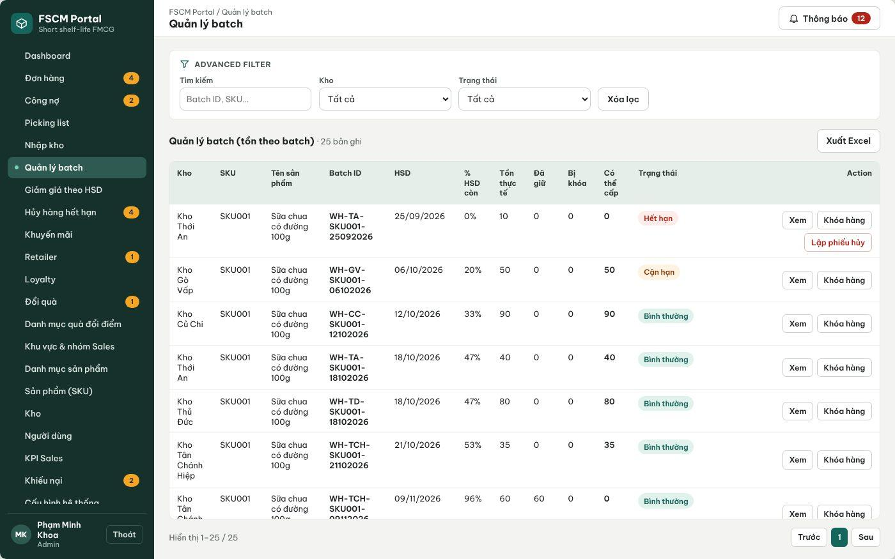
Figure 34. Web Portal – Batch management: OnHand, Reserved, Locked, Available and near-expiry status (FSCM_Prototype_Prod_v1.1)
● Function Details:
o Actors: Primary – Warehouse Keeper (assigned warehouses), Administrator (all warehouses). System – Expired Batch Detection (3.1.4).
o Fields:
▪ Warehouse; SKU; Batch ID; expiry; OnHand, Reserved and Available; no stock Held stage in this design.
o Data Processing:
▪ Scope inventory query to authorized warehouses.
▪ Retrieve batch-level balances and relevant receiving history.
o Business Rules:
▪ Available excludes reservations. Tentative allocations are visible separately and do not reduce inventory balances.
▪ Stock lock (BR-71): a Warehouse Keeper or Administrator may lock a damaged or otherwise unusable quantity of a batch with reason and evidence; Available = OnHand − Reserved − Locked. Locking does not reduce OnHand; locked stock leaves the warehouse only through an approved write-off (3.8.3); only the Administrator can unlock.
o Acceptance Criteria:
AC ID | Acceptance criterion (Given / When / Then) | Ref.
AC-3.8.2-01 | Given batch OnHand 50, Reserved 20 and Locked 5, when it is displayed, then Available shows 25. | BR-41, BR-71
AC-3.8.2-02 | Given a lock that overlaps quantity already reserved for an order, when it is saved, then that order is set to Needs handling and no shipment of it can be dispatched. | BR-46, BR-71
AC-3.8.2-03 | Given a batch past its expiry date, when the daily detection job runs, then the batch is marked Expired and excluded from allocation and dispatch (MSG019). | BR-43
AC-3.8.2-04 | Given a run proposal awaiting approval, when inventory is viewed, then tentative quantities are shown separately and Available is unchanged. | BR-22, BR-41
AC-3.8.2-05 | Given a Warehouse Keeper, when inventory of an unassigned warehouse is requested, then MSG006 is returned. | BR-03
o Traceability: UC-30, UC-33 | BR-03, BR-41, BR-43, BR-71 | CR-07 | Screens: Batch Management, QR Lookup; Non-screen: Expired Batch Detection

3.8.3 Manage Warehouse Inventory Write-Off
● Function type: Screen function (see 3.1.2).
● Function trigger:
o Open Write-off Management.
o Create a write-off with affected batches, reason and supporting evidence.
o An authorized reviewer processes the submitted request.
● Function description: Records proposed removal of unusable or expired batch stock with supporting files.
● Screen layout: see Figures 35 – 36 (captured from the approved prototype FSCM_Prototype_Prod_v1.1).
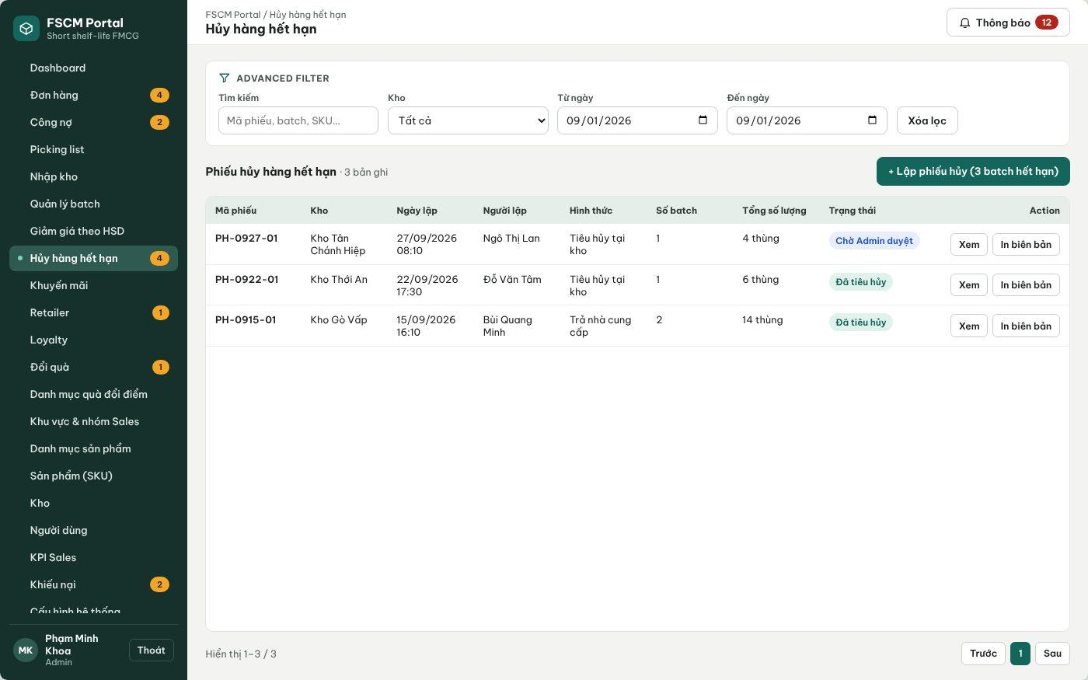
Figure 35. Web Portal – Write-off records (FSCM_Prototype_Prod_v1.1)
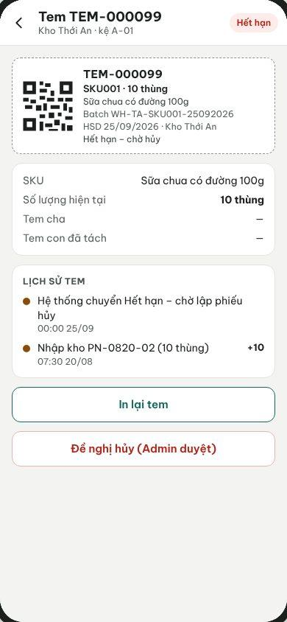
Figure 36. Warehouse App – Expired label with Request write-off (Admin approval) (FSCM_Prototype_Prod_v1.1)
● Function Details:
o Actors: Primary – Warehouse Keeper (creates and submits). Secondary – Administrator (approves or rejects; may also create). System – Write-off Posting (3.1.4).
o Fields:
▪ Affected Batch ID; quantity; reason; evidence attachment; approval status.
o Data Processing:
▪ Validate batch ownership, status and available quantity.
▪ Save request, supporting evidence and audit details.
▪ Apply approved stock reductions while preserving movement traceability.
o Business Rules:
▪ Requests for unapproved write-off must not silently alter confirmed stock balances.
▪ States: Draft → Pending Admin approval → Approved (stock deducted) or Rejected (reason required). Only the Administrator approves. The quantity may not exceed the batch's OnHand − Reserved (locked or expired quantity may be written off); a quantity still reserved must first be released through the order exception flow (MSG047). Disposal method (destroy at warehouse / return to supplier) and evidence are mandatory.
o Acceptance Criteria:
AC ID | Acceptance criterion (Given / When / Then) | Ref.
AC-3.8.3-01 | Given a Pending write-off of 4 cartons, when the Administrator approves it, then OnHand decreases by 4 exactly once and any matching locked quantity is cleared (MSG048). | BR-44, BR-71
AC-3.8.3-02 | Given a write-off quantity greater than OnHand − Reserved, when it is submitted, then it is rejected with MSG047. | BR-44, CR-16
AC-3.8.3-03 | Given a Rejected write-off, when inventory is viewed, then no stock quantity has changed. | BR-44
AC-3.8.3-04 | Given a write-off without evidence, when it is submitted, then it is blocked (MSG001). | BR-44, CR-16
o Traceability: UC-65 – UC-70 | BR-43, BR-44, BR-58, BR-71 | CR-16, CR-22 | Screens: Write-off List, Write-off Details; Non-screen: Write-off Posting

3.9 Picking & Retailer Receipt Confirmation

3.9.1 Scan Batch QR and Confirm Picking List
● Function type: Screen function (see 3.1.2).
● Function trigger:
o Open an assigned warehouse picking list.
o Scan the source batch QR and enter the actual picked quantity.
o Confirm completion of the picking list.
● Function description: Fulfills a warehouse picking list by recording actual batch quantities rather than generating a separate Goods Issue document.
● Screen layout: see Figures 37 – 38 (captured from the approved prototype FSCM_Prototype_Prod_v1.1).
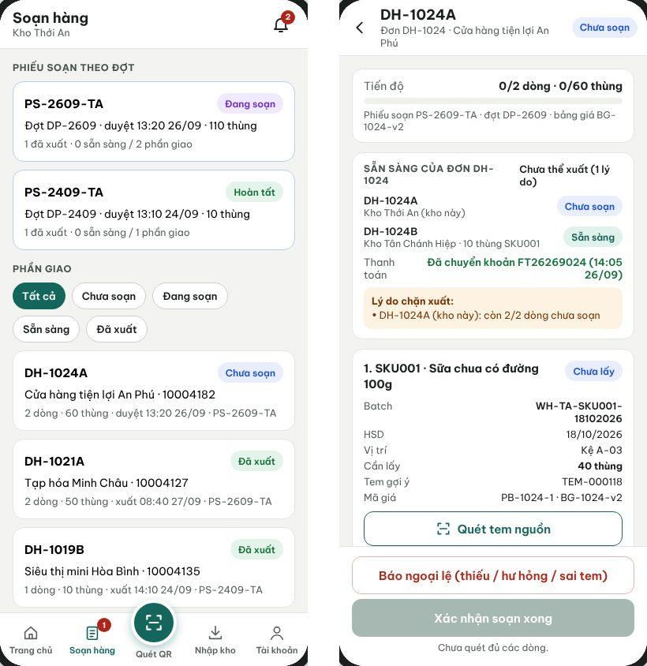
Figure 37. Warehouse App – Picking slips by run and order portion with source-label scan (FSCM_Prototype_Prod_v1.1)
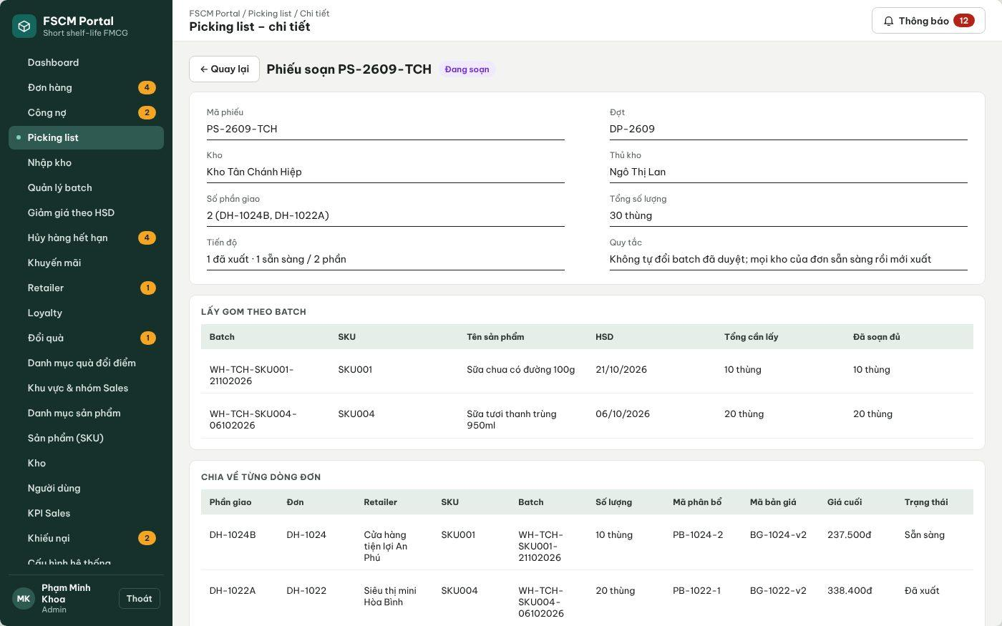
Figure 38. Web Portal – Picking slip by warehouse (FSCM_Prototype_Prod_v1.1)
● Function Details:
o Actors: Primary – Warehouse Keeper of the warehouse. Secondary – Administrator resolves picking exceptions. System – Portion Ready Confirmation, Dispatch Readiness Check, Dispatch Posting, Label Split (3.1.4).
o Fields:
▪ Picking list item; source batch QR; actual picked quantity; stock-out batch QR.
o Data Processing:
▪ Validate scanned Batch ID against the assigned PickingItem.
▪ When part of a batch is picked, preserve remaining stock and issue a traceable stock-out batch / QR as needed.
▪ Record picking readiness per shipment, check readiness of all warehouse portions, then record idempotent dispatch confirmation to reduce Reserved and OnHand. A picking scan alone does not issue stock.
o Business Rules:
▪ Picking completion marks readiness. Only authorized dispatch confirmation after all warehouse portions are ready records stock-out; repeated confirmation does not deduct twice.
▪ Mismatch: a scan may not exceed the listed quantity and must match warehouse, batch and picking list (MSG038). If fewer cartons can be picked (shortage, damage, wrong label), the keeper records an exception; the order becomes Needs handling, no warehouse ships its portion, and the Administrator either resolves it or cancels the order as an exception before dispatch with a refund obligation if paid (BR-26, BR-46). The keeper cannot substitute another batch.
o Acceptance Criteria:
AC ID | Acceptance criterion (Given / When / Then) | Ref.
AC-3.9.1-01 | Given an order that is not yet a PO, when picking slips are listed, then it does not appear. | BR-45
AC-3.9.1-02 | Given a listed quantity of 40 from label TEM-000118, when the keeper scans a label of another batch, then the scan is rejected with MSG038. | BR-45
AC-3.9.1-03 | Given 10 cartons picked from a 40-carton label, when the scan is confirmed, then a child label of 10 is created linked to the parent and the parent keeps 30. | BR-10, CR-05
AC-3.9.1-04 | Given portion W1 Ready and W2 not Ready, when dispatch of W1 is requested, then it is blocked. | BR-46
AC-3.9.1-05 | Given dispatch is confirmed twice for the same shipment, when processed, then OnHand and Reserved decrease once by the dispatched quantity. | BR-41, BR-47
o Traceability: UC-31, UC-32 | BR-10, BR-26, BR-41, BR-45 – BR-47 | CR-05, CR-07, CR-13 | Screens: Picking Lists, Picking Details; Non-screen: Portion Ready Confirmation, Dispatch Posting

3.9.2 Confirm Retailer Receipt by QR
● Function type: Screen function (see 3.1.2).
● Function trigger:
o Open an order receipt confirmation.
o Scan the issued stock-out batch QR and confirm received quantity.
● Function description: Reconciles actually received quantities with the batch identifiers issued by the warehouse.
● Screen layout: see Figure 39 (captured from the approved prototype FSCM_Prototype_Prod_v1.1).
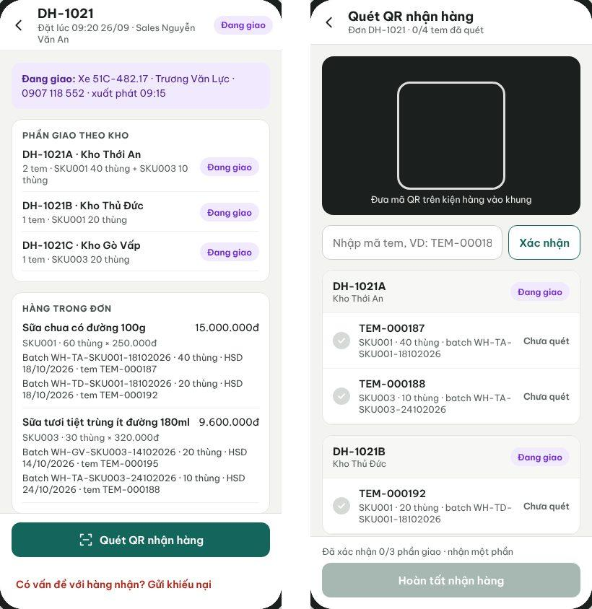
Figure 39. Retailer App – Delivering order with shipments and QR receipt scan (FSCM_Prototype_Prod_v1.1)
● Function Details:
o Actors: Primary – Retailer. System – Receipt Validation, Order Completion (3.1.4).
o Fields:
▪ Order; QR label / stock-out Batch ID; received quantity.
o Data Processing:
▪ Check QR label matches a batch issued for the order.
▪ Record receipt confirmation items and compare to the completed picking result.
▪ Preserve mismatch details for any discrepancy workflow.
o Business Rules:
▪ Do not create retail-store inventory.
▪ Receipt is confirmed per shipment. For each line/batch the Retailer enters received and damaged quantities with 0 ≤ damaged ≤ received ≤ dispatched; missing = dispatched − received. A shipment is confirmed once; scanning the same label again in a session is ignored and a repeated submission returns the existing confirmation. Any missing or damaged quantity keeps the actual figures and prompts a complaint (3.9.3).
o Acceptance Criteria:
AC ID | Acceptance criterion (Given / When / Then) | Ref.
AC-3.9.2-01 | Given an order with shipments W1 and W2, when only W1 is confirmed, then the order is not Delivered; it becomes Delivered when W2 is also confirmed and the confirmation date is stored. | BR-49
AC-3.9.2-02 | Given a label issued for another retailer's order, when it is scanned, then it is rejected. | BR-49, CR-17
AC-3.9.2-03 | Given dispatched 30, received 28 and damaged 0, when the shipment is confirmed, then missing = 2 is recorded and the Retailer is prompted to file a complaint. | BR-50
AC-3.9.2-04 | Given damaged 3 and received 2, when submitted, then it is rejected because damaged cannot exceed received. | CR-17
AC-3.9.2-05 | Given a confirmation resent after a network error, when processed, then no second receipt, payment due date or loyalty event is created. | BR-47, BR-54
o Traceability: UC-26 | BR-49, BR-50, BR-52, BR-54 | CR-17 | Screens: Retailer Order Details, Scan QR Receipt; Non-screen: Receipt Validation

3.9.3 Report Receipt Discrepancy
● Function type: Screen function (see 3.1.2).
● Function trigger:
o Open a received order and select Report Issue.
o Provide quantity/condition and evidence; authorized staff process the report.
● Function description: Reports missing/damaged goods without automatically changing the recorded delivery outcome.
● Screen layout: see Figures 40 – 41 (captured from the approved prototype FSCM_Prototype_Prod_v1.1).
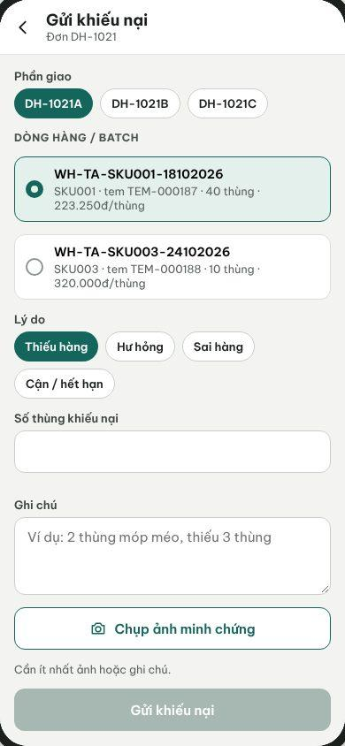
Figure 40. Retailer App – Submit complaint by shipment, line/batch and reason (FSCM_Prototype_Prod_v1.1)
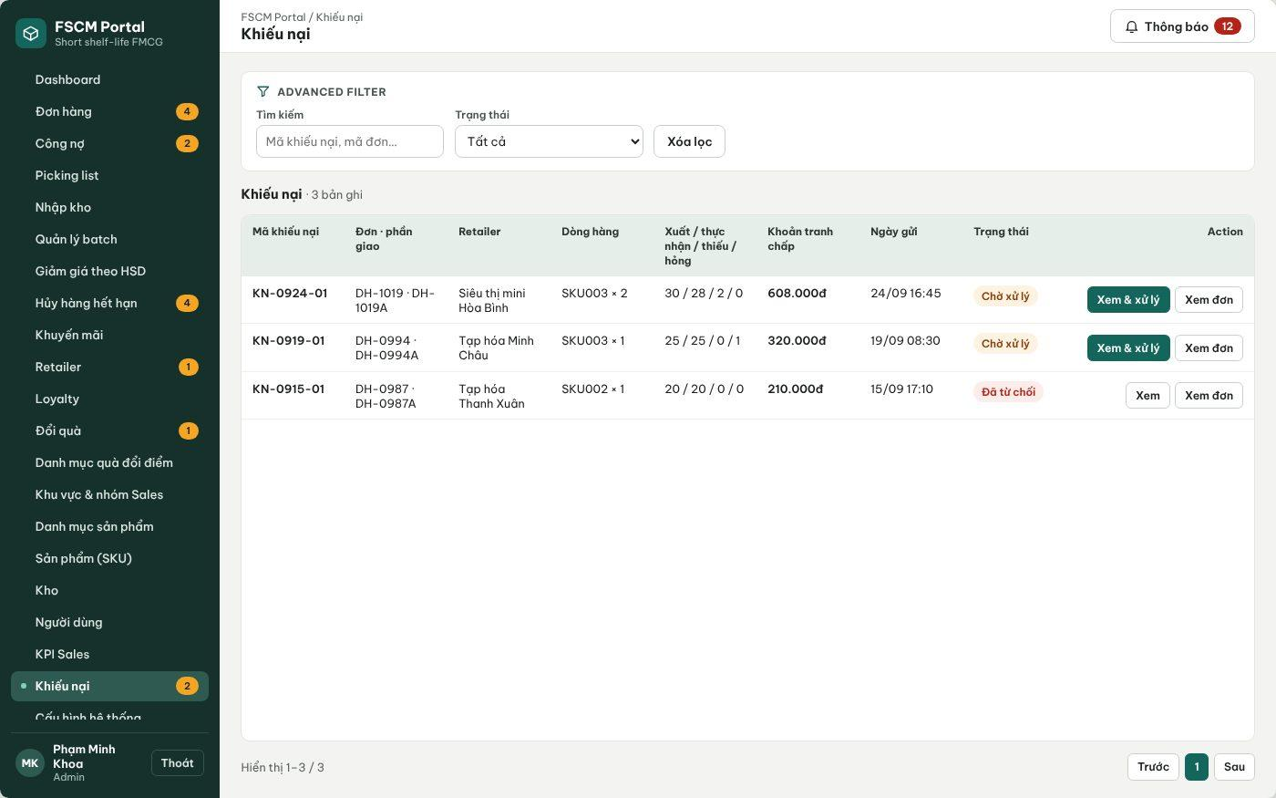
Figure 41. Web Portal – Complaints with dispatched / received / missing / damaged quantities (FSCM_Prototype_Prod_v1.1)
● Function Details:
o Actors: Primary – Retailer (submits). Secondary – Operator (checks evidence and prepares a recommendation), Administrator (accepts or rejects). System – Complaint Adjustment (3.1.4).
o Fields:
▪ Order; affected batch; affected quantity; issue type; evidence / notes.
o Data Processing:
▪ Validate order and recipient ownership.
▪ Create a separate discrepancy record and route to the Operator.
▪ Track investigation and resolution independently of receipt status.
o Business Rules:
▪ A complaint does not automatically reverse delivery or stock. Track disputed net value; an approved adjustment reduces debt or creates a manual refund obligation.
▪ Financial adjustments and manual refunds follow BR-67–BR-70. Automatic returns, replacement goods and bank settlement are outside scope.
o Acceptance Criteria:
AC ID | Acceptance criterion (Given / When / Then) | Ref.
AC-3.9.3-01 | Given a delivered shipment, when the Retailer submits a complaint for 1 carton of batch A1 with a photo, then a KN record is created with disputed value = 1 × actual net unit price (72,000 VND) and delivery status is unchanged (MSG042). | BR-50, BR-67
AC-3.9.3-02 | Given a complaint quantity greater than the dispatched quantity of that line/batch, when submitted, then it is rejected. | CR-17
AC-3.9.3-03 | Given a complaint under review on a credit order, when overdue reminders run, then the disputed portion is excluded and the undisputed debt keeps its due date. | BR-52, BR-67
AC-3.9.3-04 | Given a complaint is submitted, when it is saved, then physical stock is not changed. | BR-50, CR-17
o Traceability: UC-17, UC-29 | BR-50, BR-52, BR-67 – BR-70 | CR-17 | Screens: Submit Complaint, Complaint List; Non-screen: Complaint Adjustment

3.10 Payment & Loyalty Management

3.10.1 Record Order Payment
● Function type: Screen function (see 3.1.2).
● Function trigger:
o Retailer sends a bank-transfer proof after accepting the quotation and the Operator verifies it; or authorized staff record a credit collection.
● Function description: Records authorized payment against the final approved amount, with allocation/payment gating and linked adjustment/refund records.
● Screen layout: see Figures 42 – 44 (captured from the approved prototype FSCM_Prototype_Prod_v1.1).
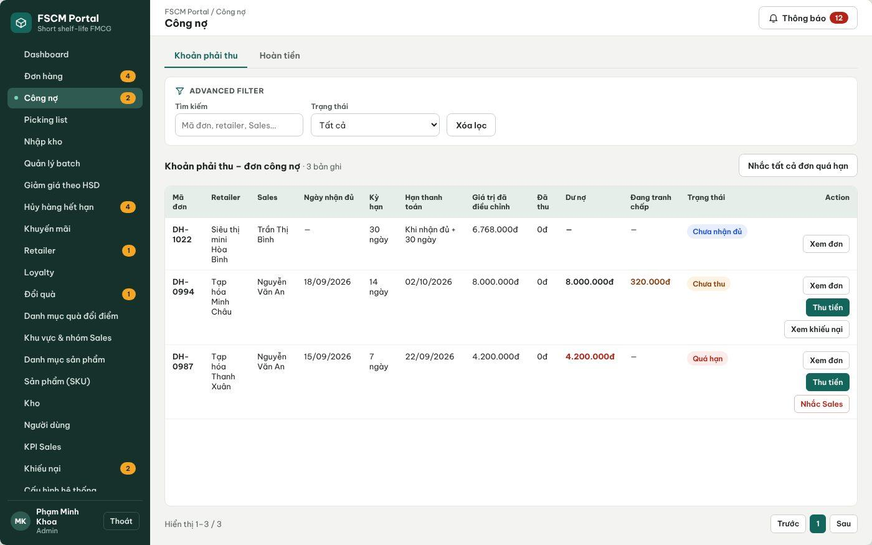
Figure 42. Web Portal – Receivables of credit orders: due date, adjusted value, collected, disputed (FSCM_Prototype_Prod_v1.1)
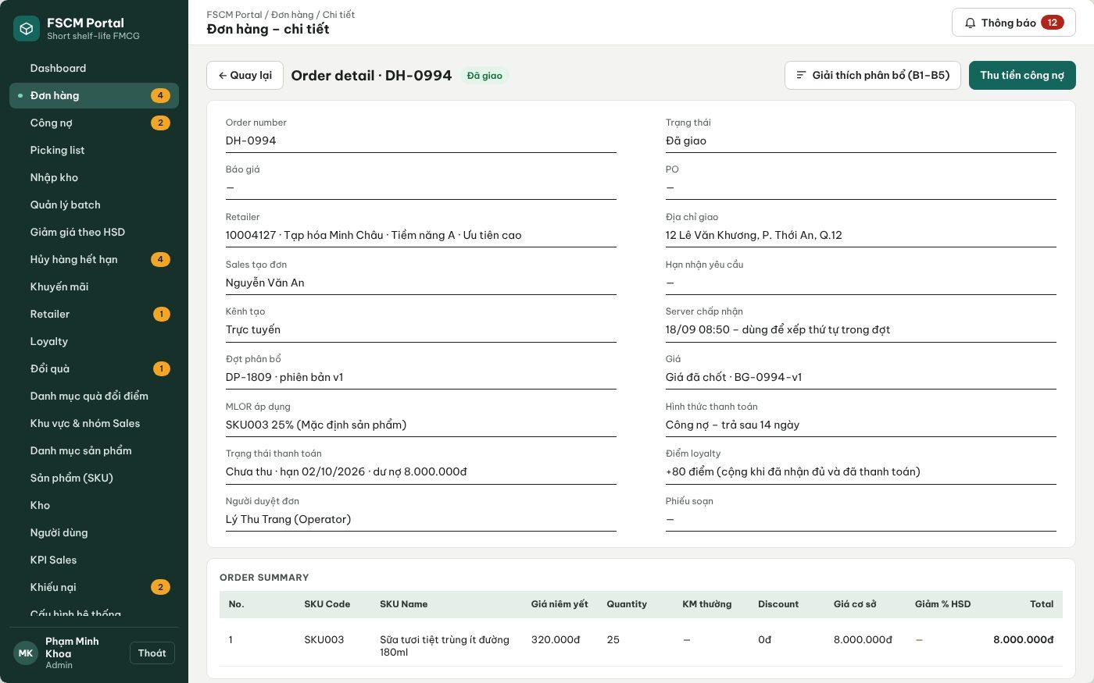
Figure 43. Web Portal – Credit order with Collect payment (FSCM_Prototype_Prod_v1.1)
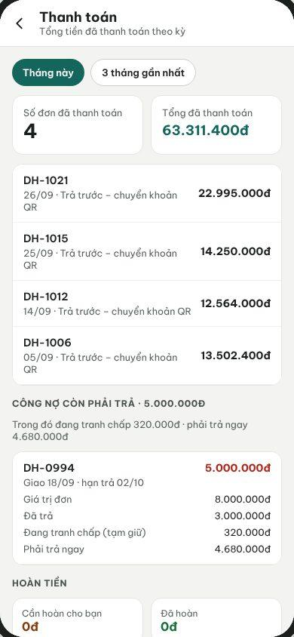
Figure 44. Retailer App – Payments and outstanding credit (FSCM_Prototype_Prod_v1.1)
● Function Details:
o Actors: Primary – Operator (verifies prepaid transfers, records credit collections). Secondary – Sales (records cash collection of a credit receivable within assigned retailers), Retailer (sends transfer proof, views obligations). System – Debt Due Date and Status (3.1.4).
o Fields:
▪ Order reference; payment method (prepaid bank transfer with transaction code and proof image; credit collection by cash or transfer); amount; payment status; confirmation detail.
o Data Processing:
▪ Verify the payment relates to the expected order and amount after applicable discounts.
▪ Accept a prepaid proof only after the Retailer accepts the quotation; once the Operator verifies the funds the order becomes a PO, so picking starts only after payment. Record credit collections manually with evidence and idempotency.
▪ Update the Payment record independently of the SalesOrder status.
o Business Rules:
▪ Prepaid bank transfer is paid after quotation acceptance and verified before the order becomes a PO; credit is paid after receipt within the retailer term. COD and prepaid cash are not used. Short unallocated orders collect nothing. Paid cancellations/accepted claims use BR-66–BR-70.
▪ Manual refund evidence and approval follow BR-66–BR-70. Payment-gateway reconciliation is outside scope.
o Acceptance Criteria:
AC ID | Acceptance criterion (Given / When / Then) | Ref.
AC-3.10.1-01 | Given a credit order fully received on 18/09 with a 14-day term, when the due date is computed, then it is 02/10. | BR-52
AC-3.10.1-02 | Given an outstanding balance of 8,000,000 VND with 320,000 VND disputed, when collection is recorded, then only full settlement of the 7,680,000 VND undisputed balance is accepted (MSG043). | BR-52, BR-69
AC-3.10.1-03 | Given an unpaid credit order past its due date, when the 08:00 job runs, then it is Overdue and Sales and the Operator are notified (MSG044). | BR-53
AC-3.10.1-04 | Given a collection submitted twice, when processed, then one payment record exists. | CR-19
AC-3.10.1-05 | Given an order still Awaiting final price, when a payment is attempted, then it is rejected. | BR-66
o Traceability: UC-16, UC-23, UC-35, UC-36, UC-91 | BR-51 – BR-53, BR-66, BR-69 | CR-18, CR-19 | Screens: Receivables, Order Details – Collect payment, Retailer Payments; Non-screen: Debt Due Date and Status

3.10.2 View Retailer Loyalty Points
● Function type: Screen function (see 3.1.2).
● Function trigger:
o Open the Retailer loyalty screen or assigned retailer view.
● Function description: Displays retailer point balance and available loyalty benefits.
● Screen layout: see Figures 45 – 46 (captured from the approved prototype FSCM_Prototype_Prod_v1.1).
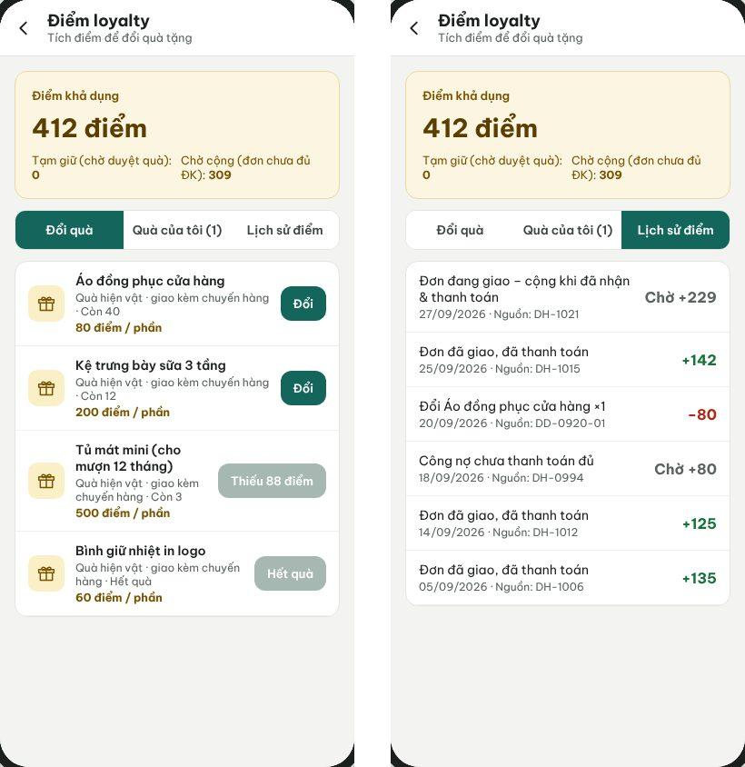
Figure 45. Retailer App – Loyalty points, gifts and point history (FSCM_Prototype_Prod_v1.1)
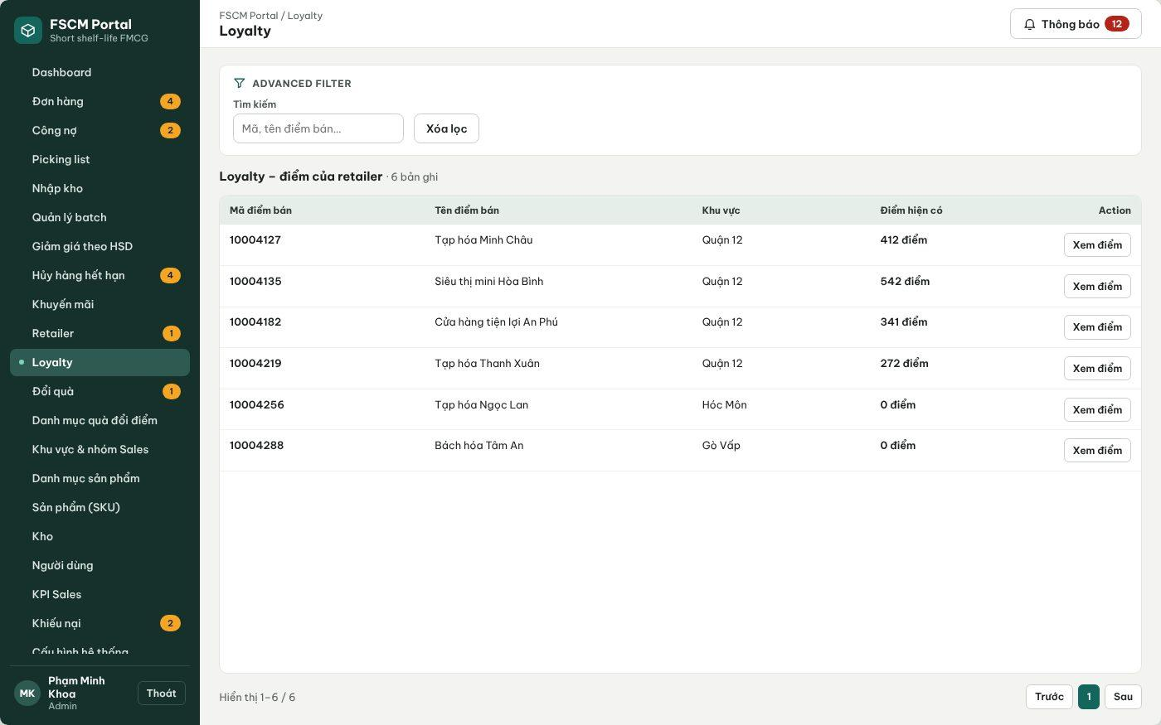
Figure 46. Web Portal – Retailer loyalty points (FSCM_Prototype_Prod_v1.1)
● Function Details:
o Actors: Primary – Retailer (own points). Secondary – Sales (retailer currently served), Administrator (all retailers).
o Fields:
▪ Retailer loyalty balance; earned and redeemed points; transaction history.
o Data Processing:
▪ Retrieve the retailer loyalty summary and transactions.
▪ Restrict Sales visibility to the currently assigned retailer.
o Business Rules:
▪ Loyalty transactions must retain an auditable earn/redeem history.
o Acceptance Criteria:
AC ID | Acceptance criterion (Given / When / Then) | Ref.
AC-3.10.2-01 | Given points earned, held, used and corrected, when the Retailer opens the loyalty screen, then available points = total − held and every movement shows its source order or request. | BR-54, BR-55
AC-3.10.2-02 | Given a Sales user not assigned to the retailer, when its loyalty is requested, then MSG006 is returned. | BR-03
AC-3.10.2-03 | Given a negative corrected balance, when it is displayed, then it is shown as negative and redemption buttons are disabled. | BR-54
o Traceability: UC-76, UC-82 | BR-03, BR-54, BR-55 | CR-20 | Screens: Retailer Loyalty, Loyalty (Portal)

3.10.3 Redeem Loyalty Reward / Points
● Function type: Screen function (see 3.1.2).
● Function trigger:
o Retailer requests a reward; Sales may apply a permitted loyalty benefit.
o Administrator reviews a reward request when approval is required.
● Function description: Supports reward redemption and loyalty-program management for retailers.
● Screen layout: see Figures 47 – 48 (captured from the approved prototype FSCM_Prototype_Prod_v1.1).
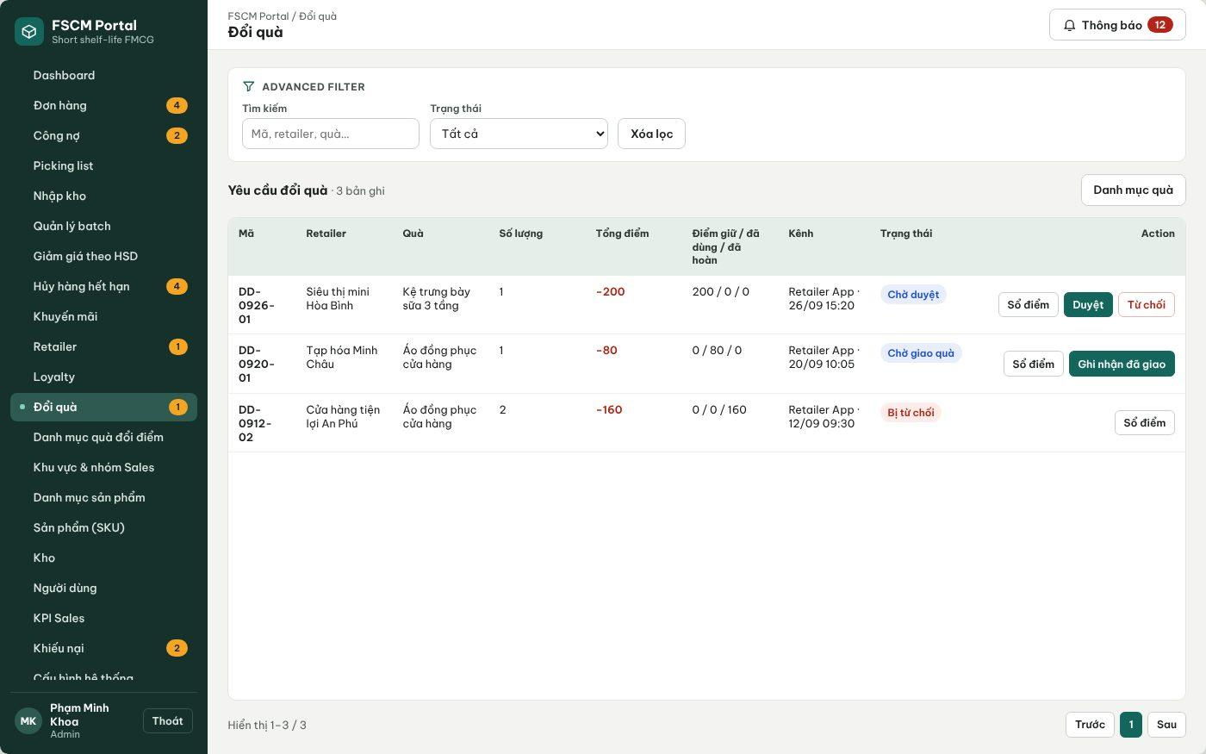
Figure 47. Web Portal – Gift redemption requests (held / used / released points) (FSCM_Prototype_Prod_v1.1)
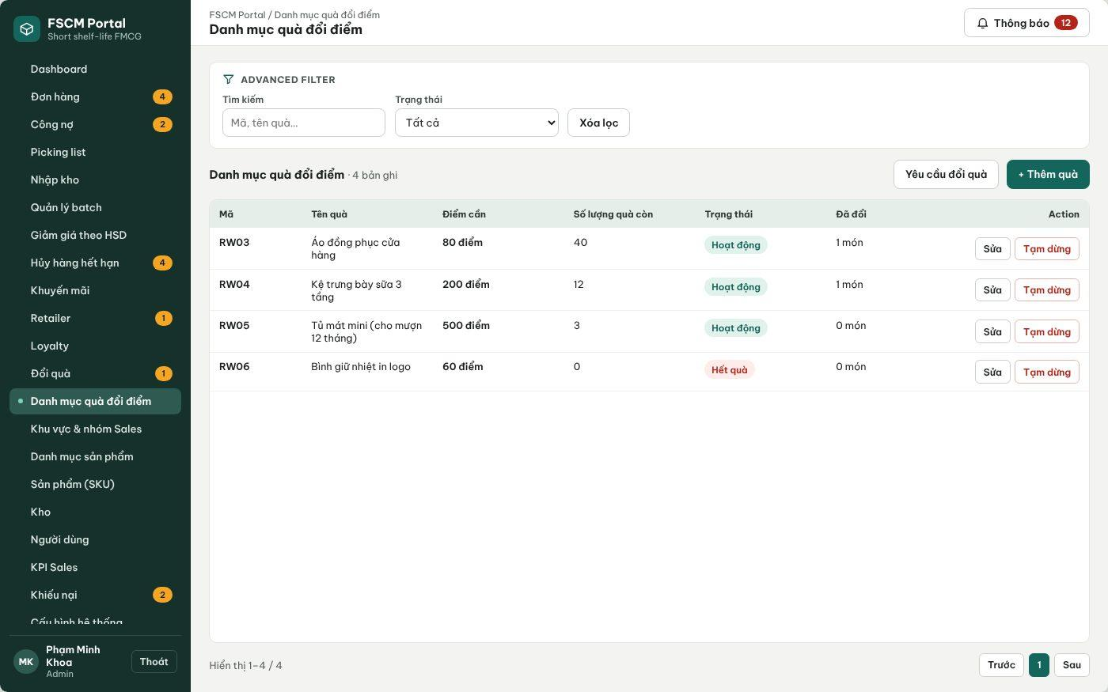
Figure 48. Web Portal – Gift catalog (FSCM_Prototype_Prod_v1.1)
● Function Details:
o Actors: Primary – Retailer (requests a gift). Secondary – Administrator (manages the gift catalog, approves/rejects, records delivery and completion). System – Gift Redemption Points (3.1.4).
o Fields:
▪ Reward; required points; retailer balance; request status; approval information.
o Data Processing:
▪ Verify reward eligibility and sufficient available points.
▪ Record pending redemption or the completed point movement according to configured approval rules.
▪ Preserve an audit entry and communicate the outcome.
o Business Rules:
▪ The Admin manages the reward catalog and reviews redemptions.
▪ Apply BR-54–BR-55 and BR-70. Test award/correction idempotency and redemption with a negative corrected balance.
▪ Lifecycle (BR-75): Pending approval (points and gift stock held) → Awaiting delivery (approved; held points become used) → Delivered → Completed; Rejected or Cancelled before approval releases the held points and gift stock once. Gift stock is separate from goods inventory.
o Acceptance Criteria:
AC ID | Acceptance criterion (Given / When / Then) | Ref.
AC-3.10.3-01 | Given 412 available points and a 200-point gift with stock, when the Retailer requests it, then 200 points and 1 gift are held and available points become 212 (MSG046). | BR-55, BR-75
AC-3.10.3-02 | Given 112 available points and a 200-point gift, when the request is made, then it is rejected with MSG045. | BR-75
AC-3.10.3-03 | Given a Pending request, when the Administrator rejects it, then the 200 held points and the gift stock are released exactly once. | BR-55, BR-75
AC-3.10.3-04 | Given a corrected balance of −6 points, when any redemption is requested, then it is blocked. | BR-54
AC-3.10.3-05 | Given Approve is clicked twice, when processed, then points are used once and one gift is issued. | BR-75
o Traceability: UC-77, UC-96, UC-97 | BR-54, BR-55, BR-70, BR-75 | CR-20 | Screens: Gift Redemption, Gift Catalog, Retailer Loyalty; Non-screen: Gift Redemption Points

3.10.4 Review Disputes and Record Financial Adjustments or Refunds
● Function type: Screen function (Complaint Details, Refunds – Web Portal). Adjustment posting runs automatically – see Complaint Adjustment in 3.1.4.
● Function trigger:
o The Operator or Administrator opens a complaint awaiting decision, or a refund record awaiting transfer or verification.
o A paid order is cancelled before dispatch (refund obligation created automatically).
● Function description: Decides complaints, posts approved financial adjustments, and tracks manual refunds from obligation to verified completion without transferring bank funds.
● Screen layout: see the figures below.
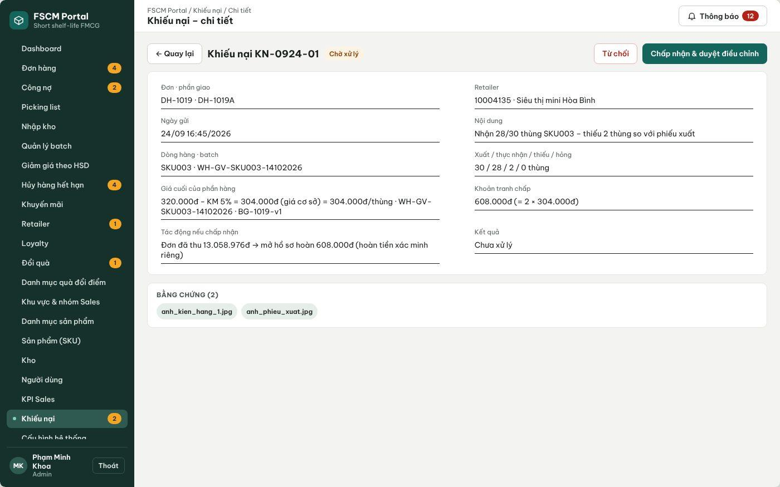
Figure 49. Web Portal – Complaint decision with disputed value and impact (FSCM_Prototype_Prod_v1.1)
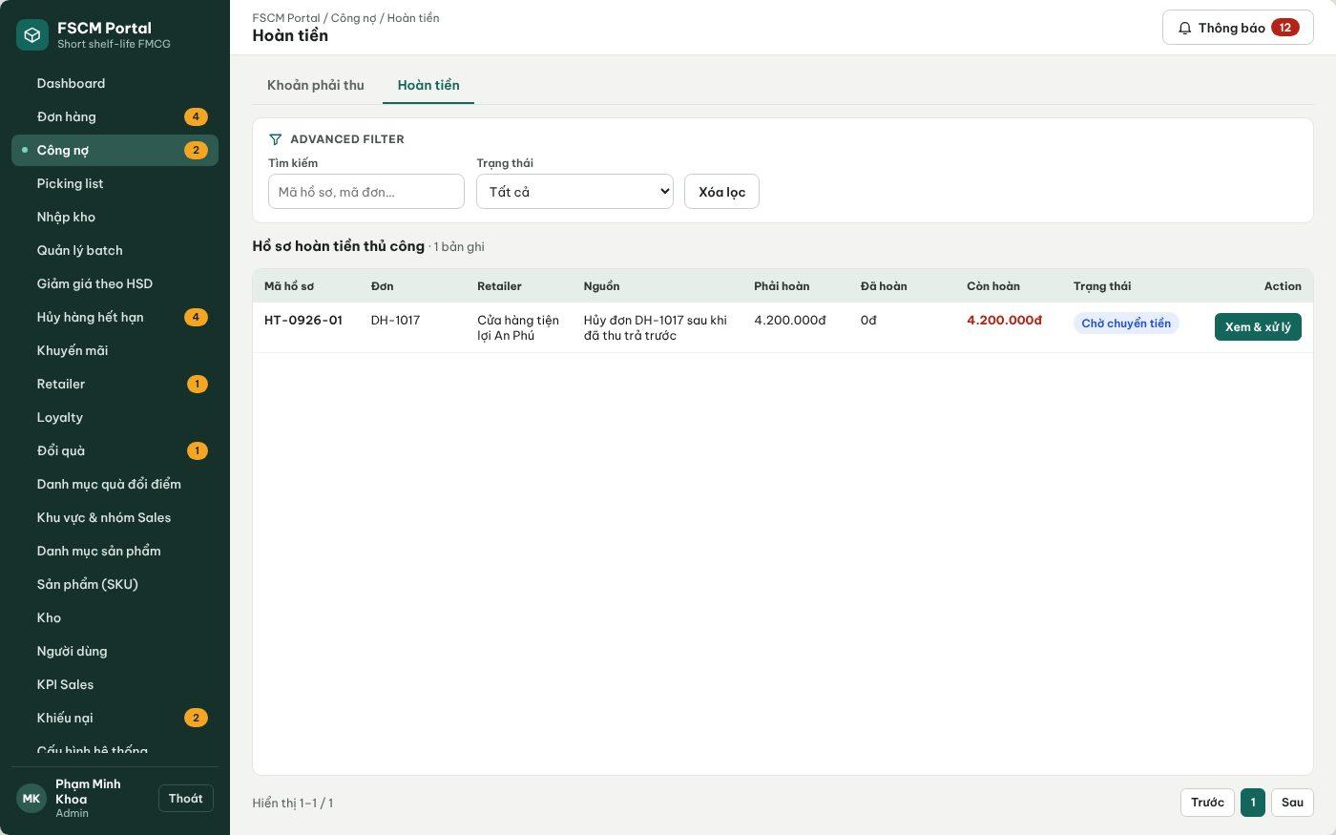
Figure 50. Web Portal – Refund records (FSCM_Prototype_Prod_v1.1)
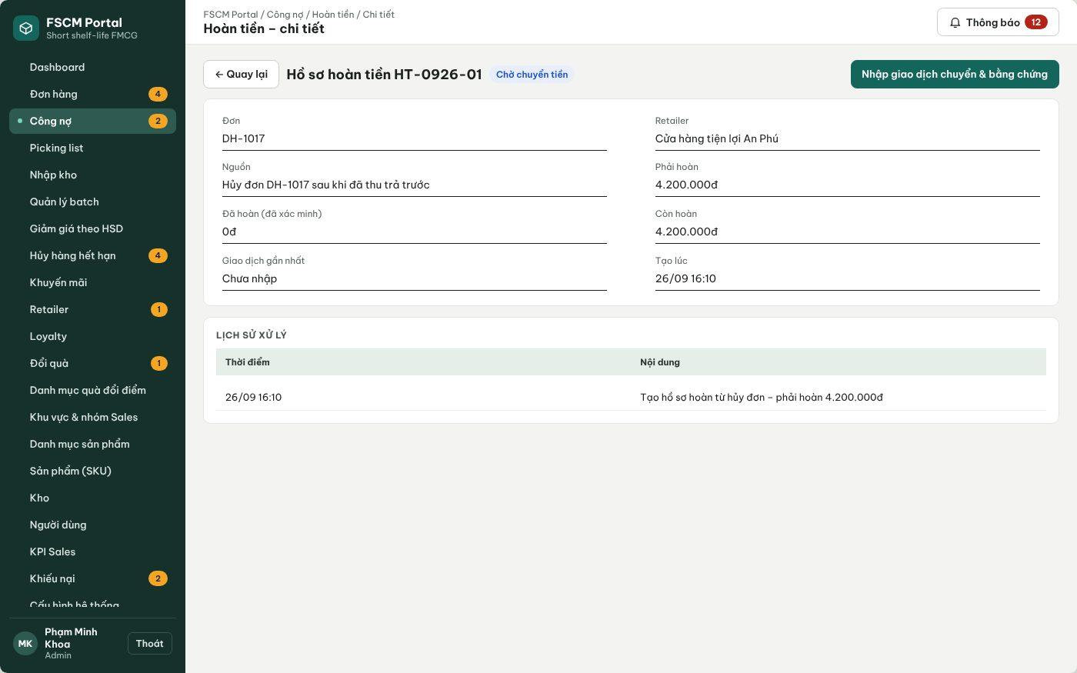
Figure 51. Web Portal – Refund record: enter transfer and evidence for Administrator verification (FSCM_Prototype_Prod_v1.1)
● Function Details:
o Actors: Primary – Administrator (approves adjustments, verifies refund evidence). Secondary – Operator (reviews complaints, records the external transfer and evidence). Retailer – views disputed, adjusted, payable and refund status separately.
o Fields:
▪ Complaint, shipment, line/batch, accepted affected quantity, actual net unit price, adjustment amount, decision and reason; refund record (HT-code), source, refund due, refunded, transaction reference, evidence, status.
o Data Processing:
▪ A pending complaint separates its net disputed value from undisputed debt. Acceptance posts an approved adjustment; rejection restores the original obligation and records how collection resumes. Undisputed debt keeps its due date.
▪ Use the allocated net unit price and accepted affected quantity with rounding, quantity/value caps and duplicate prevention. If confirmed receipts exceed the adjusted amount, create a manual refund obligation; never record bank funds as returned merely because a complaint was approved.
▪ Paid cancellation before dispatch requires a full manual refund. A short order before allocation has collected amount zero.
▪ Refund lifecycle (BR-74): Pending refund → Awaiting verification (transfer and evidence entered) → Refunded (Administrator verified); a rejected evidence moves the record to Needs supplement while the obligation remains.
▪ Recalculate eligible points through linked ledger corrections; prevent a duplicate award and block redemption while the corrected balance is negative. No automatic goods return, inventory restoration or cash recovery is introduced.
o Business Rules:
▪ BR-50, BR-54, BR-66 – BR-70, BR-74 apply.
o Acceptance Criteria:
AC ID | Acceptance criterion (Given / When / Then) | Ref.
AC-3.10.4-01 | Given P1 paid 612,000 VND and an accepted complaint for 1 carton A1 at 72,000 VND, when the Administrator approves, then the obligation becomes 540,000 VND, refund due = 72,000 VND and the loyalty target changes from 61 to 54 points (−7 correction). | BR-54, BR-68, BR-69
AC-3.10.4-02 | Given the complaint is on an unpaid credit order, when it is accepted, then the receivable is reduced and no refund record is created. | BR-69
AC-3.10.4-03 | Given a refund record in Awaiting verification, when the Administrator rejects the evidence with a reason, then the status is Needs supplement and refund due is unchanged. | BR-74
AC-3.10.4-04 | Given refund due of 72,000 VND, when a second refund record or a total above 72,000 VND is entered, then it is rejected. | BR-69, BR-74
AC-3.10.4-05 | Given the refund is verified, when ledgers are reconciled, then net collected = 540,000 VND, balance = 0 and no further point correction is made. | BR-69, BR-70
AC-3.10.4-06 | Given an approved adjustment, when inventory is viewed, then no stock is returned automatically. | BR-68
o Traceability: UC-17, UC-93, UC-94 | BR-50, BR-54, BR-66 – BR-70, BR-74 | CR-17, CR-19, CR-20 | Screens: Complaint Details, Refunds, Refund Details; Non-screen: Complaint Adjustment

3.11 Sales Groups & Operational Reporting

3.11.1 Manage Sales Groups and Coverage
● Function type: Screen function (see 3.1.2).
● Function trigger:
o Open Sales Group Management.
o Create, update, view or delete a permitted sales group.
● Function description: Maintains regional Sales-group membership and retailer coverage.
● Screen layout: see Figure 52 (captured from the approved prototype FSCM_Prototype_Prod_v1.1).
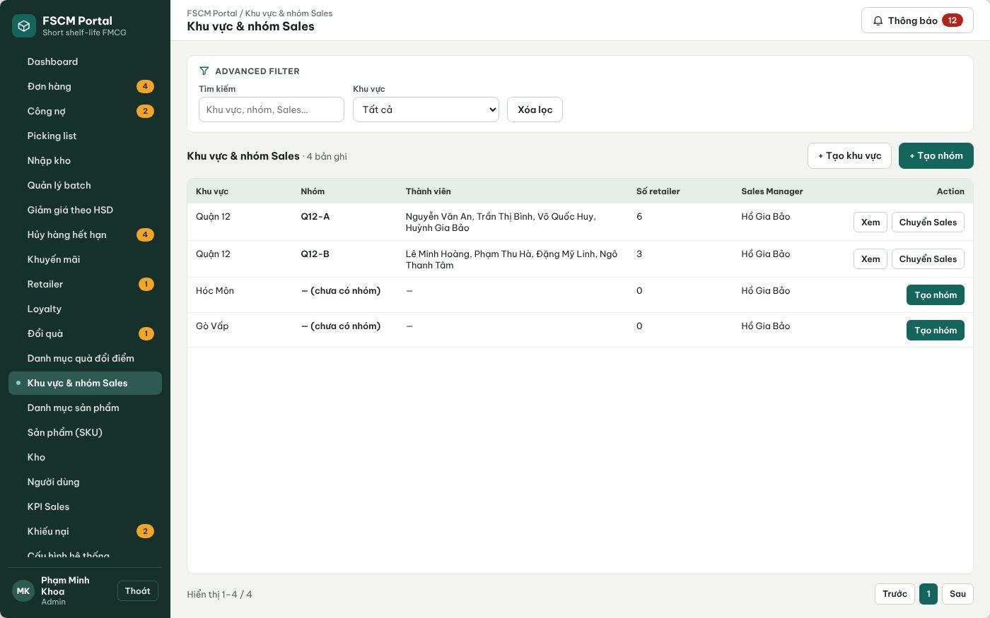
Figure 52. Web Portal – Sales regions and groups (FSCM_Prototype_Prod_v1.1)
● Function Details:
o Actors: Primary – Sales Manager (regions, groups, member and retailer assignments of own regions). Secondary – Administrator (all regions).
o Fields:
▪ Sales group; sales region; member assignments; assigned retailers.
o Data Processing:
▪ Validate the manager’s organization scope.
▪ Update memberships and assignments with dependent data checks.
▪ Apply the new coverage to Sales order visibility.
o Business Rules:
▪ Sales users may operate only within permitted personal and group scope.
▪ A sales group can be deleted only when it has no members and no assigned retailers; otherwise members and retailers must be reassigned first. Reassigning a Sales user or a retailer changes visibility for later actions only; historical orders keep their creator and group snapshot for performance attribution.
o Acceptance Criteria:
AC ID | Acceptance criterion (Given / When / Then) | Ref.
AC-3.11.1-01 | Given a group with members, when Delete is selected, then it is blocked until members and retailers are reassigned. | BR-03
AC-3.11.1-02 | Given Sales A moved from Q12-A to Q12-B, when Q12-A performance is reported for last month, then A's earlier orders remain attributed to A and Q12-A. | BR-56
AC-3.11.1-03 | Given a Sales Manager of Quận 12, when a group in Gò Vấp is edited through the API, then MSG006 is returned. | BR-03
AC-3.11.1-04 | Given a retailer reassigned to Q12-B, when a Q12-A member opens it, then it is no longer listed. | BR-03, BR-20
o Traceability: UC-18, UC-19, UC-40 – UC-42 | BR-03, BR-20, BR-56 | CR-01 | Screens: Regions & Sales Groups

3.11.2 View Sales and Management Dashboards
● Function type: Screen function (see 3.1.2).
● Function trigger:
o Open the role-specific dashboard.
o Select supported reporting filters.
● Function description: Displays order KPIs, net revenue after discounts and authorized performance summaries.
● Screen layout: see Figures 53 – 55 (captured from the approved prototype FSCM_Prototype_Prod_v1.1).
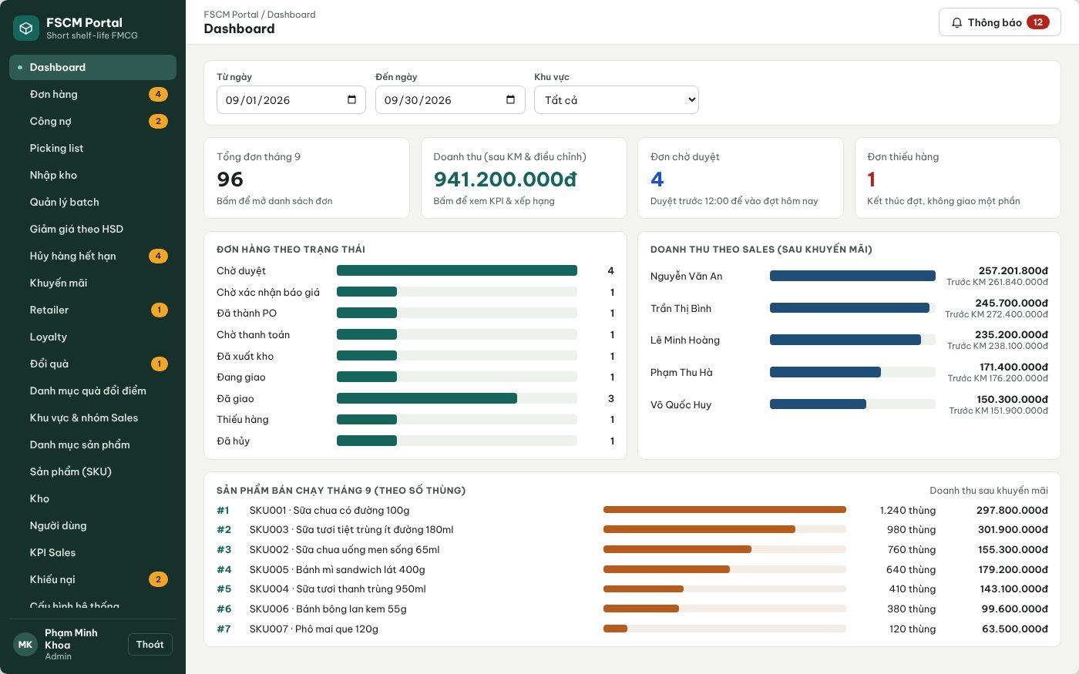
Figure 53. Web Portal – Administrator dashboard (FSCM_Prototype_Prod_v1.1)
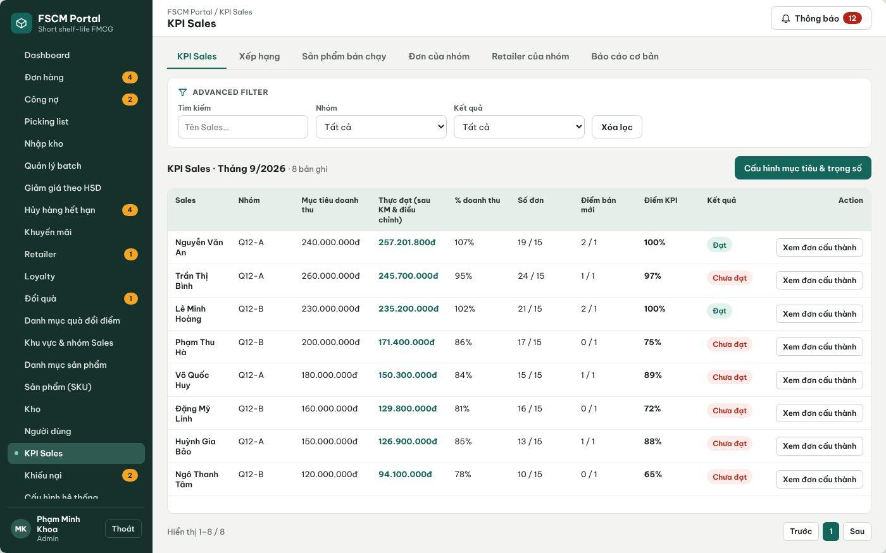
Figure 54. Web Portal – Sales KPI with targets, net revenue and score (FSCM_Prototype_Prod_v1.1)
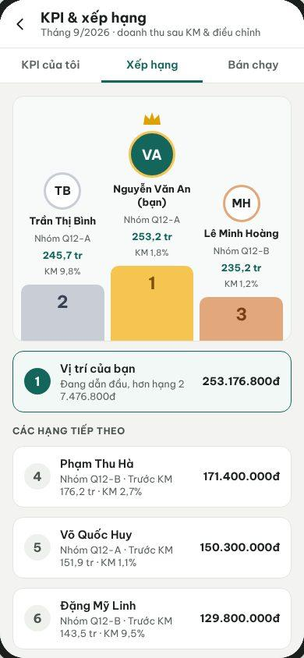
Figure 55. Sales App – Ranking (FSCM_Prototype_Prod_v1.1)
● Function Details:
o Actors: Primary – Administrator (system dashboard), Sales Manager (team KPI and ranking), Sales (own KPI and ranking). Secondary – Retailer (own spending summary, UC-84). System – Net Revenue and KPI Calculation (3.1.4).
o Fields:
▪ Reporting period; net revenue; order counts / values; sales leaderboard; best-selling products.
o Data Processing:
▪ Aggregate relevant order and transaction data within the requester’s scope.
▪ Deduct applied promotion discounts in revenue calculations.
▪ Show Sales Manager team indicators and Admin system indicators; display best-selling products where supported.
o Business Rules:
▪ Revenue must be calculated after promotion discounts.
▪ KPI score = 70% × min(net revenue / revenue target, 1) + 15% × min(orders / order target, 1) + 15% × min(new retailers / new-retailer target, 1); weights and targets are configured per period. Result is Achieved when the score is 100%. Revenue is recognized on the Delivered date at approved net value after promotions, shelf-life discounts and approved adjustments; Cancelled, Rejected, Insufficient-stock and not-yet-Delivered orders are excluded. Filters: Today, 7 days, This month, custom range; region and group.
o Acceptance Criteria:
AC ID | Acceptance criterion (Given / When / Then) | Ref.
AC-3.11.2-01 | Given revenue attainment 95%, orders 24/15 and new retailers 1/1, when the KPI score is computed, then it is 0.7 × 0.95 + 0.15 + 0.15 = 96.5% (displayed 97%) and Not achieved. | BR-56
AC-3.11.2-02 | Given an order of 612,000 VND later adjusted by −72,000 VND, when revenue is reported, then 540,000 VND is counted. | BR-56, BR-69
AC-3.11.2-03 | Given an order with two shipments, when dashboards count orders, then it is counted once. | BR-56
AC-3.11.2-04 | Given a Sales user, when the ranking is opened, then the user's own figures are shown and other users' order details are not accessible. | BR-03
AC-3.11.2-05 | Given a dashboard for one month of 10,000 orders, when it is loaded, then it responds within 3 s (p95). | NFR-P04
o Traceability: UC-01, UC-09, UC-20, UC-25, UC-27, UC-72, UC-73, UC-75, UC-84 | BR-03, BR-56 | Screens: Dashboard, KPI Sales, Sales Ranking; Non-screen: Net Revenue and KPI Calculation

3.12 System Configuration & Notifications

3.12.1 Manage Warehouse Location and Service Configuration
● Function type: Screen function (see 3.1.2).
● Function trigger:
o Open Warehouse / System Configuration.
o Edit service-distance settings or location through the configured map view.
● Function description: Maintains warehouse visualization and distance-based receipt-estimation parameters.
● Screen layout: see Figures 56 – 57 (captured from the approved prototype FSCM_Prototype_Prod_v1.1).
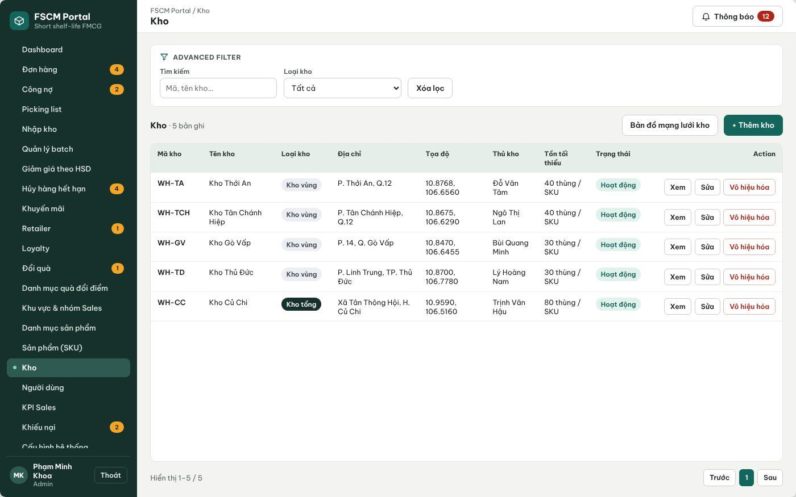
Figure 56. Web Portal – Warehouses with type, address, coordinates and keeper (FSCM_Prototype_Prod_v1.1)
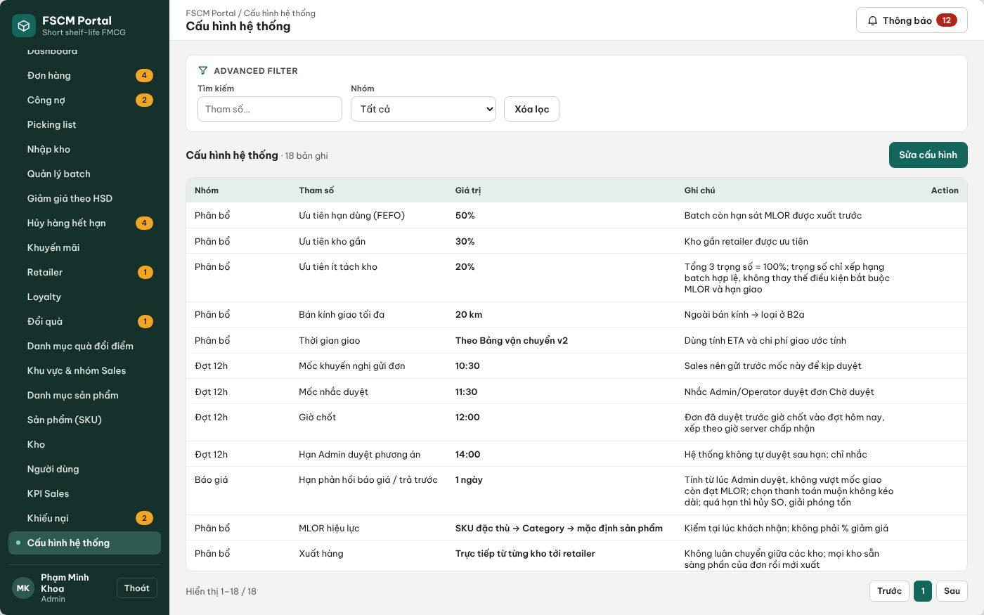
Figure 57. Web Portal – System configuration (allocation, 12:00 run, quotation, MLOR, pricing) (FSCM_Prototype_Prod_v1.1)
● Function Details:
o Actors: Primary – Administrator (warehouses, map locations, service distance, transit table, allocation weights, schedule and quotation deadline). Secondary – Operator may view the transit table.
o Fields:
▪ Warehouse address / map location; service distance; transit time bands; allocation settings.
o Data Processing:
▪ Resolve and save map-derived geographic information for configured warehouses.
▪ Validate distance-band coverage and service constraints.
▪ Use updated values for subsequent estimates and allocation attempts.
o Business Rules:
▪ Map coordinates need not be manually displayed or entered as latitude and longitude.
▪ Map: OpenStreetMap base tiles; locations are picked on the map or by device GPS and stored in MapLocation; offline map selection uses a coordinate grid. Distance: shortest road distance computed server-side on the road graph (Dijkstra), recomputed when a location changes; no external routing or traffic API. Only the Administrator may change these values. Weights follow BR-33 (default 0.5 / 0.3 / 0.2, non-negative, sum = 1); changes apply only to later runs (BR-57).
o Acceptance Criteria:
AC ID | Acceptance criterion (Given / When / Then) | Ref.
AC-3.12.1-01 | Given weights 0.5, 0.3 and 0.3, when they are saved, then they are rejected because the sum is not 1. | BR-33
AC-3.12.1-02 | Given Dmax changed from 20 to 15 km during a running run, when the run continues, then it uses its snapshot value of 20 km; the next run uses 15 km. | BR-28, BR-57
AC-3.12.1-03 | Given a warehouse location moved on the map, when it is saved, then road distances to retailers are recalculated before the next run. | BR-32
AC-3.12.1-04 | Given an Operator, when the configuration save API is called, then MSG006 is returned. | CR-01
AC-3.12.1-05 | Given any configuration change, when it is saved, then the old value, new value, actor and time are in the audit log. | BR-58
o Traceability: UC-03, UC-50 – UC-53, UC-95 | BR-28, BR-32, BR-33, BR-57, BR-58 | CR-10, CR-21 | Screens: Warehouses, System Configuration

3.12.2 Send Operational Notifications
● Function type: Non-screen function – runs automatically, no screen of its own (see Operational Notifications in 3.1.4).
● Function trigger:
o An eligible order, approval, inventory or loyalty event occurs.
● Function description: Creates and dispatches user-facing operational notifications.
● Screen layout: Not applicable – non-screen function.
● Function Details:
o Actors: System – Operational Notifications (3.1.4). Recipients – all six human roles according to the matrix below. External – Azure Notification Hubs.
o Fields:
▪ Recipient; event type; notification content; related business reference.
o Data Processing:
▪ Resolve intended recipients using role and assignment information.
▪ Persist notification records and attempt push delivery through the configured notification service.
▪ Record outcomes without changing the source transaction success state.
o Business Rules:
▪ Azure Notification Hubs is the external push delivery service listed in the system context.
▪ Matrix: order approved/rejected → Sales; cutoff reminder 11:30 → Administrator, Operator; proposal ready / 13:30 reminder → Administrator; quotation sent / deadline in 2 h → Retailer, Sales; prepaid proof submitted → Operator; PO released → Warehouse Keeper; shipment Delivering / Delivery failed → Retailer, Sales, Operator; complaint submitted → Operator, Administrator; complaint decided, refund status changed → Retailer; overdue 08:00 → Sales, Operator; redemption decided → Retailer; offline sync result → Sales. Retry: in-app record is always stored; push is retried 3 times (after 1, 5 and 15 minutes) and the final failure is logged without changing the source transaction.
o Acceptance Criteria:
AC ID | Acceptance criterion (Given / When / Then) | Ref.
AC-3.12.2-01 | Given a quotation is sent, when the event is committed, then an in-app notification is stored for the Retailer and Sales within 10 s and a push is requested. | NFR-P07
AC-3.12.2-02 | Given Azure Notification Hubs is unavailable, when a push fails, then it is retried after 1, 5 and 15 minutes and the quotation remains valid. | NFR-R06
AC-3.12.2-03 | Given a Warehouse Keeper of WH-TA, when a PO with portions only in WH-GV is released, then the WH-TA keeper is not notified. | BR-03
AC-3.12.2-04 | Given the same event processed twice, when notifications are created, then only one notification per recipient exists. | CR-23
o Traceability: UC-83 (status updates) | BR-25, BR-37, BR-53 | CR-23 | Non-screen: Operational Notifications

3.13 Delivery Operations

3.13.1 Process Delivery Assignment
● Function type: Screen function (Order Details – Assign vehicle, Start delivery, Record delivery failure – Web Portal).
● Function trigger:
o A PO shipment is Ready (all warehouse portions picked) and the Operator assigns a vehicle and delivery person.
o After dispatch confirmation the Operator selects Start delivery; on a failed attempt the Operator selects Record delivery failure.
● Function description: Assigns a vehicle and delivery person to each warehouse shipment, tracks Delivering, and records failed delivery attempts with reason and evidence. There is no driver account or app and no route optimization (BR-05, LI-04).
● Screen layout: see the figures below.
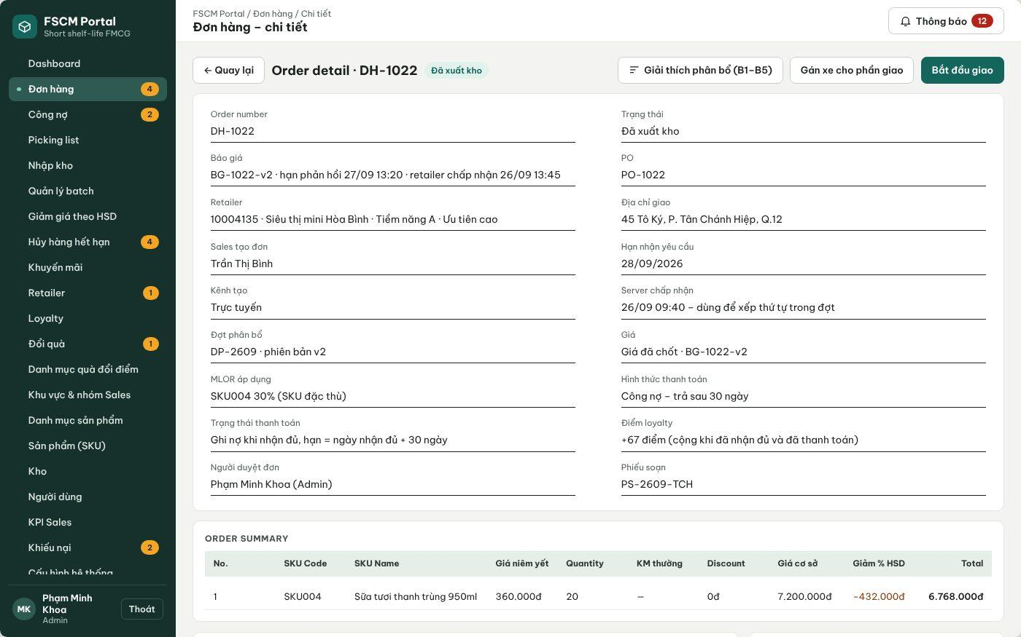
Figure 58. Web Portal – Dispatched order with Assign vehicle and Start delivery (FSCM_Prototype_Prod_v1.1)
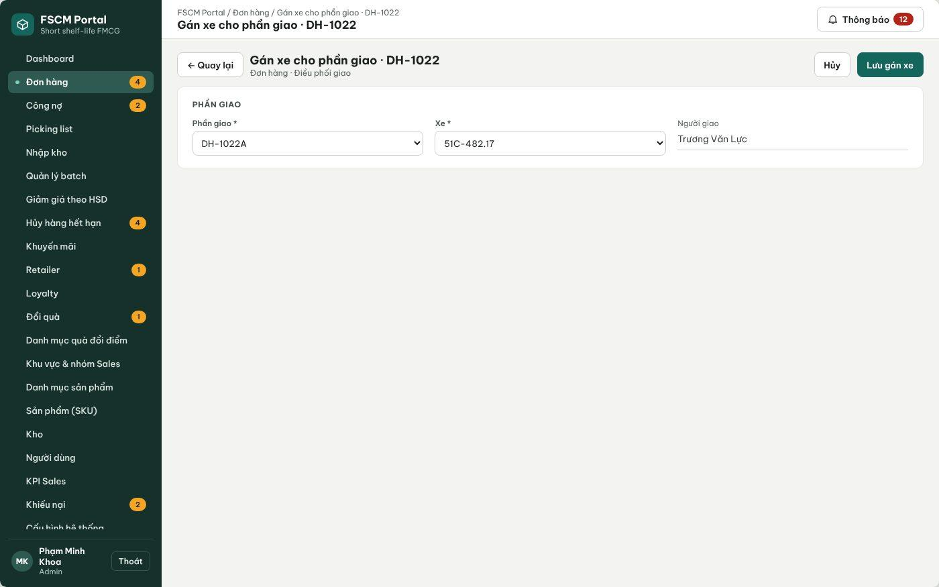
Figure 59. Web Portal – Assign vehicle and delivery person to a shipment (FSCM_Prototype_Prod_v1.1)
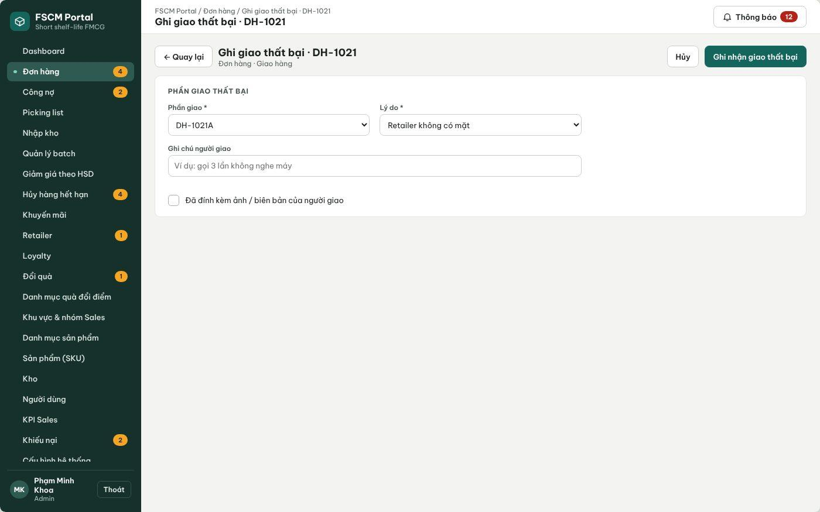
Figure 60. Web Portal – Record delivery failure with reason and evidence (FSCM_Prototype_Prod_v1.1)
● Function Details:
o Actors: Primary – Operator. Secondary – Administrator (resolves failed deliveries and exceptions). Warehouse Keeper confirms dispatch (3.9.1). Retailer confirms receipt (3.9.2).
o Fields:
▪ Shipment (order–warehouse portion); vehicle (licence plate) and delivery person from master data, stored as a snapshot; assignment time; delivery status; failure reason (Retailer absent, Retailer refused, Wrong address, Other); notes; evidence photo.
o Data Processing:
▪ Allow assignment only for shipments of a PO; one active assignment per shipment; changing the vehicle before dispatch replaces the assignment and keeps history.
▪ Start delivery sets the shipment to Delivering only after its dispatch has been confirmed; the order is Delivering when its dispatched shipments are on the way.
▪ Record delivery failure sets the shipment to Delivery failed with reason and evidence; no automatic refund, stock restoration, Delivered status or loyalty posting occurs.
▪ The Administrator decides the outcome: a new delivery attempt of the same shipment if ETA, deadline and MLOR are still met, or an exception settlement under BR-26/BR-66 – BR-69.
o Business Rules:
▪ BR-05, BR-46 – BR-49 and BR-76 apply. Delivery arrival is an estimate, not a guarantee.
o Acceptance Criteria:
AC ID | Acceptance criterion (Given / When / Then) | Ref.
AC-3.13.1-01 | Given a shipment of a sales order that is not yet a PO, when assignment is attempted, then it is rejected. | BR-45, BR-76
AC-3.13.1-02 | Given an assigned vehicle 51C-482.17 and delivery person, when the assignment is saved, then the licence plate and person name are stored as a snapshot on the shipment (MSG040). | BR-48
AC-3.13.1-03 | Given a shipment whose dispatch is not confirmed, when Start delivery is selected, then it is blocked. | BR-47, BR-76
AC-3.13.1-04 | Given a failed attempt with reason 'Retailer absent' and a photo, when it is recorded, then the shipment is Delivery failed, the order is not Delivered, and no refund or stock movement is created. | BR-49, BR-76
AC-3.13.1-05 | Given a vehicle or delivery person marked inactive in master data, when the assignment list is opened, then it is not selectable. | BR-05
o Traceability: UC-14, UC-74 | BR-05, BR-26, BR-46 – BR-49, BR-76 | Screens: Order Details – Delivery Assignment, Record Delivery Failure

4. Non-Functional Requirements

4.1 External Interfaces
• User interfaces: FSCM provides a Web Portal (React/TypeScript) for administrative, warehouse, finance and delivery-coordination work and one Flutter Mobile App for Sales Representatives, Warehouse Keepers and Retailers, which opens the part for the signed-in role. Each interface displays only the functions and data permitted by the signed-in role. Supported clients: Web Portal on the latest two versions of Chrome and Edge at 1366 × 768 or larger; Mobile App on Android 10 (API 29) or later with screen widths of 360 – 430 dp (iOS 15+ build optional). The user interface language is Vietnamese; business codes and amounts follow 5.1. Accessibility target: WCAG 2.1 AA text contrast (≥ 4.5:1) and touch targets ≥ 48 dp (NFR-U05).
• Authentication interface: Staff users may sign in with an FSCM system account or with Microsoft Entra ID (OpenID Connect authorization-code flow with PKCE, single company tenant). After Entra ID validates the user, FSCM issues its own access and refresh tokens (lifetimes in NFR-S04). Account linking follows 3.2.2 (existing Active staff account with matching e-mail; no just-in-time provisioning). Recovery: staff system accounts reset their password through an e-mailed link; Retailers through SMS OTP; Entra ID accounts through Microsoft.
• Database interface: FSCM uses Azure Database for PostgreSQL as the authoritative store for business data, including product/category and batch records, sales orders and quotations, inventory balances and locks, reservations and picking records, payments, adjustments and refunds, retailer assessments, loyalty transactions and audit history. Application components access the database only through authorized server-side services. SQLite on the Mobile App holds only authorized offline reference data and pending Sales drafts (CR-25).
• File-storage interface: FSCM uses Azure Blob Storage (private container) for evidence images and files, including cancellation, write-off, complaint, delivery-failure, storefront and refund evidence. Accepted types are JPG, PNG and PDF, at most 5 MB per file and 5 files per record, validated by extension and file signature. Files are read only through short-lived SAS links (valid ≤ 15 minutes) issued to authorized users. The application never deletes evidence linked to a stock or financial record (NFR-S06, NFR-R08).
• Push-notification interface: FSCM uses Azure Notification Hubs (FCM for Android, APNs for iOS) for push delivery; every notification is also stored in-app. Events and recipients follow the matrix in 3.12.2. Push requests are retried 3 times (after 1, 5 and 15 minutes); the target is ≥ 95% of pushes handed to the hub within 60 s of the business event (NFR-P07).
• Camera/QR interface: The Mobile App uses the device rear camera to scan batch QR labels during receiving lookup, picking and retailer receipt; a manual label-code field is provided when scanning fails. The QR payload contains only the label code (TEM-000000); the server resolves the batch, quantity and expected context and records the quantity or mismatch. Camera permission is requested at the first scan; a hand-held scanner acting as keyboard input is optional.
• Payment interface: Prepaid payment is a bank transfer to the distributor account shown with a VietQR code and the transfer content 'FSCM <order code> <retailer code>'; the Retailer submits the transaction code and proof, and authorized staff verify it (3.6.6). Credit collections are recorded by authorized staff (3.10.1). Payment-gateway settlement, bank webhooks, automatic reconciliation and automatic refunds are outside scope.
• Map and distance interface: Warehouse and retailer locations are maintained on an OpenStreetMap base map (or a coordinate grid when offline) and stored as MapLocation. Service distance is the shortest road distance computed server-side on the road graph (Dijkstra) and recalculated when a location changes; no external routing or traffic service is used. Distance bands and ETA follow BR-32; the estimate is not a guaranteed delivery time.
• Network interface: All client–server traffic uses HTTPS (TLS 1.2 or later). Mobile Sales-order creation remains possible offline; drafts are sent only when Sales taps Send (BR-23). Synchronization identifiers and conflict handling are specified in 4.2.6.
• Operations interface: Secrets, connection strings and signing keys are stored in Azure Key Vault and never in source code or mobile caches (CR-24). Azure Monitor / Application Insights collects availability tests, request latency, errors and job outcomes used to measure the NFRs below.

4.2 Quality Attributes
The following quality attributes apply to the FSCM Web Portal, Mobile App and backend services. Each requirement states a metric, a threshold and a measurement method. Thresholds are the v1.8 baseline targets for the reference test environment and workload below; they are configurable test targets agreed for Review 2, not claims of achieved results. Reference workload: 5 warehouses, 1,000 SKUs, 20,000 batches, 100 user accounts (50 concurrent), 1,000 orders per day with an average of 5 lines, and evidence files up to 5 MB.

4.2.1 Usability
ID | Requirement | Metric | Threshold | Measurement method
NFR-U01 | Role-based navigation: each role sees only the screens and actions of the Screen Authorization matrix (3.1.3). | Share of (role, screen/action) pairs that match 3.1.3 | 100% | Checklist of 3.1.3 executed for the 6 roles on the Review build; any extra or missing item is a defect.
NFR-U02 | Task efficiency for core field tasks. | Median task time on a test device | Create a 5-line online order ≤ 3 min; confirm receipt of a 3-label shipment ≤ 2 min; pick a 10-line slip ≤ 10 min; review and approve one order ≤ 1 min | Moderated usability test, 5 participants per role, scripted tasks, stopwatch; results recorded in Report 5.
NFR-U03 | Learnability and satisfaction. | Unassisted task completion rate; System Usability Scale (SUS) | ≥ 90% of scripted main tasks completed without help; mean SUS ≥ 70 | Same usability session as NFR-U02, SUS questionnaire after the session.
NFR-U04 | Feedback and input guidance: every create/update/approval, scan, upload, payment and sync action shows success, validation error or failure without implying completion before the server confirms it. | Share of actions showing a 5.3 message next to the action or field | 100% of actions in 3.2 – 3.13; result shown ≤ 1 s after the server response | UI review against 5.3 and widget/E2E tests asserting the message code.
NFR-U05 | Supported clients and accessibility. | Rendering on supported browsers/devices; Lighthouse accessibility score; contrast ratio | No layout defect on Chrome/Edge (latest 2) at ≥ 1366 × 768 and Android 10+ at 360 – 430 dp; Lighthouse accessibility ≥ 85 on Login, Orders, Allocation Run and Receivables; text contrast ≥ 4.5:1 | Manual cross-browser/device check; Lighthouse CI; contrast checker on the design tokens.

4.2.2 Reliability
ID | Requirement | Metric | Threshold | Measurement method
NFR-R01 | Availability of the API and Web Portal during the test, review and defense period. | Monthly availability = successful health checks / total checks | ≥ 99.0%, excluding announced maintenance (≤ 2 h per week, 22:00 – 06:00 ICT) | Azure Monitor availability test calling /health every 5 minutes; monthly report.
NFR-R02 | Recoverability of business data. | Recovery point objective (RPO); recovery time objective (RTO) | RPO ≤ 24 h; RTO ≤ 4 h | Azure PostgreSQL automated backups with 7-day point-in-time restore; one restore drill before Council 1.1 with timed steps.
NFR-R03 | Stock and financial consistency under concurrency. | Negative Available/OnHand; duplicate reservations, dispatches, receipts, payments, refunds or point awards | 0 in all runs | Integration test with 50 parallel requests including duplicates (approval, dispatch, payment, receipt, refund, redemption) followed by invariant SQL queries.
NFR-R04 | Idempotent scheduled jobs (12:00 allocation, expiry detection, quotation expiry, 08:00 overdue, reminders). | Duplicate business effects after re-running a job for the same period | 0; exactly one AllocationRun per date | Job re-execution tests; unique constraints on run code and job-period keys.
NFR-R05 | Daily allocation run completion. | Runs completed or failed with a logged reason; time to alert | 100% of runs end in Completed or Failed with reason; alert if not completed by 12:15; ≤ 3 automatic commit retries (BR-38) | Job log and Azure Monitor alert rule; test with injected database failure.
NFR-R06 | Integration failure handling (Entra ID, Blob Storage, Notification Hubs). | False success confirmations while a dependency is unavailable | 0; push retried 3 times (1, 5, 15 min); upload failures leave the business action unsaved or pending | Fault-injection tests that disable each dependency in the test environment.
NFR-R07 | Defect quality at release (Report 2, 1.2). | Open Critical/High defects; system-test pass rate; MTTR for Critical defects | 0 open Critical/High; ≥ 90% of system cases pass with 100% of mandatory main paths; Critical MTTR ≤ 1 working day during Sprint 3 | Defect tracker and Report 5 test results for the tagged release.
NFR-R08 | Evidence and audit retention. | Evidence/audit records deleted by the application | 0; no purge job in the MVP; delete requests on linked evidence are rejected | Code review of delete endpoints; integration test attempting deletion.

4.2.3 Performance
ID | Requirement | Metric | Threshold | Measurement method
NFR-P01 | API response time at the reference workload. | 95th-percentile (p95) server response time; error rate | Reads (catalog, order list/details, inventory, receivables) ≤ 1.0 s; writes (order submit, review, scan, payment, receipt) ≤ 2.0 s; error rate < 1% | k6 load test, 50 virtual users for 10 minutes against the staging API; Application Insights.
NFR-P02 | Sign-in time. | p95 time from Login to role workspace | ≤ 2.0 s for system accounts (excluding user time in the Microsoft pop-up) | k6 scenario and manual timing on a test device.
NFR-P03 | FEFO–MLOR allocation and approval. | Run duration; approval/reservation commit duration | 300 orders × 5 lines over 20,000 batches in 5 warehouses ≤ 5 min; approval commit ≤ 30 s | Timed run on the generated reference dataset; start/end timestamps in the run log.
NFR-P04 | Dashboards and reports. | p95 load time | ≤ 3.0 s for one month with 10,000 orders | k6 scenario on dashboard and KPI endpoints.
NFR-P05 | QR scan validation. | p95 time from scan to validation result (online) | ≤ 1.5 s | Instrumented mobile test on Android 10 device over 4G profile.
NFR-P06 | Offline queue and synchronization. | Local queue capacity; time to send drafts; catalog refresh time | ≥ 200 drafts stored; 20 drafts sent ≤ 60 s on 4G; catalog cache refresh ≤ 30 s | Device test with SQLite queue fixture and network profile.
NFR-P07 | Notification latency. | Time from committed event to in-app record and to hub hand-off | In-app ≤ 10 s; push hand-off ≤ 60 s for ≥ 95% of events | Timestamps of outbox, notification and hub response in logs.
NFR-P08 | Resource headroom and monitoring. | Average API CPU at reference load; slow queries; 5xx rate alert | CPU < 70%; queries > 1 s logged; alert when 5xx > 2% over 5 minutes | Azure Monitor metrics and alert rules; PostgreSQL slow-query log.

4.2.4 Security
ID | Requirement | Metric | Threshold | Measurement method
NFR-S01 | Server-side authentication and authorization on every protected endpoint, including role and data scope (warehouse, region, sales group, retailer). | Unauthorized or cross-scope requests accepted | 0; unauthenticated → 401, unauthorized/cross-scope → 403 (MSG006) | Automated authorization matrix test: 6 roles × all endpoints × own/other scope.
NFR-S02 | Transport security. | Protocols accepted; plain HTTP access | TLS 1.2+ only; HTTP redirected to HTTPS; HSTS enabled | testssl.sh / SSL Labs scan of the API and Portal hosts.
NFR-S03 | Credential protection. | Password storage; lockout; OTP rules | Passwords hashed with ASP.NET Core Identity PBKDF2; ≥ 8 characters with letters and digits; 5 failures → 15-minute lockout; OTP 6 digits, valid 5 minutes, ≤ 5 attempts, resend after 60 s | Unit/integration tests of the identity configuration; database inspection shows no plain passwords.
NFR-S04 | Session and token lifetime. | Access/refresh token lifetime; revocation delay | Access 60 min; refresh 8 h sliding (Portal) / 7 days (Mobile); deactivation or password change revokes tokens at the next request | Token inspection and integration test after deactivation.
NFR-S05 | Secret management. | Secrets in repositories, logs or mobile storage | 0; secrets only in Azure Key Vault; tokens on the device only in secure storage (Keystore/Keychain) | gitleaks scan in CI; log review; mobile storage inspection.
NFR-S06 | File upload security. | Rejected invalid files; access without authorization | 100% of non-JPG/PNG/PDF or > 5 MB files rejected (MSG049); private container; SAS links ≤ 15 min; malware scanning outside MVP scope (accepted risk) | Upload tests with invalid type/size/signature; anonymous blob access test.
NFR-S07 | Encryption at rest. | Encryption setting of PostgreSQL and Blob Storage | Enabled (AES-256, platform-managed keys) | Azure configuration review recorded in Report 5.
NFR-S08 | Auditability of critical actions (BR-58). | Critical actions with an audit entry (actor, time, action, reason) | 100%; audit log append-only (no update/delete API) | Integration tests assert an audit row for each critical action type.
NFR-S09 | Common web vulnerabilities. | OWASP ZAP baseline findings | 0 High; Medium findings documented with a decision | ZAP baseline scan of Portal and API before each review build.

4.2.5 Data Integrity and Traceability
ID | Requirement | Metric | Threshold | Measurement method
NFR-D01 | Financial accuracy of prices, adjustments and refunds. | Difference between quotation total and the sum of its batch lines; BR-69 formula test coverage | 0 VND difference; amounts are whole VND, rounded half-up per batch line; 100% of BR-69 formulas unit-tested including boundary values | xUnit tests with the P1/C1/P2 examples of the five-flow workbook and generated cases.
NFR-D02 | Snapshot immutability. | Historical prices, MLOR, promotion, tier rule and transit snapshots changed by later configuration | 0 | Regression test that changes configuration after orders exist and compares snapshots.
NFR-D03 | Batch-level traceability. | Links retrievable from a QR label | 100% of labels resolve receipt → batch → allocation → reservation → picking → dispatch → receipt → complaint in one trace call | Integration test on seeded end-to-end data.
NFR-D04 | Loyalty correctness. | Orders with more than one initial award; corrections without a linked source | 0; points posted once after receipt, full settlement and complaint resolution | Ledger invariant tests including replayed events.
NFR-D05 | Configuration validation. | Invalid values accepted | 0: MLOR and offer ratios strictly between 0 and 1; weights ≥ 0 summing to 1 (± 0.001); Dmax 1 – 100 km; discounts 0 < % < 100; non-overlapping tier ranges | Validation unit tests and API tests.
NFR-D06 | Algorithm evaluation against strict FEFO (Registration NFR). | Complete/short orders, quantity from near-expiry batches, average distance, warehouses per order, run time – for both methods on identical eligible data | Comparison produced for every evaluation dataset; 0 eligibility violations (expiry, MLOR, radius, deadline) for either method; no global-optimality claim | Algorithm Evaluation function (3.1.4 #19) output and Report 5 analysis.

4.2.6 Offline Operation and Synchronization
ID | Requirement | Metric | Threshold | Measurement method
NFR-O01 | Offline order capture with cached data. | Ability to create and save a draft without connectivity; cache age shown | 100% of Create Order steps work offline; cache age shown; warning when cache is older than 24 h | Device test in airplane mode.
NFR-O02 | Local queue durability. | Drafts lost after app kill or device restart | 0 of 20 forced terminations | Device test killing the app during save and send.
NFR-O03 | Duplicate prevention. | Server orders created when the same draft (UUID idempotency key) is sent repeatedly | Exactly 1 for 10 repeated sends | API test replaying the same request code (BR-23).
NFR-O04 | Conflict handling. | Drafts accepted with changed price, promotion, MLOR or retailer status without Sales confirmation | 0; changed conditions shown with MSG035 and require confirmation | Integration test changing server data between cache and send.
NFR-O05 | Local data protection and expiry. | Data stored on the device; stale drafts | Only authorized reference data and own drafts; drafts older than 7 days are flagged Stale and must be refreshed before sending; no automatic deletion | Mobile storage inspection and device test with an aged draft.

5. Requirement Appendix

5.1 Business Rules
These rules specify the daily 12:00 design and FEFO version 3, including accepted MLOR for near-expiry offers (BR-59–BR-70). They apply consistently to screens, APIs and jobs. Distances, weights, retry limits and reminder times are configurable defaults. This SRS specifies the target behavior, not a claim that implementation is complete. Mentor corrections clarify payment timing, complaint adjustments, replacement bounds and resubmission priority. Version 1.8 adds BR-71 – BR-80 (group K) to close the gaps found in the Registration reconciliation (5.5) and refines BR-11, BR-34, BR-41, BR-55 and BR-60.
ID | Rule Definition
A. Accounts, roles and data scope
BR-01 | FSCM has six business roles: Administrator, Operator, Sales Manager, Warehouse Keeper, Sales Representative (Sales) and Retailer. Each user account holds exactly one role.
BR-02 | Administrator accounts are pre-provisioned at deployment. No screen may create an Administrator account or assign the Administrator role to an existing user.
BR-03 | Data scope is enforced by the server: Sales see only retailers of their assigned sales area and group; Warehouse Keepers see only their assigned warehouses; Sales Managers see only their regions and groups; Retailers see only their own orders, payments, complaints and loyalty records.
BR-04 | Retailers cannot self-register or create orders in FSCM. They track their orders, confirm receipt, file complaints, view payment obligations and redeem loyalty points.
BR-05 | Delivery persons do not have FSCM accounts. Vehicles (identified by licence plate) and delivery persons are master data maintained by the Administrator and selected by the Operator.
B. Master data and identifiers
BR-06 | Server-generated business codes are unique and not reused. Key examples: SKU000 (product), WH-XX (warehouse), {warehouse}-{SKU}-{expiry ddMMyyyy} (batch), TEM-000000 (QR quantity label), DH-000000 (order), OFF-{device}-0000 (offline order), PN-{yyMMdd}-{nn} (goods receipt), PH-{yyMMdd}-{nn} (write-off), KN-{yyMMdd}-{nn} (complaint), KMB-{yyMMdd}-{nn} (near-expiry offer), KM-000 (ordinary campaign), LP-000 (loyalty program) and QUA-000 (gift). AR-{yyMMdd} identifies the daily Allocation Run, not a stock document; recalculation creates proposal revisions under the same run code. Identifier formatting details belong to the data dictionary.
BR-07 | A product follows the lifecycle Draft → Published → Inactive. Only Draft products can be edited. A Published product (name, price, shelf life, default MLOR) cannot be edited in place; a change is made by deactivating it and creating a new product from it.
BR-08 | Only Published products can be received, promoted and ordered. Inactive products remain visible in historical records only.
BR-09 | Stock of the same warehouse, SKU and expiration date forms one batch. Further receipts with the same three values are added to that batch; the batch code always uses the expiration date, never the receipt date.
BR-10 | Every received quantity is identified by QR labels linked to exactly one batch. When a label is split, the child labels keep the parent reference and their total quantity equals the parent quantity.
BR-11 | MLOR duration = effective line ratio × product shelf life. Standard lines use the retailer's SKU-level MLOR, else its Category-level MLOR (nearest ancestor), else the product default (BR-78). Accepted near-expiry-offer lines use the offer ratio under BR-59–BR-61. Ratios must be strictly between 0 and 1; all durations use the same unit.
BR-12 | A potential retailer declared by Sales (including forecast revenue, store size and purchasing capacity) must be approved by the Administrator before it becomes active; approval assigns the retailer code. Only active retailers can receive orders.
BR-13 | Each retailer has one payment term: none, 7, 14 or 30 days. Deferred payment (credit) is allowed only for retailers with a term; a newly registered retailer has no term until the Administrator assigns one.
C. Pricing and promotions
BR-14 | Promotions are created by the Administrator for a SKU or a category group with a validity period and can be paused. Paused or expired promotions are not applied.
BR-15 | Prices calculated when an order is created, including offline estimates on the device, are provisional. The server recalculates prices and promotions when it accepts or synchronizes the order; device values are never final.
BR-16 | An Administrator-confirmed KMB identifies its eligible batches, price/discount, validity/version and minimum shelf-life ratio on receipt. Discount percent and remaining shelf-life percent are separate fields.
BR-17 | Standard order lines use ordinary campaign pricing without assuming a near-expiry offer requiring different MLOR. Offer lines keep the selected offer/version and accepted price conditions. The run proposes prices from the actual eligible batches; Admin approval fixes the official price. No silent price increase or switch to standard-price stock is allowed. A change outside accepted conditions requires customer confirmation before commitment.
BR-18 | Discounts do not waive expiry, distance, ETA/deadline or effective MLOR checks and are not scoring weights. An offer-specific MLOR is used only after explicit line acceptance, not inferred from the discount.
BR-19 | Store line ID/type, offer/version and price, default/effective MLOR and source, customer acceptance, allocated batch/quantity and configuration as historical snapshots. Later changes do not silently rewrite an accepted line.
D. Order capture and review
BR-20 | Only Sales create orders, and only for active retailers in their assigned area. Orders for retailers outside the area are blocked on the device and rejected by the server.
BR-21 | Orders contain distinct SKU lines with quantity, line type, effective MLOR and optional accepted offer conditions. Sales chooses no receive date and no payment method; the Retailer chooses the payment method after the quotation (BR-51). Same-SKU standard and offer lines remain separate. Deferred payment requires a retailer term.
BR-22 | Creating, synchronizing or approving an order does not select batches and does not hold or reserve stock. Stock shown to Sales is indicative only and is not a fulfilment commitment.
BR-23 | Offline orders are stored in the device queue with a UUID idempotency key and a temporary OFF code. The server assigns the DH code on acceptance; repeated submissions with the same key never create a second order.
BR-24 | Order priority is the server acceptance time of the valid order, not the device creation time. Equal times are ordered by order code.
BR-25 | Administrator or Operator reviews each order before cutoff without stock or payment commitment. Reminders default to 11:30 for orders received before 11:00; an order not reviewed by cutoff waits for the next run. This is an operational target, not guaranteed same-day processing.
BR-26 | Sales may cancel before run inclusion. After reservation and before picking, an authorized cancellation releases reservations and affected picking/shipment records. Warehouse exceptions may be cancelled by Admin before any shipment is dispatched, with stock reconciliation and a refund obligation if paid. Once any portion is dispatched, ordinary cancellation is blocked; handle affected quantities through the complaint/adjustment workflow, not an automatic full cancellation.
E. Daily allocation run
BR-27 | Allocation runs once a day at 12:00 (Asia/Ho_Chi_Minh). The run takes approved orders whose server acceptance and approval are both before 12:00, plus orders resubmitted under BR-39. Later orders wait for the next run.
BR-28 | A run is locked when it starts: only one execution per run code, and orders in a running run cannot be edited or cancelled. The run records a snapshot of available stock, transit rules, distances, weights and MLOR values.
BR-29 | Group by SKU to retrieve candidates, but preserve order-line ID, retailer, effective MLOR, offer/version/price, acceptance, deadline and ETA. Never merge standard and offer lines or average their MLOR.
BR-30 | Orders are processed in priority order (BR-24). A higher MLOR or order value gives no priority, and a later order cannot take quantity tentatively assigned to an earlier order except through BR-35.
BR-31 | Each candidate must match SKU, be issuable and unexpired, have positive pool quantity, be within Dmax (default 20 km), meet the deadline, and satisfy EXP − ETA ≥ effective line ratio × SL. Offer lines must also match the accepted offer’s batch scope, validity and price conditions.
BR-32 | ETA = first dispatch slot after picking preparation and buffer time + transit days from the shared transit table: 0–10 km = 1 day; >10–20 km = 2 days; beyond Dmax = not served. The same table is used by every function, is versioned by effective date and is copied to the order as a snapshot.
BR-33 | Score eligible batches using S = wE·fE + wD·fD + wQ·fQ. fE = clamp(1 − (L − M)/(SL − M), 0, 1), where L = EXP − ETA and M is the effective line MLOR duration; fD = clamp(1 − distance/Dmax, 0, 1); fQ = min(pool quantity, remaining line need)/remaining line need, only while need > 0. Default weights 0.5/0.3/0.2 are nonnegative and sum to 1. Clamp confines a score to 0–1.
BR-34 | The highest-scoring batch is taken first for min(pool quantity, remaining need); fQ and S are recalculated after each take. Ties are broken by earlier expiry, then shorter distance, then batch code. One order line may use several batches and warehouses.
BR-35 | A short line permits direct one-level replacement only: move one earlier line’s quantity from a contested batch to one eligible alternative batch, validating all affected quantities and conditions atomically. Each alternative candidate evaluation counts as one attempt. Stop when full, candidates exhausted or 20 attempts reached per short line (configurable positive finite limit); no recursive chain. Log each attempt, outcome and stop reason. Earlier orders remain fully covered and retain accepted offer/price/MLOR/ETA conditions.
BR-36 | No partial fulfillment: if any order line remains short, including an offer line, mark the whole order Insufficient stock in run and return all its tentative quantities to the pool. Do not substitute standard-price stock, relax MLOR or create an automatic backorder.
BR-37 | Each run produces a proposal (complete orders, short orders, chosen batches and warehouses, replacements and reasons) that the Administrator must approve or send back for recalculation with a reason. Reminder at 13:30, approval deadline 14:00; a run is never approved automatically. Approval reserves stock and sends quotations; no picking list exists before an order becomes a PO.
BR-38 | On run approval, recheck stock versions, batch status, current ETA, effective line MLOR, accepted offer scope/validity/price and acceptance. Commit all complete-order reservations transactionally. Failure rolls back; a changed proposal needs renewed review. Retry limit defaults to 3; repeated approval creates no duplicate reservation or picking list.
BR-39 | Sales may resubmit a short order once for the immediately following run before cutoff, retaining its original acceptance time and order code for priority only if quantities, retailer, price/offer, MLOR and deadline are unchanged and still valid. No stock or fulfillment is guaranteed. Changed conditions, a second retry or a missed resubmission window require a new order and new server acceptance time; renewed offer acceptance is required when conditions change.
BR-40 | Keep proposal revisions and per-line quantities, batches, scores, effective MLOR/source, offer/version/price, acceptance, replacements and shortages. Administrator or Operator closes the run after dispatch and exceptions are reconciled.
F. Warehouse and stock
BR-41 | Available = OnHand − Reserved − Locked (BR-71). Reserved increases only when a run is approved; OnHand and Reserved decrease together only when dispatch is confirmed. No stock quantity changes when an order is created, synchronized or approved.
BR-42 | Stock enters a warehouse only through an approved goods receipt (PN). Internal transfers and near-expiry rotation between warehouses are out of scope.
BR-43 | A nightly job classifies near-expiry and expired batches. Expired batches cannot be allocated or dispatched and leave stock only through a write-off.
BR-44 | A write-off (PH) requires a reason, evidence and authorized approval; stock is reduced only after approval.
BR-45 | Picking lists are released per warehouse only for orders that became a PO after run approval and quotation acceptance: goods are picked in bulk by SKU and batch, then split per order. Each scan must match the warehouse, batch and picking list and must not exceed the listed quantity; the Warehouse Keeper cannot substitute another batch.
BR-46 | An order may be dispatched only when the portions of every warehouse in the order are ready. Damage or shortage found at any warehouse puts the whole order in “Needs handling”, and no warehouse ships its portion until it is resolved.
BR-47 | Dispatch confirmation is recorded once even if submitted again. The order becomes “Dispatched” only when every shipment of the order has been dispatched.
G. Delivery, receipt and complaints
BR-48 | Each warehouse portion of an order is a separate shipment with its own vehicle and delivery person chosen from master data and stored as a snapshot. Delivery arrival is an estimate, not a guarantee.
BR-49 | The Retailer confirms receipt of each shipment by scanning the QR labels issued for it. The order becomes “Delivered” when every shipment is confirmed; the confirmation date is used for payment due dates and loyalty. It is shown as “Completed” once it is delivered, fully settled and has no open complaint or pending refund. A failed delivery attempt is recorded by the Operator as “Delivery failed” with reason and evidence.
BR-50 | Complaints reference shipment, allocated line/batch, affected quantity and evidence. A complaint does not automatically reverse delivery or change physical stock. Separate its disputed net value from current collection while under review; only an approved decision posts a financial adjustment or creates a manual refund obligation (BR-67–BR-69).
H. Payment and deferred payment
BR-51 | Payment methods are prepaid bank transfer and deferred payment (credit) for retailers with a term; COD and prepaid cash are not used. A sales order carries no payment method. After run approval the Retailer receives a versioned quotation with a response deadline (default 1 day) and accepts or rejects it; on acceptance the Retailer chooses the payment method. Credit converts the order into a PO at once; prepaid requires a transaction code and proof that the Operator verifies before the order becomes a PO. Rejection or expiry cancels the order and releases its reservation. Submission and provisional prices cannot trigger collection. Payment status is separate from order status.
BR-52 | Deferred due date is final receipt confirmation plus the agreed term. Track original amount, approved adjustments, confirmed payments, pending disputed value and completed refunds separately. Only full settlement of the undisputed adjusted balance is recorded; credit limits and installment payments are excluded. A pending disputed portion is excluded from overdue reminders until reviewed; undisputed debt retains its due date.
BR-53 | A daily job at 08:00 marks unpaid receivables past their due date as Overdue and notifies the responsible Sales and the Operator.
I. Loyalty
BR-54 | Earned points = floor(adjusted eligible order amount ÷ 100,000 VND), under the program. Post once only after all receipt, adjusted full settlement and complaint-review conditions are met. Subsequent approved financial adjustments create linked point corrections, never a duplicate award. Negative corrected balance blocks new redemptions until recovered; no automatic cash recovery.
BR-55 | Points expire according to the program. A redemption request holds the required points and gift stock; approval turns the held points into used points, and staff record delivery and completion; a rejected or cancelled request releases the held points (BR-75). Every point movement is recorded in the loyalty ledger.
J. Reporting, configuration and audit
BR-56 | Revenue and Sales performance use the approved net order value after discounts and accepted financial adjustments, for eligible Sales-created orders. Exclude cancelled, rejected and unfulfilled orders; retain adjustment history rather than silently rewriting earlier records.
BR-57 | Changes to allocation weights, service distance, transit table, cutoff and reminder times and loyalty rate apply only to later orders and runs; existing records keep their snapshots.
BR-58 | Order and run approvals or rejections, reservations, stock movements, payments, loyalty movements and configuration changes record the actor, time, action and reason in the audit log.
BR-59 | Ordinary campaigns do not change default MLOR. A near-expiry offer may supply a separate minimum remaining shelf-life ratio on receipt, configured by Admin and explicitly accepted by the customer through Sales for that line only.
BR-60 | Standard lines use the effective MLOR of BR-78. Offer lines use the accepted offer ratio, strictly between 0 and 1. Selecting a discounted price alone is not acceptance; Sales cannot freely reduce the ratio.
BR-61 | For every batch portion, EXP − ETA must be at least the effective ratio × product shelf life. Use consistent time units, include all waiting and handling time, and evaluate again when ETA changes. Equality is eligible.
BR-62 | Each offer line records line type, offer/version, eligible conditions, price, default/effective MLOR, source and acceptance actor/time. Same-SKU lines with different offer conditions must not be merged.
BR-63 | Offer lines may use only batches within their selected valid offer and accepted price/conditions. Filter first, then score using effective MLOR. No automatic substitution to standard-price stock or unaccepted offer conditions is allowed.
BR-64 | Batch replacement and run approval must preserve accepted offer/price/MLOR conditions for every affected line. If a proposal changes, review it again. New price or customer conditions require renewed acceptance before commitment; accepting an offer does not reserve stock.
BR-65 | The Sales interface separates standard products and near-expiry offers and displays price, minimum life on receipt, normal retailer MLOR and indicative quantity. The acceptance checkbox is never preselected. A line that remains short triggers whole-order shortage handling under BR-36.
BR-66 | Payment is Awaiting final price until allocation approval. An unallocated short order has zero funds collected. A prepaid order is Awaiting payment after quotation acceptance and becomes a PO, with picking, only after the Operator verifies the transfer. A paid order cancelled before dispatch creates a full manual refund obligation; exceptional early receipts must also be reconciled before closure.
BR-67 | Record a complaint’s disputed value using affected quantity and the actual allocated net unit price after discounts. Separate disputed and undisputed balances while reviewing; the disputed portion is not chased as overdue. Rejection restores the amount and resumes collection with a recorded reason and due-date handling; no automatic overdue penalty is applied for the review interval.
BR-68 | Admin-approved missing/damaged quantity creates a linked financial adjustment at actual allocated net price, with documented rounding, evidence and actor/time. Limit it to delivered quantity and remaining unadjusted line value; prevent duplicate adjustments. The adjustment does not automatically return goods to usable stock.
BR-69 | Adjusted amount = original approved amount − approved adjustments. Outstanding = max(0, adjusted amount − confirmed payments). Collectible now = max(0, outstanding − pending disputed net value). Refund due = max(0, confirmed payments − adjusted amount − completed refunds). Authorized staff execute refunds externally and record evidence; Admin confirms completion. Pending/Completed status stays visible and retries cannot duplicate effects.
BR-70 | Receipts, payments, approved adjustments, refund obligations/completions and point corrections retain immutable linked records. Closing an order must not hide an unpaid refund obligation; outstanding refunds and unresolved disputes remain in operational review lists.
K. Rules added in v1.8 (scope reconciliation)
BR-71 | Stock lock: a Warehouse Keeper (assigned warehouse) or the Administrator may lock a quantity of a batch that is damaged or otherwise unusable, with reason and evidence. Available = OnHand − Reserved − Locked; this refines BR-41. Locking does not change OnHand. If a lock affects quantity reserved for an order, that order becomes Needs handling (BR-46). Locked quantity leaves stock only through an approved write-off (BR-44); only the Administrator may unlock.
BR-72 | Quotation deadline = min(run approval time + n days (default n = 1), the latest acceptance/payment time that still allows picking, dispatch and receipt within the deadline and MLOR). The same deadline applies to quotation acceptance and to prepaid verification and is not extended by choosing the payment method late. On expiry the sales order is cancelled and its reservation released; money received afterwards creates a refund obligation and does not revive the order.
BR-73 | Credit eligibility is re-checked on the server when the Retailer accepts the quotation (active term, retailer Active). If it is no longer valid, no Credit PO is created; the Retailer may choose Prepaid – bank transfer within the remaining deadline or the order expires.
BR-74 | Manual refund lifecycle: Pending refund → Awaiting verification (external transfer reference and evidence entered by authorized staff) → Refunded (Administrator verified). Rejected evidence moves the record to Needs supplement with a reason; the obligation remains and the same record is resubmitted. The sum of refunds for an order never exceeds Refund due (BR-69).
BR-75 | Gift redemption lifecycle: Pending approval (required points and one gift unit held) → Awaiting delivery (approved; held points become used) → Delivered → Completed. Rejection or cancellation before approval releases the held points and gift stock exactly once. A request is accepted only when available points ≥ required points and the corrected balance is not negative. Gift stock is separate from goods inventory.
BR-76 | Delivery assignment: the Operator assigns one vehicle and one delivery person (active master data) to each shipment of a PO and stores them as a snapshot. Delivering is set only after dispatch confirmation. A failed attempt is recorded as Delivery failed with reason and evidence; it does not set Delivered, post points, refund money or restore stock. The Administrator decides a new attempt (only if deadline, ETA and MLOR are still met) or an exception settlement under BR-26 and BR-66 – BR-69.
BR-77 | User accounts: the Administrator creates Operator, Sales Manager, Warehouse Keeper and Sales accounts; Retailer accounts are created only by approving a retailer declaration; Administrator accounts follow BR-02. Required scope: Warehouse Keeper ≥ 1 warehouse, Sales exactly 1 sales group, Sales Manager ≥ 1 region. An account referenced by any business record is deactivated, never deleted; deactivation revokes active sessions.
BR-78 | Effective MLOR resolution for standard lines: retailer SKU-level MLOR, else retailer Category-level MLOR of the nearest ancestor category, else the product default MLOR. The value and its source are stored on the order line (refines BR-11 and BR-60).
BR-79 | Pricing order: list price → best ordinary promotion of the line (BR-14) → base price → batch selection meeting all eligibility rules → shelf-life tier discount of the allocated batch at the run pricing point (SKU rule before Category rule; no matching tier = 0%) → final price. Promotion and tier discounts are percentages strictly below 100% and are applied successively, never added. Amounts are whole VND rounded half-up per batch line. Each allocated batch stores list, base and final price, rule codes and discount amounts.
BR-80 | Near-expiry offer lines (BR-59 – BR-65), where retained, use the accepted offer price and do not receive an additional shelf-life tier discount; standard lines receive the tier discount of BR-79. Discount tiers never relax expiry, MLOR, radius or deadline checks.

5.2 Common Requirements
ID | Description
CR-01 | FSCM must enforce role-based permissions and assigned warehouse, region, sales-group and retailer data scopes on the server, not only in the interface.
CR-02 | Only pre-provisioned Administrator accounts may hold Administrator privileges; the user interface must not allow creation of additional Administrator accounts.
CR-03 | All business records must use unique server-generated identifiers; internal identifiers use UUID, and displayed business codes must follow configured naming rules without reuse.
CR-04 | Batch codes must follow WarehouseCode–SKU–Expiry(ddMMyyyy); receipts for the same warehouse, SKU and expiration date are consolidated according to the approved batch rule.
CR-05 | QR labels must identify the associated batch quantity and preserve parent-child traceability when quantities are split.
CR-06 | Product categories must support parent-child hierarchy; Published products and their published prices cannot be edited in place and must be replaced using the Inactive/new-product lifecycle.
CR-07 | All stock-affecting operations must validate nonnegative eligible availability and apply transactional concurrency protection to prevent duplicate allocation or negative balances.
CR-08 | Allocation must respect expiry, serviceability, ETA/deadline and effective line MLOR. A separately accepted offer may provide line MLOR; it never silently changes retailer master MLOR or other lines.
CR-09 | If any line remains unfilled, mark the whole order Insufficient stock in run and return its tentative quantities to the pool. No physical or Reserved quantity was changed; partial fulfillment and automatic backorders are excluded.
CR-10 | Order prices, discounts, product names and allocation/configuration inputs used for decisions must be recorded as historical snapshots.
CR-11 | Offline Sales orders must be stored in a local queue with unique idempotency keys and clearly distinguish local creation, synchronization and server acceptance states.
CR-12 | On synchronization the server must revalidate current retailer eligibility, inventory, prices and promotions; repeated requests must not create duplicate orders.
CR-13 | Order review creates no stock commitment. Only Admin approval of a revalidated run reserves stock; picking lists are released only when the order becomes a PO. Physical stock decreases on confirmed dispatch, not on order approval or a picking scan.
CR-14 | Cancelled orders must record a reason and linked evidence files, with inventory release governed by the order stage; already dispatched stock is not automatically restored.
CR-15 | Batch offers require Administrator confirmation and explicit customer acceptance of any separate MLOR for the chosen line. Every actual batch must pass the accepted conditions; no silent offer, price or MLOR substitution is permitted.
CR-16 | Only authorized staff may approve goods receipts and write-offs; a write-off must have evidence, validate eligible quantities and adjust stock only after all required approvals.
CR-17 | Receipt and complaint quantities must reference dispatched shipment/order-line/batch quantities. No automatic stock reversal or retailer inventory is created. Approved complaint decisions may reduce receivables or require manual refund records under BR-67–BR-69.
CR-18 | Payment status must be independent of order status; deferred payment due dates are calculated from confirmed delivery plus the retailer term (7, 14 or 30 days).
CR-19 | Only full settlement of the adjusted undisputed balance is recorded. Authorized staff record cash/transfer payments and externally executed refunds with evidence and duplicate protection. Credit limits and installment payments remain excluded; financial adjustments are not installment payments.
CR-20 | Award points once after complete receipt, adjusted full payment and complaint resolution. Approved later adjustments create a traceable points correction and may block redemption while the corrected balance is negative.
CR-21 | Critical approvals, rejections, stock movements, order transitions, payments and administrative changes must retain actor, time, action and relevant reasons in audit records.
CR-22 | Uploaded images and documents must be validated and stored through authorized file access; relational records retain the attachment association.
CR-23 | Background jobs must identify near-expiry and expired batches, overdue payments and notification events without bypassing authorization or transaction rules.
CR-24 | All protected client-server communications must use HTTPS; tokens, secrets and connection strings must not be exposed in mobile caches, logs or source code.
CR-25 | PostgreSQL is the authoritative business database; SQLite is limited to authorized offline reference data and pending Sales orders.

5.3 Application Messages List
# | Message code | Message Type | Context | Content
1 | MSG001 | Validation | Required field missing | Please complete the required fields.
2 | MSG002 | Validation | Invalid field value | The entered value is invalid.
3 | MSG003 | Validation | Duplicate business code | This code already exists.
4 | MSG004 | Authentication | Invalid credentials | Invalid username or password.
5 | MSG005 | Authentication | Inactive account | This account is inactive. Contact an administrator.
6 | MSG006 | Authorization | Role or data scope denied | You do not have permission to perform this action.
7 | MSG007 | Authentication | Session expired | Your session has expired. Please sign in again.
8 | MSG008 | User management | Restricted Administrator creation | Additional Administrator accounts cannot be created here.
9 | MSG009 | Retailer | Duplicate retailer | A retailer with matching information already exists.
10 | MSG010 | Retailer | Pending retailer assessment | Retailer assessment submitted for review.
11 | MSG011 | Retailer | Retailer request approved | Retailer request approved.
12 | MSG012 | Retailer | Retailer request rejected | Retailer request rejected. Review the reason.
13 | MSG013 | Product | Published product edit | Published products cannot be edited. Create a new version.
14 | MSG014 | Product | Product published | Product published successfully.
15 | MSG015 | Product | Category dependency | This category cannot be deleted while it has dependent records.
16 | MSG016 | Goods receipt | Missing batch expiry | Batch expiration date is required.
17 | MSG017 | Goods receipt | Receipt submitted | Goods receipt submitted for approval.
18 | MSG018 | Goods receipt | Receipt approved | Goods receipt approved and inventory updated.
19 | MSG019 | Inventory | Batch expired | This batch has expired and cannot be allocated.
20 | MSG020 | Inventory | Insufficient available quantity | The available batch quantity is insufficient.
21 | MSG021 | Inventory | Concurrent inventory change | Inventory changed during processing. Please retry.
22 | MSG022 | Allocation | MLOR not satisfied | No eligible batch satisfies the required remaining shelf life.
23 | MSG023 | Allocation | Delivery deadline exceeded | No eligible stock can meet the requested receipt deadline.
24 | MSG024 | Allocation | Service radius exceeded | No eligible warehouse serves this delivery location.
25 | MSG025 | Allocation | Full-order allocation failed | The order is insufficient in this run because one or more lines cannot be fully allocated under their accepted conditions.
26 | MSG026 | Order | Order submitted | Purchase order submitted for review.
27 | MSG027 | Order | Order approved | Purchase order approved.
28 | MSG028 | Order | Order rejected | Purchase order rejected. Review the reason.
29 | MSG029 | Order | Cancellation evidence required | Provide a cancellation reason and required evidence.
30 | MSG030 | Order | Cancellation not permitted | This order cannot be cancelled at its current stage.
31 | MSG031 | Offline sync | Order saved offline | Order saved on this device. It has not been submitted to the server.
32 | MSG032 | Offline sync | Synchronization started | Synchronizing pending orders…
33 | MSG033 | Offline sync | Synchronization successful | Order synchronized. Awaiting server processing or approval.
34 | MSG034 | Offline sync | Synchronization failed | Synchronization failed. Check the connection and retry.
35 | MSG035 | Offline sync | Server data changed | Order details changed after server validation. Review the updated result.
36 | MSG036 | Promotion | Batch discount requires confirmation | Review and confirm the batch discount before activation.
37 | MSG037 | Promotion | Promotion not applicable | This promotion is not applicable to the selected items.
38 | MSG038 | Picking | Incorrect QR batch | Scanned QR code does not match the assigned batch.
39 | MSG039 | Picking | Picking confirmed | Picking confirmed and dispatch recorded.
40 | MSG040 | Delivery | Delivery assignment saved | Delivery assignment saved successfully.
41 | MSG041 | Receipt | Receipt confirmed | Order receipt confirmed successfully.
42 | MSG042 | Complaint | Complaint submitted | Your complaint has been submitted for review.
43 | MSG043 | Payment | Payment recorded | Full payment recorded successfully.
44 | MSG044 | Payment | Payment overdue | This order payment is overdue.
45 | MSG045 | Loyalty | Insufficient points | Insufficient loyalty points for this reward.
46 | MSG046 | Loyalty | Redemption requested | Reward redemption request submitted.
47 | MSG047 | Write-off | Write-off exceeds availability | Write-off quantity exceeds eligible available stock.
48 | MSG048 | Write-off | Write-off approved | Write-off approved and inventory updated.
49 | MSG049 | File upload | Invalid attachment | The attachment type or size is not supported.
50 | MSG050 | System | Unexpected error | An unexpected error occurred. Please try again.
51 | MSG051 | Offer / allocation | Offer acceptance missing | Confirm customer acceptance of the offer-specific MLOR.
52 | MSG052 | Offer / allocation | Offer no longer eligible | Selected offer is no longer eligible; review the order.
53 | MSG053 | Offer / allocation | Proposal changed | Proposal changed. Review the current revision.

5.4 Traceability Matrix
Table 5.4.1 synchronizes use cases, functional requirements and rules for the six cross-cutting topics; Table 5.4.2 lists, for every function in 3.2 – 3.13, its use cases, rules and screens. Each function also carries its own acceptance criteria (AC-x.y.z-nn), which are the test basis for Report 5.
Table 5.4.1. Topic traceability – allocation, approval, reservation, payment, refund and loyalty
Topic | Use cases | Functional requirements | Business / common rules | Consistency fixes in v1.8
Allocation | UC-85, UC-86, UC-87 | 3.7.1, 3.7.3, 3.7.4; 3.1.4 #12 – #15, #19 | BR-24, BR-27 – BR-36, BR-40, BR-61, BR-71, BR-78; CR-07 – CR-09 | Category-level MLOR added to BR-11/BR-60 (BR-78) to match UC-87 and 3.1.4 #13; tie-break in BR-34 aligned with the five-flow workbook; locked stock excluded (BR-71).
Approval (order review and run approval) | UC-10, UC-12, UC-85 | 3.6.3, 3.7.2 | BR-25, BR-27, BR-37, BR-38, BR-58; CR-13 | Order review (Admin/Operator, before cutoff) and run approval (Admin only) separated in actors and AC; quotation step added as UC-92.
Reservation | UC-85, UC-92 | 3.7.2, 3.6.6, 3.6.4 | BR-22, BR-38, BR-41, BR-45, BR-72; CR-07, CR-13 | Reservation only on run approval; release on rejection/expiry of the quotation governed by BR-72; picking slips only after PO (3.6.6).
Payment | UC-16, UC-23, UC-34 – UC-36, UC-91, UC-92 | 3.6.6, 3.10.1 | BR-13, BR-51 – BR-53, BR-66, BR-72, BR-73; CR-18, CR-19 | UC-16/23/34/35/36 rewritten: prepaid = bank transfer verified by Operator; cash only for credit collections recorded by Sales; COD removed consistently.
Refund and adjustment | UC-17, UC-29, UC-93, UC-94 | 3.9.3, 3.10.4, 3.6.4 | BR-26, BR-50, BR-66 – BR-70, BR-74; CR-17, CR-19 | Refund lifecycle (Pending refund → Awaiting verification → Refunded / Needs supplement) added as BR-74; UC-93/UC-94 added for screens that had no use case.
Loyalty | UC-76, UC-77, UC-82, UC-96, UC-97 | 3.10.2, 3.10.3, 3.10.4 | BR-54, BR-55, BR-70, BR-75; CR-20 | UC-77 and BR-55 aligned with 3.1.4 #32 (points held on request, used on approval, released on rejection); program/catalog and request processing given UC-96/UC-97.

Table 5.4.2. Function → use case → rule → screen traceability
Function | Use cases | Rules | Screens / non-screen functions | Acceptance criteria
3.2.1 Login with System Account | UC-37, UC-38 | BR-01, BR-03, BR-77 ; CR-01, CR-24 | Screens: Login (Web Portal, Mobile App) | AC-3.2.1-01 – 05
3.2.2 Login with Microsoft Account | UC-37, UC-39 | BR-01, BR-02, BR-77 ; CR-01, CR-24 | Screens: Login, Microsoft pop-up | AC-3.2.2-01 – 04
3.2.3 Manage User Accounts | UC-02, UC-54 – UC-57 | BR-01 – BR-03, BR-58, BR-77 ; CR-01, CR-02, CR-21 | Screens: User Management | AC-3.2.3-01 – 05
3.3.1 Register Retailer and Collect Assessment | UC-15, UC-87 | BR-11, BR-12, BR-20 ; CR-01 | Screens: Declare Retailer, Declarations List | AC-3.3.1-01 – 05
3.3.2 Review Retailer Registration and Assessment | UC-13, UC-64 | BR-06, BR-12, BR-13 ; CR-01, CR-21 | Screens: Retailer List, Review Declaration | AC-3.3.2-01 – 05
3.3.3 Manage Retailer Profile | UC-08, UC-43 – UC-45 | BR-03, BR-12, BR-13, BR-57, BR-70 ; CR-01, CR-10 | Screens: Retailer List, Retailer Details | AC-3.3.3-01 – 04
3.4.1 Manage Product Category Tree | UC-59 – UC-63 | BR-07, BR-11 ; CR-06 | Screens: Product Category | AC-3.4.1-01 – 04
3.4.2 Create and Publish Product | UC-88, UC-90 | BR-06 – BR-08, BR-19 ; CR-06, CR-10 | Screens: Product (SKU) List, Create SKU | AC-3.4.2-01 – 04
3.4.3 View Product Catalog and Best-Selling Products | UC-71, UC-89 | BR-03, BR-08, BR-56 ; CR-01 | Screens: Product Catalog, KPI & Ranking, Dashboard | AC-3.4.3-01 – 04
3.5.1 Manage Promotion Rules | UC-07, UC-46 – UC-49 | BR-14, BR-15, BR-17, BR-19, BR-79 ; CR-10 | Screens: Promotions, Create Promotion, Sales Promotions | AC-3.5.1-01 – 05
3.5.2 Scan and Apply Near-Expiry Batch Promotion | UC-58 | BR-16, BR-43, BR-59 – BR-65 ; CR-15 | Screens: Batch Management (near-expiry filter) | AC-3.5.2-01 – 04
3.5.3 Select and Accept a Near-Expiry Offer | UC-86 | BR-29, BR-36, BR-59 – BR-65, BR-80 ; CR-15 | Screens: Create Order (offer view – not prototyped) | AC-3.5.3-01 – 04
3.5.4 Manage Shelf-Life Discount Rules and Batch Pricing | UC-58 (pricing part), UC-85 | BR-17 – BR-19, BR-79, BR-80 ; CR-10 | Screens: Shelf-life Discount Rules; Non-screen: Expiry Discount Pricing | AC-3.5.4-01 – 05
3.6.1 Create Purchase Order for Retailer | UC-21 | BR-11, BR-15, BR-20 – BR-24, BR-29 ; CR-08, CR-10 | Screens: Select Retailer, Create Order | AC-3.6.1-01 – 05
3.6.2 Synchronize Offline Purchase Orders | UC-80, UC-81 | BR-15, BR-23, BR-24, BR-27 ; CR-11, CR-12 | Screens: Sync Queue | AC-3.6.2-01 – 05
3.6.3 Process Purchase Order Request | UC-10, UC-12 | BR-22, BR-25, BR-27, BR-41, BR-58 ; CR-13, CR-21 | Screens: Order List, Order Details | AC-3.6.3-01 – 05
3.6.4 Cancel Purchase Order with Evidence | UC-78, UC-79 | BR-26, BR-28, BR-51, BR-66 ; CR-14, CR-22 | Screens: Order Details – Cancel; Non-screen: Quotation Expiry | AC-3.6.4-01 – 05
3.6.5 View Order Status and History | UC-05, UC-22, UC-24, UC-83 | BR-03, BR-19, BR-49 ; CR-10 | Screens: Order List, Order Details, Retailer Orders | AC-3.6.5-01 – 04
3.6.6 Respond to Quotation and Choose Payment Method | UC-34, UC-36, UC-16, UC-92 | BR-13, BR-45, BR-51, BR-66, BR-72, BR-73 ; CR-13, CR-18 | Screens: Order Details, Choose Payment Method, Bank Transfer Payment, Verify Payment & Create PO | AC-3.6.6-01 – 06
3.7.1 Allocate Inventory across Warehouses | UC-85 (input) | BR-24, BR-27 – BR-36, BR-40, BR-71 ; CR-07 – CR-09 | Non-screen: Daily Order Consolidation, Batch Allocation, Algorithm Evaluation | AC-3.7.1-01 – 05
3.7.2 Review Run Proposals and Commit Reservations | UC-85 | BR-17, BR-37, BR-38, BR-40, BR-41, BR-64, BR-72 ; CR-13 | Screens: Allocation Run List, Allocation Run Details; Non-screen: Proposal Approval, Reservation and Quotation | AC-3.7.2-01 – 05
3.7.3 Estimate Receipt Time by Distance Band | UC-85 (input) | BR-31, BR-32, BR-57 ; Non-screen: Batch Allocation (B2) |  | AC-3.7.3-01 – 03
3.7.4 Effective Line MLOR and Offer Validation | UC-85, UC-86, UC-87 | BR-11, BR-18, BR-31, BR-59 – BR-64 ; CR-08 | Non-screen: Effective MLOR Resolution | AC-3.7.4-01 – 05
3.8.1 Create and Process Goods Receipt | UC-04, UC-06, UC-11 | BR-03, BR-06, BR-09, BR-10, BR-42 ; CR-04, CR-05, CR-16 | Screens: Goods Receipt List, Create Goods Receipt, Warehouse App Receive | AC-3.8.1-01 – 05
3.8.2 View Warehouse Inventory and Batch Details | UC-30, UC-33 | BR-03, BR-41, BR-43, BR-71 ; CR-07 | Screens: Batch Management, QR Lookup; Non-screen: Expired Batch Detection | AC-3.8.2-01 – 05
3.8.3 Manage Warehouse Inventory Write-Off | UC-65 – UC-70 | BR-43, BR-44, BR-58, BR-71 ; CR-16, CR-22 | Screens: Write-off List, Write-off Details; Non-screen: Write-off Posting | AC-3.8.3-01 – 04
3.9.1 Scan Batch QR and Confirm Picking List | UC-31, UC-32 | BR-10, BR-26, BR-41, BR-45 – BR-47 ; CR-05, CR-07, CR-13 | Screens: Picking Lists, Picking Details; Non-screen: Portion Ready Confirmation, Dispatch Posting | AC-3.9.1-01 – 05
3.9.2 Confirm Retailer Receipt by QR | UC-26 | BR-49, BR-50, BR-52, BR-54 ; CR-17 | Screens: Retailer Order Details, Scan QR Receipt; Non-screen: Receipt Validation | AC-3.9.2-01 – 05
3.9.3 Report Receipt Discrepancy | UC-17, UC-29 | BR-50, BR-52, BR-67 – BR-70 ; CR-17 | Screens: Submit Complaint, Complaint List; Non-screen: Complaint Adjustment | AC-3.9.3-01 – 04
3.10.1 Record Order Payment | UC-16, UC-23, UC-35, UC-36, UC-91 | BR-51 – BR-53, BR-66, BR-69 ; CR-18, CR-19 | Screens: Receivables, Order Details – Collect payment, Retailer Payments; Non-screen: Debt Due Date and Status | AC-3.10.1-01 – 05
3.10.2 View Retailer Loyalty Points | UC-76, UC-82 | BR-03, BR-54, BR-55 ; CR-20 | Screens: Retailer Loyalty, Loyalty (Portal) | AC-3.10.2-01 – 03
3.10.3 Redeem Loyalty Reward / Points | UC-77, UC-96, UC-97 | BR-54, BR-55, BR-70, BR-75 ; CR-20 | Screens: Gift Redemption, Gift Catalog, Retailer Loyalty; Non-screen: Gift Redemption Points | AC-3.10.3-01 – 05
3.10.4 Review Disputes and Record Financial Adjustments or Refunds | UC-17, UC-93, UC-94 | BR-50, BR-54, BR-66 – BR-70, BR-74 ; CR-17, CR-19, CR-20 | Screens: Complaint Details, Refunds, Refund Details; Non-screen: Complaint Adjustment | AC-3.10.4-01 – 06
3.11.1 Manage Sales Groups and Coverage | UC-18, UC-19, UC-40 – UC-42 | BR-03, BR-20, BR-56 ; CR-01 | Screens: Regions & Sales Groups | AC-3.11.1-01 – 04
3.11.2 View Sales and Management Dashboards | UC-01, UC-09, UC-20, UC-25, UC-27, UC-72, UC-73, UC-75, UC-84 | BR-03, BR-56 ; Screens: Dashboard, KPI Sales, Sales Ranking; Non-screen: Net Revenue and KPI Calculation |  | AC-3.11.2-01 – 05
3.12.1 Manage Warehouse Location and Service Configuration | UC-03, UC-50 – UC-53, UC-95 | BR-28, BR-32, BR-33, BR-57, BR-58 ; CR-10, CR-21 | Screens: Warehouses, System Configuration | AC-3.12.1-01 – 05
3.12.2 Send Operational Notifications | UC-83 (status updates) | BR-25, BR-37, BR-53 ; CR-23 | Non-screen: Operational Notifications | AC-3.12.2-01 – 04
3.13.1 Process Delivery Assignment | UC-14, UC-74 | BR-05, BR-26, BR-46 – BR-49, BR-76 ; Screens: Order Details – Delivery Assignment, Record Delivery Failure |  | AC-3.13.1-01 – 05

5.5 Scope Reconciliation with Registration
Sources compared: FSCM_Dang_ky_V10_Chot_scope (Registration V10), FA26SE083 Registration v1.8, Report 1 v1.6, Report 2 v1.4, the five-flow workbook FSCM_5_Main_Flows (26/10/2026) and FSCM_Prototype_Prod_v1.1. "Gap fixed" items are changed in this version; "Conflict" items need a recorded decision at Review 2 (29/10/2026) before the scope baseline is frozen for Council 1.1.
# | Registration item (V10 / v1.8) | SRS v1.8 coverage | Status | Resolution / action
R-01 | Six human roles; Retailers track, confirm receipt and complain, but do not order or manage store inventory. | 2.1; BR-01, BR-04; 3.2, 3.6.5, 3.9 | Aligned | No change.
R-02 | Admin manages users, master data, MLOR and pricing settings; Administrator accounts pre-provisioned. | 3.2.3, 3.4, 3.5.4, 3.12.1; BR-02, BR-77 | Aligned (refined) | Role matrix and deactivate-not-delete rule added (BR-77).
R-03 | Daily allocation of orders received and approved before cutoff; V10 states 12:00, Registration v1.8 and Report 1 v1.6 state 00:00. | 3.7.1; BR-27 (12:00) | Conflict between Registration versions | SRS keeps 12:00, which matches V10 'Chốt scope', the five-flow workbook, Task Tracking and the prototype. Update Registration v1.8 and Report 1 §4/FR-08 to 12:00.
R-04 | Retailer MLOR by Category with SKU priority, product default otherwise. | UC-87; 3.1.4 #13; BR-11, BR-78; 3.7.4 | Gap fixed | BR-11/BR-60 previously named only retailer–SKU MLOR; BR-78 adds the Category level; RetailerProductMLOR updated.
R-05 | Filter by usable stock, expiry, radius, ETA, deadline and line MLOR; weighted greedy scoring; shared run pool; incomplete order gets no allocation. | 3.7.1, 3.7.4; BR-29 – BR-36 | Aligned | No change.
R-06 | Registration excludes 'batch reassignment for later orders'; workbook F3 and the schedule state 'no batch swaps'. | BR-35 permits a one-level direct replacement (mentor review v1.5) | Conflict – decision required | Confirm at Review 2 (29/10/2026). Recommended: keep BR-35 only if the supervisor confirms the v1.5 mentor decision; otherwise set the replacement limit to 0 and delete the replacement steps from 3.7.1.
R-07 | After selecting batches, apply the configured remaining-shelf-life discount; Admin approves final prices before reservation. | 3.5.4 (new), BR-79, BR-80, 3.1.4 #15, 3.7.2 | Gap fixed / scope question | Shelf-life tier pricing added as 3.5.4 and BR-79. Near-expiry offers with a customer-accepted MLOR (3.5.2, 3.5.3, BR-59 – BR-65, UC-86) are not in the Registration and not in Prototype Prod v1.1: keep as conditional until Review 2, then either add them to the Registration or remove them.
R-08 | Discount type: Registration says percentage or fixed amount per unit; the five-flow workbook says percentage only (< 100%). | BR-79 | Conflict between sources | SRS follows the latest decision (percentage only, < 100%, no zero-price lines). Update the Registration wording.
R-09 | Reserve approved complete orders and generate warehouse picking lists. | 3.7.2, 3.6.6; BR-37, BR-45 | Refined | Reservation on run approval as registered; picking lists are released only when the order becomes a PO after quotation acceptance (workbook decision of 26/10/2026). Registration wording to be updated.
R-10 | All warehouse portions fully picked before any dispatch; physical stock decreases only on dispatch; Delivered after full receipt of all portions. | 3.9.1, 3.9.2; BR-41, BR-46, BR-47, BR-49 | Aligned | No change.
R-11 | Warehouse Keeper blocks expired/damaged stock and records authorized write-offs. | 3.8.2, 3.8.3; BR-43, BR-44, BR-71; UC-98 | Gap fixed | Stock lock (Locked quantity) was missing from the SRS; added BR-71, UC-98, StockLock and Available = OnHand − Reserved − Locked.
R-12 | Payment methods: V10 lists prepaid, COD and deferred; Registration v1.8 and Report 1 v1.6 remove COD. | BR-51; 3.6.6, 3.10.1 | Conflict between Registration versions | SRS has no COD (matches v1.8, Report 1 v1.6 and the workbook). UC-23/UC-35 rewritten so cash is only a credit-collection method. Update V10.
R-13 | Deferred payment under approved retailer terms; payment due date. | BR-13, BR-52; 3.10.1 | Aligned with SRS; Report 1 differs | SRS: due date = full receipt + term (matches workbook and prototype configuration). Report 1 FR-14 states 'Administrator approval + period' – update Report 1.
R-14 | Separate disputed amounts; approved complaint adjustments at the affected batch's actual net price; manual refund evidence verified by Admin. | 3.9.3, 3.10.4; BR-67 – BR-70, BR-74 | Aligned (refined) | Refund lifecycle with Needs supplement added (BR-74).
R-15 | Operator assigns vehicles and delivery persons, handles delivery exceptions. | 3.13.1; BR-05, BR-48, BR-76 | Gap fixed | 3.13.1 was PENDING; now fully specified with assignment, Delivering, Delivery failed and Admin resolution.
R-16 | Retailer views deferred-payment balances, loyalty points and history; requests gifts and tracks redemption. | 3.10.1 – 3.10.3; UC-91, UC-77; BR-54, BR-55, BR-75 | Aligned (refined) | Redemption lifecycle unified (BR-75). Report 1 FR-15 'Retailer confirms gift receipt' is not in the Registration – staff record delivery.
R-17 | Sales declares retailer profiles through General Information and Shelf-life Requirements tabs, including business potential. | 3.3.1, 3.3.2 | Aligned (refined) | Mandatory fields and duplicate criteria specified.
R-18 | Offline drafts using cached data; manual submission after reconnection; confirm changed server-validated conditions. | 3.6.2; BR-15, BR-23; NFR-O01 – O05 | Aligned | No change.
R-19 | Loyalty points posted once after full receipt and settlement with no unresolved complaint; later adjustments recorded. | BR-54, BR-70; 3.10.4 | Aligned | Earning rate stays 1 point per 100,000 VND (prototype DH-1022: 6,768,000 VND → 67 points); the workbook's 10,000 VND rate is an illustration only.
R-20 | NFR: permissions, transactions/idempotency, preserved conditions, evaluation against strict FEFO; no global optimality or guaranteed arrival. | 4.2 (NFR-S01, R03, R04, D02, D06) | Gap fixed | Measurable NFRs added, including NFR-D06 for the strict-FEFO comparison.
R-21 | Technology: React/TypeScript, Flutter + SQLite, ASP.NET Core, PostgreSQL, Entra ID, Key Vault, Blob Storage, Azure Monitor. | 4.1 | Gap fixed | Key Vault and Azure Monitor added to the external interfaces.
R-22 | Exclusions: internal transfers, automatic backorders, route optimization, retailer-store inventory, automated returns and bank refunds. | 1; BR-36, BR-42, BR-68, BR-76 | Aligned | No change.
R-23 | Registration: priority carry-over excluded; new orders after shortages receive new server acceptance times. | BR-39 lets a short order be resubmitted once with its original acceptance time (mentor review v1.5) | Conflict – decision required | Confirm at Review 2 together with R-06. Recommended for the frozen Registration: a resubmitted short order is a new order with a new server acceptance time (workbook F3 step 32).

